Edited by: Dr. M. W. Moktan

Contributed by : Mrs. Akriti Pradhan

: Dr. Pranab Barma

: Mrs. Snehalata Lama

: Dr. Ranajit Panda

: Dr. Subrata Manna

: Dr. Basu Deo Kharga

: Mr. Akash Deep Thapa

: Mr. Dinesh Kumar Diyali

Compiled by : Dr. Subrata Manna

Dr. Basu Deo Kharga

**PROFORMA FOR ANNUAL REPORT 2020 (January 2020 to December 2020)**

1. GENERAL INFORMATION ABOUT THE KVK

1.1. Name and address of KVK with phone, fax and e-mail

|  |  |  |  |
| --- | --- | --- | --- |
| Address | Telephone | | E mail |
|  | Office | FAX |  |
| Darjeeling KVK  Uttar Banga Krishi Viswavidyalaya  Kalimpong, Darjeeling, West Bengal - 734301 | 03552 256283 | 03552 256283 | [djkvk@yahoo.com](mailto:djkvk@yahoo.com)  djkvk93@gmail.com |

1.2 .Name and address of host organization with phone, fax and e-mail

|  |  |  |  |
| --- | --- | --- | --- |
| Address | Telephone | | E mail |
| Office | FAX |  |
| Dr. Prabhat Pal  Uttar Banga Krishi Viswavidyalaya  P.O Pundibari, Cooch Behar | 03582-270141/986 | 03582-270249/986 | dee_ubkv@gmail.com |

1.3. Name of Senior Scientist and Head with phone & mobile No.

|  |  |  |  |
| --- | --- | --- | --- |
| Name | Telephone / Contact | | |
|  | Residence | Mobile | Email |
| Dr. Mendel Wangchuk Moktan | 10½ Mile, Kalimpong  9434407412 | 9434407412 | mendelmw@gmail.com |

1.4. Year of sanction of KVK: 1993

1.5. Staff Position (**as on 1st Jan, 2021)**

|  |  |  |  |  |  |  |  |  |
| --- | --- | --- | --- | --- | --- | --- | --- | --- |
| **Sl.**  **No.** | **Sanctioned post** | **Name of the incumbent** | **Designation** | **Discipline/** | **Pay**  **Scale with present basic** | **Date of joining** | **Permanent/**  **Temporary** | **Category (SC/ST/**  **OBC/**  **Others)** |
| 1 | Senior Scientist& Head | Dr. Mendel Wangchuk Moktan | Senior Scientist- cum- Head | Agril. Extension | PB-4 | 10.12.2001 | Permanent | ST |
| 2 | Subject Matter Specialist | Mrs Akriti Pradhan | SMS | Home Science | PB – 3 | 14/07/2014 | Permanent | OBC |
| 3 | Subject Matter Specialist | Dr. Pranab Barma | SMS | Plant Protection | PB – 3 | 21/07/2014 | Permanent | SC |
| 4 | Subject Matter Specialist | Mrs. Snehlata Lama | SMS | Horticulture | PB – 3 | 25/11/2014 | Permanent | ST |
| 5 | Subject Matter Specialist | Dr. Ranajit Panda | SMS | Soil Science | PB-3 | 02/11/2018 | Permanent | General |
| 6 | Subject Matter Specialist | Dr. M Hasan Khan | SMS | Animal Science | PB-3 |  | Permanent | OBC |
| 7 | Subject Matter Specialist | Vacant | SMS | Agril Extension |  |  |  |  |
| 8 | Programme Assistant | Dr. Basu Deo Kharga | Programme Assistant (Training) | Agril. Extension | PB – 3 | 20.06.2007 | Permanent | General |
| 9 | Computer Programmer | Dr. Subrata Manna | Programme Assistant | Computer Science | PB – 3 | 30.01.2006 | Permanent | OBC |
| 10 | Farm Manager | Akash Deep Thapa | Farm Manager | Agril. Extension | PB – 3 | 02.07.2007 | Permanent | OBC |
| 11 | Accountant / Superintendent | Dinesh Kr.Diyali | Assistant | M.com. | PB – 2 | 30.01.2006 | Permanent | SC |
| 12 | Stenographer | Mr. Bhaskar Roy | Stenographer Gr III | B.A | PB-1 | 31/05/2019 | Permanent | SC |
| 13. | Driver | Ashok Tamang | Driver | HS | PB – 1 | 12.09.2007 | Permanent | ST |
| 14. | Driver | Harish Kr.Chhetri | Driver | HS | PB – 1 | 13.09.2007 | Permanent | General |
| 15. | Supporting staff | Mrs. Mingma Lhamu Lama | Supporting staff | HS | PB-1 | 31/10/2014 | Permanent | ST |
| 16. | Supporting staff | Sri Sandeep Thapa | Supporting staff | B.A. | PB-1 | 03/11/2014 | Permanent | OBC |

1.6. Total land with KVK (in ha) :

|  |  |  |
| --- | --- | --- |
| **S. No.** | **Item** | **Area (ha)** |
| 1 | Under Buildings |  |
| 2. | Under Demonstration Units | 1.00 |
| 3. | Under Crops | 2.50 |
| 4. | Orchard/Agro-forestry | 1.88 |
| 5. | Others with details | 16.77 |
|  | Total | **22.4** |

*Total area should be matched with breakup*

1.7. Infrastructure Development:

1. Buildings and others

|  |  |  |  |  |  |  |  |  |  |
| --- | --- | --- | --- | --- | --- | --- | --- | --- | --- |
| S. No. | Name of infrastructure | Not yet started | Completed up to plinth level | Completed up to lintel level | Completed up to roof level | Totally completed | Plinth area (sq.m) | Under use or not* | Source of funding |
| 1. | Administrative  Building |  |  |  |  | 2004 | 293 | Yes | ICAR |
| 2. | Farmers Hostel |  |  |  |  | 2006 | 293 | Yes | ICAR |
| 3. | Staff Quarters (6) |  |  |  |  | 2009 | 400 | 4 out of 6 | ICAR |
| 4. | Piggery unit |  |  |  |  | 2012 | 14 | Yes | RKVY Project |
| 5 | Fencing |  |  |  |  | 2018 |  |  |  |
| 6 | Rain Water harvesting |  |  |  |  | 2009 | 75000 L | Yes | ICAR |
| 7 | Threshing floor |  |  |  |  | 2012 | 400 sq ft | Yes | RKVY Project |
| 8 | Farm godown |  |  |  |  | 2010 | 800 Sq ft | Yes | ICAR |
| 9. | Dairy unit |  |  |  |  | 2018 |  |  |  |
| 10. | Poultry unit |  |  |  |  | 2012 | 450 Sq ft | Yes | RKVY Project |
| 11. | Goatary unit |  |  |  |  | /2012 | 120 Sq ft | Yes | RKVY Project |
| 12. | Mushroom Lab |  |  |  |  | 2018 |  |  |  |
| 13. | Mushroom production unit |  |  |  |  | 2012 | 800 Sq ft | No | RKVY Project |
| 14. | Shade house |  |  |  |  | 2012 | 180 Sq ft | Yes | University |
| 15. | Soil test Lab |  |  |  |  | 2012 | 300 sq ft | No | RKVY Project |
| 16 | Others,Please Specify |  |  |  |  | 2018 | 293 | Yes | ICAR |
| 17 | Vermi Compost Unit |  |  |  |  | 2004 | 293 | Yes | ICAR |

* If not in use then since when and reason for non-use

B) Vehicles

|  |  |  |  |  |
| --- | --- | --- | --- | --- |
| Type of vehicle | Year of purchase | Cost (Rs.) | Total km. Run | Present status |
| Mahindra Max (4 wheel drive) | 2006 | 5.0 lacks | More than 2 Lakh | Condemned by MVI |
| Honda Unicon Bike | 2016 | 0.75 Lakh | 4856 | Good |
| Mahindra Gusto Scooty | 2016 | 0.60 Lakh | 6879 | Good |

C) Equipment & AV aids

|  |  |  |  |  |
| --- | --- | --- | --- | --- |
| **Name of equipment** | **Year of purchase** | **Cost (Rs.)** | **Present status** | **Source of fund** |
| **a. Lab equipment** | | | | |
| Spectrophotometer |  | 0.60 |  | ICAR |
| Flame Photometer |  | 0.50 |  | ICAR |
| PH Meter |  | 0.10 |  | ICAR |
| Conductivity bridge |  | 0.10 |  | ICAR |
| Physical balance |  | 0.10 |  | ICAR |
| Chemical balance |  | 1.00 |  | ICAR |
| Digestion unit |  |  |  | ICAR |
| Kjeldhal Distillation set |  | 0.60 |  | ICAR |
| Mechanical shaker |  | 0.50 |  | ICAR |
| Refrigerator |  | 0.20 |  | ICAR |
| Hot air oven |  | 0.15 |  | ICAR |
| Hot plate |  | 0.25 |  | ICAR |
| Grinder |  | 0.30 |  | ICAR |
| Water distillation unit (double) |  | 1.00 |  | ICAR |
| Chemical and Glass wares |  | 2.50 |  | ICAR |
| Soxlet Apparatus (Big &Small) |  | 0.50 |  | ICAR |
| Laboratory set up |  | 3.30 |  | ICAR |
| Soil and plant sample processing and storage facility |  | 0.50 |  | ICAR |
| **b. Farm machinery** | | | | |
| Power tiller | (2 nos) one from RRS, Hill Zone & another from Khoribari | One is in working condition another working but need some repairing | |  |
| Mini Power tiller | 2019 | 1,00,000 | Working |  |
| Rotary power tiller | 2011 | 68500 | working | RKVY |
| Weed cutter | 2011 | 32800 | Working | RKVY |
| Mobile sprayer | 2011 | 32600 | Working | RKVY |
| Rocker sprayer | 2011 | 4800 | Working | RKVY |
| Branch cutter | 2011 | 61000 (2nos) | Working | RKVY |
| Paddy cutter | 2011 | 36000 | working | RKVY |
| Weigh machine | 2011 | 16640(2nos) | Working | RKVY |
| P.A. System | 2011 | 2860 | working | RKVY |
| **C. AV Aids** | | | | |
| Over Head Projector | 1995 | 9042 | Not good |  |
| Television | 2004 | 13500 | Good |  |
| DVD | 2006 | 4050 | Good |  |
| Camera | 1994 | 2350 | Not good |  |
| Digital Camera Sony F217 | 2004 | 64990 | Not good |  |
| LCD Projector | 2008 | 78000 | Not Working |  |
| LCD Projector | 2009 | 56000 | Not Good |  |
| Nikon SLR Camera | 2009 | 30000 | Not Good |  |
| Handy Cam | 2009 | 25000 | Not Good |  |
| Laptop | 2009 | 30000 | outdated |  |
| Laptop | 2011 | 30000 | Not Good |  |
| Netbook | 2011 | 25000 | Not Good |  |
| Ahuja Sound system for Conference Hall |  |  | Not Good |  |
| Canon Photo copier |  |  | Good |  |
| FAX Machine |  |  | Good |  |
| Laptop | 2011 | 44780 | Working |  |
| Desktop | 2011 | 40980 | Not Working |  |
| LCD Projector | 2011 | 54000 | Working |  |
| Printer | 2011 | 10900 | Not Working |  |
| UPS | 2011 | 1750 | Not working |  |
| LCD Projector | 2021 |  |  | SCSP |
|  |  |  |  |  |

D) Farm implements

|  |  |  |  |  |
| --- | --- | --- | --- | --- |
| **Name of equipment** | **Year of purchase** | **Cost (Rs.)** | **Present status** | **Source of fund** |
| Maize Sheller | 2011 | 1500 (10 pcs) | Working | ICAR |
| Secateurs | 2011 | 2100 (6pcs) | Working | RKVY |
| Tree pruner | 2011 | 1645 (1pc) | Working | RKVY |
| Hedge shear | 2011 | 1000 (1pc) | Working | RKVY |
| Pruning saw | 2011 | 400 (2pcs) | Working | RKVY |
| Garden tools | 2011 | 1200 (3 pcs) | Working | RKVY |
| Spade | 2011 | 3750 (12 pcs) | Working | RKVY |
| Rake | 2011 | 1344 (6 pcs) | Working | RKVY |
| Khurpa | 2011 | 900 (8 pcs) | Working | RKVY |
| Datri | 2011 | 375 (3pcs) | Working | RKVY |
| Knapsack sprayer | 2011 | 5100 (2 pcs) | Working | RKVY |
| Turmeric cutter machine | 2016 | 14000 ( 1 Pcs) | Working | TSP |
| Honey Extractor | 2016 | 6600 (2 pcs) | Working | TSP |
| Bee Hives | 2016 | 5400 ( 3 Pcs) | Working | TSP |
| Drier with 2 trays |  |  | Working | ICAR |
| Refrigerator LG |  |  | Not working | ICAR |
| Electronic weighing scale | 2018 | 5000 | Working | ICAR |
| Mixer grinder  (Morphy Richards) | 2018 | 4500 | Working | ICAR |
| Electric Kettel (Scarlet) | 2018 | 1500 | Working | ICAR |
| Hand Sealing Machine | 2018 | 2500 | Working | ICAR |
| Gas Stove | 2018 | 5500 | Working | ICAR |
| Kitchen Utensils (37 nos.) | 2018 | 16,500 | Working | ICAR |
| Cardamom harvesting knife (5 No.s) | 2017 | 600 | Working | ICAR |
| Spade and Fork (5 piece each) | 2018 | 9000 | Working | ICAR |

1.8. Details of SAC meeting* conducted in the year

|  |  |  |  |  |  |
| --- | --- | --- | --- | --- | --- |
| Sl.  No. | Date | Number of Participants | Salient Recommendations | Action taken | If not conducted, state reason |
|  |  |  |  |  |  |
|  |  |  |  |  |  |
|  |  |  |  |  |  |
|  |  |  |  |  |  |
|  |  |  |  |  |  |
|  |  |  |  |  |  |
|  |  |  |  |  |  |
|  |  |  |  |  |  |

*\* Salient recommendation of SAC in bullet form*

*Attach a copy of SAC proceedings along with list of participants*

**Proceedings of**

**20th Scientific Advisory Committee**

**Krishi Vigyan Kendra, UBKV, Kalimpong**

**Date: 22.03.2021**

20th SAC Meeting of Darjeeling Krishi Vigyan Kendra, Uttar Banga Krishi Viswavidyalaya, Kalimpong (virtual Mode) was held on 22nd March, 2021. The meeting was chaired by honorable Vice Chancellor Dr Swarup Kumar Chakrabarti Uttar Banga Krishi Viswavidalaya ,Pundibari Coochbehar. Director of Extension Education Dr Prabhat Kumar Pal, Uttar Banga Krishi Viswavidalaya ,Pundibari Coochbehar. DDEE Dr Saikat Mukarjee Dr Abhijit Haldar Principal Scientist ATARI ,Kolkata , Prof.Tulsi Saran Ghimiray RRS Hill Zone Kalimpong Prof. Binay Raj Sharma RRS Hill Zone Kalimpong, Dr. Rakesh Roy, SS & Head. Malda KVK, UBKV .Mr. Nirmal Chandra Barma, DDA, Kalimpiong, Dr Navin Kumar Pradhan, A.D.O, Kalimpong. Farmers` Representative- Usha Tamang, Kumar Pakhrin, Arun Chhetri, Yohan Lepcha, Shailesh Darnal and Rajen Bhetwal.The Action taken report 2020-21 and the Action plan 2021-22 were presented by Dr M.W Moktan (S.S & Head, DJKVK).The recommendations suggested during the meeting were as follows:

1. As suggested by the honorable Vice Chancellor Dr. Swarup Kumar Chakrabarti, UBKV, Pundibari, COOch Behar that an orientation training programme for the newly appointed SMS to be organized at U.B.K.V main campus.
2. OFT on Horticulture, Dr A. Halder, PS, ATARI, Kolkata suggested that considering the negative result of the third technology option the said technology option should be dropped.
3. OFT 4 on
4. Dr A. Halder PS, ATARI, Kolkata suggested that the successful OFT conducted in the previous years may be converted to FLD.
5. Dr Halder, PS, ATARI, Kolkata, suggested that while considering the training programme the content should be specific he further added that SMS (Soil Science) must encourage the farmers more on Hands on Training programme on vermicompost production.
6. Dr Halder PS, ATARI, Kolkata suggested that as rainfall is very high in Kalimpong Hills we must emphasize more on conservation of rain water through propagation of Jalkund Technology.
7. OFTs on Animal Science should be re-casted. Dr Halder suggested considering the availability of Rani variety of pig, the said variety may be propagated at KVK farm and then the OFT programme may be conducted at the farmers level. He further added that the OFTs of Animal Science on Nutrition of Pig and Backyard poultry may be taken up.
8. As suggested by Dr Tulsi S Ghimiray, RRS (Hill Zone), UBKV, Kalimpong, and DDEE Dr Saikat Mukarjee, UBKV, Majhian, Short duration rice variety should be incorporated as for example Annada ,parijat etc in the OFT of Soil Science.
9. OST trial on capsicum to be conducted on Dalapchand Farm.
10. OFTs on Home Science should be re-casted.
11. As per the queries on failure of technology by DDEE Dr Saikat Mukherjee, Dr Pranav Barma, SMS, PP, KVK, Kalimpong reported that use of methyl eugenol in Poison Bait to control fruit fly of Mandarin was a failure.
12. Mr Kumar Pakhrin, representative-KOFPC reported that apple cultivation under ATMA Scheme of Agriculture dept. is found successful in Sakyong village and suggested for supply of apple sapling for cultivation from KVK if possible..
13. Mr Arun Chettri and Mrs Usha Tamang progressive farmers engaged in floricultural activity shared their experiences expressing that the cultivation of Orchid, ornamental flowers and succulents have been found economically viable.
14. Dr Haldar PS, ATARI, Kolkata, suggested that the considering the decline in yield of Manadarin, Ginger and other spices crop, more programmes should be taken up simultaneously. Hort.SMS should work in collaboration with RRS, SAUs and UBKV.
15. Dr Haldar PS, ATARI, Kolkata, further suggested that more programmers on Pig farming, Backyard poultry farming and Animal Nutrition should be taken up. He also suggested that Considering Soil erosion in hill areas, fodder crop cultivation having soil conservation capacity should be grown.
16. Dr P.K.Pal, DEE, UBKV, Pundibari, Cooch Behar suggested that OFT and FLD should be framed with the consultation of RRS, Hill Zone, UBKV, Kalimpong and further emphasized on dissemination of Field need based technology. He also suggested that the technology developed by the institution should be presented to such type of scientific meeting and forwarded to the university authority.
17. Honorable Vice Chancellor, UBKV, Pundibari, Cooch Behar stressed upon the offseason vegetable and fruits cultivation, floriculture and good quality mushroom cultivation as well as entrepreneurship development. Honorable sir also suggested that there should be communication between University Authority as well other Research and Extension wings.
18. Honorable Vice Chancellor UBKV, Pundibari, Cooch Behar and the chairman of the meeting declared the meeting was over.

2.a. District level data on agriculture, livestock and farming situation (2020)

|  |  |  |  |  |
| --- | --- | --- | --- | --- |
| **Sl. no.** | **Item** | **Information** | | |
| 1 | Major Farming system/enterprise | Hill and mountain farming system with horticulture base crop enterprise | | |
| 2 | Agro-climatic Zone | | | |
|  | Hill Zone | 1. Sloppy land – high soil erosion, shallow depth 2. Acidity problem 3. Low soil fertility – due to NPK and micro nutrient 4. Low Nitrogen release from organic matter due to soil acidity and low temperature | | |
|  | Tarai Zone | 1. High leaching loss of nutrient due to light texture soil 2. Low availability of P due to soil acidity 3. Bo and Mo deficiency | | |
| 3 | Agro ecological situation | 1. Due to sub-humid climate organic matter content moderate to high (2%) but decrease with depth 2. The eastern Himalayan region acidic to neutral range pH found | | |
| 4 | Soil type |  | | |
|  | Brown forest soil | 1. Slow release nutrients from organic matter due to acidity and low temperature 2. Micro nutrient deficiency 3. Leaching loss of nutrients due to high rainfall | | |
| 5 | Productivity of major 2-3 crops under cereals, pulses, oilseeds, vegetables, fruits and others | Crop | Productivity (q/ha) | |
| Rice | 16.98 | |
| Wheat | 13.18 | |
| Maize | 20.42 | |
| Gram | 10.65 | |
| Other Pulses | 6.19 | |
| Mustard | 3.01 | |
| Linseed | 2.05 | |
| Potato | 164.40 | |
| Tea | 18.89 | |
| Chilli (dry) | 7.5 | |
| Ginger | 35 | |
| Mandarin Orange | 92 | |
| Tomato | 160.79 | |
| Cabbage | 340.21 | |
| Cauliflower | 343.55 | |
| Radish | 135.04 | |
| Gladiolus | 146733 spikes | |
| 7 | Production of major livestock products like milk, egg, meat etc. | **Category** | | **Population** |
| **Cattle** | |  |
| *Crossbred* | | **277057** |
| *Indigenous* | |  |
| **Buffalo** | | **5520** |
| **Sheep** | |  |
| Crossbred | | **2649** |
| *Indigenous* | |  |
| **Goats** | | **187975** |
| **Pigs** | | **53875** |
| *Crossbred* | |  |
| *Indigenous* | |  |
| **Rabbits** | |  |
| **Poultry** | | **673026** |
| Hen | |  |
| *Desi* | |  |
| *Improved* | |  |
| Duck | |  |
| others | | **71593** |

Note: Please give recent data only

2.b. Details of operational area / villages (2020-21)

|  |  |  |  |  |  |  |
| --- | --- | --- | --- | --- | --- | --- |
| **Sl.**  **No.** | **Name of Taluk** | **Name of the block** | **Name of the villages** | **Major crops**  **& enterprises** | **Major problems identified (crop-wise)** | **Identified Thrust Areas** |
| Horticulture | | | | | | |
| 01 | Kalimpong | Kalimpong -I | Tirwa Gaon, Chibbo | Vegetables, Maize, | Low productivity of vegetables | Labour intensive and Improper management practices. |
| Bong Busty, Darnal Gaon | Ginger  Paddy, Vegetables, Maize, | Ginger Rhizome rot, low productivity of paddy and vegetables | Rhizome rot disease of ginger |
| Sindebong | Paddy, Maize, Potato Vegetables | Blight in potato, less production, Improper management practices. | Soil Health Management |
| Kalimpong-II | Sangsay | Large Cardamom  Vegetables  Ginger  Potato | Blight in Large cardamom and potato, low market price for vegetables Rhizome rot in ginger. | Rhizome rot in ginger, Blight of large cardamom. |
| Kagey | Paddy, Vegetables, maize ,potato, Ginger | low productivity of paddy and vegetables | Rhizome rot in ginger, high acidity of soil |
| Sakyong | Large Cardamom, Potato, Maize, Zinger, Round chilli | Low productivity of Potato, Mandarin orange. | Citrus dieback, disease pest infestation, high acidity of soil. |
|  | Lingsey | Paddy, Mandarin orange, Large Cardamom, Vegetables | Low productivity of Paddy & Mandarin orange. | Citrus dieback, disease pest infestation, high acidity of soil. |
| Gorubathan | Jaldhaka | Black pepper, Paddy , areca-nut and vegetables | low productivity of paddy and vegetables. | Labour intensive and Improper management practices. |
| Kurseong | Mirik | Duptin no 10  Zimba Gaon  Sadhu gaon  Rangamohan  Panighatta | Mandarin  Large cardamom  Vegetables  Ginger  Paddy ,Mustard , maize, | Decline in yield of Mandarin, Rhizome rot in ginger, Low production of vegetables ,Blight of large cardamom | Blight of large cardamom, fruit drop of mandarin , rhizome rot of ginger .  Labour intensive and Improper management practices of paddy . |

2. c. Details of village adoption programme:

Name of the villages adopted by PC and SMS (2020) for its development and action plan

|  |  |  |
| --- | --- | --- |
| ***Name of village*** | ***Block*** | ***Action taken for development*** |
| Lower Ecchey | Block I | Income and enterprise generating activities on Value addition, Mushroom cultivation, Kitchen gardening for nutrition security, Observation of important events like National Nutrition week, International Breast feeding week, Swach Bharat abhiyan |
| Sangsay | Block II | Income generation through Off season cultivation of vegetables in low cost polyhouse, Nutritional management of Darjeeling Mandarin, media preparation for the Commercial cultivation of Alstromeria flower. Strawberry cultivation, |
| Sindebong | Kpg-I | Cultivation of Potato with application of vermi-compost for better production and soil health management. |
| Sakyong | Kpg-II | Application of Bio-products and vermi-compost for cultivation of Potato check the acidity of soil and improve the nutritional status of soil. |
| Tirwa Gaon | Kpg – I | FLD on Vermi-compost production for income and enterprise generation. |
| Darnal Gaon | Kpg-I | Vermi-compost production in polybag method for improving organic cultivation. |
| Lower Dungra | Kpg-I | Eco-friendly management of diamond back moth in cauliflower grown in Darjeeling Hills |
| Tare Gaon | Kpg-I | Integrated disease management strategy of rice blast disease (*Pyriculariaoryzae*) |
| Duptin Busty | Mirik | Management of Trunk borer in Mandarin orange |
| Bong Busty  Kagey  Sakyong | Kpg- I | FLD on Azolla feeding in backyard poultry for reduction of feed cost. |
| Sakyong  Kagey  Sangsay | Kpg-II | Training on Livestock and Poultry for sustainable development |
| Today-Tangta | Gorubathan | Training on Livestock and Poultry for sustainable development |
| Kagey | Kpg – II | Training on low cost food preparation and nutri-gardening |
| Dungra | Kpg-I | Training and FLD on Value Addition of local fruits and vegetables |
| Sakyong | Kpg – II | Training on entrepreneur development for farm women |
| Tirwa Gaon | Kpg – I | OFT on preparation of Soymilk for entrepreneur development |

2.1 Priority thrust areas

|  |  |
| --- | --- |
| **S. No** | **Discipline wise Thrust area** |
| Soil Science | |
| 1. | Soil fertility management |
| 2. | Soil Acidity management |
| 3. | Integrated Nutrient Management |
| 4. | Production and use of organic inputs |
| 5. | Management of Problematic soils |
| 6. | Micro nutrient deficiency in crops |
| 7. | Nutrient Use Efficiency |
| Plant Protection | |
| 8 | Integrated Pest Management |
| 9 | Integrated Disease Management |
| 10 | Bee Keeping |
| 11 | Mushroom Cultivation |
| 12 | Bio-control of pests and diseases |
| 13 | Production of bio control agents and bio pesticides |
| Animal Science | |
| 14 | Low productive breed |
| 15 | Feeding with poor quality feed |
| 16 | Improper Bio-security and vaccination. |
| 17 | Irregular deworming of animals. |
| 18 | Improper management especially in winter season. |
| Home Science | |
| 19 | Food insecurity and under-nutrition (kitchen gardening) |
| 20 | Food storage and shelf-life enhancement |
| 21 | Income generating activity for women |
| 22 | Processing and value addition |
| 23 | Location specific drudgery reduction technologies |
| Horticulture | |
| 23 | Crop Production |
| 24 | Integrated nutrient management |
| 25 | Off-season vegetables |
| 26 | Production of low volume and high value crops |
| 27 | Cultivation of Fruit |
| 28 | Nursery Management |
| 29 | Spices crop management |
| 30 | Post-harvest technology |

**Achievements on technologies assessed and refined**

OFT-1 (Horticulture)

|  |  |  |
| --- | --- | --- |
| 1. | Title of On farm Trial | Assessment of Turmeric Varieties *(Curcuma longa)* in Kalimpong Hills |
| 2. | Problem diagnosed | Local variety gives very low yield. |
| 3. | Details of technologies selected for assessment/refinement | Farmers’ practice - use of local variety with FYM 20 t/ha.  Tech. option I: use of with Uttar Rangini (TCP-129) FYM 15 t/ha and N:P:K 60:60:90 kg/ha  Tech. option II: use of Suranjana (TCP-2)variety with FYM 15 t/ha and N:P:K 60:60:90 kg/ha  Tech. option III: use of Uttar Rupanjana (TCP-64) variety) with FYM 15 t/ha and N:P:K 60:60:90 kg/ha |
| 4. | Source of Technology (ICAR/ AICRP/SAU/other, please specify) | U.B.K.V |
| 5. | Production system and thematic area | Vegetable based production system |
| 6. | Performance of the Technology with performance indicators | Based on the rhizome yield, Average weight of rhizome and comparative economics of different varieties compared to locally available variety |
| 7. | Final recommendation for micro level situation | Among the different Varieties , the Technology option III was recommended but further trial on commercial production against the local variety. |
| 8. | Constraints identified and feedback for research | Non-availability of quality materials and lack of awareness about the proper production technology. That’s why further research and training programmes have to be conducted to standardize the variety. |
| 9. | Process of farmers participation and their reaction | Farmers participated actively through phone calls, personal contacts, field days, etc. Farmers participated in this programme were highly interested in raising crops from the different variety and demanded a larger quantity and a regular supply of the different varieties for turmeric production. |

Results

|  |  |  |  |  |  |  |  |
| --- | --- | --- | --- | --- | --- | --- | --- |
| Technology option | No. of trials | Yield component  Average weight of rhizome  (g) | Yield  (t/ha) | Gross return  (Rs/ha) | Gross cost (Rs/ha) | Net return  (Rs./ha) | BC ratio |
| Farmers Practice : - use of local variety with FYM 20 t/ha– | 6 | 103.385 | 12.77 | 3,83,100/- | 1,93,400/- | 1,89,700/- | 1.98:1 |
| Tech. option I: use of with Uttar Rangini (TCP-129) FYM 15 t/ha and N:P:K 60:60:90 kg/ha | 184.43 | 19.19 | 5,75,700/- | 1,97,200/- | 3,78,500/- | 2.9:1 |
| Tech. option II: use of Suranjana (TCP-2)variety with FYM 15 t/ha and N:P:K 60:60:90 kg/ha | 164.49 | 17.95 | 5,38,500/- | 1,97,200/- | 3,41,300/- | 2.7:1 |
| Tech. option III: use of Uttar Rupanjana (TCP-64) variety) with FYM 15 t/ha and N:P:K 60:60:90 kg/ha | 236.15 | 21.08 | 6,32,400/- | 1,97,200/- | 4,35,200/- | 3.2:1 |

OFT-2 (Plant Protection)

|  |  |  |
| --- | --- | --- |
| 1. | Title of On farm Trial | Eco-friendly management of diamond back moth in cauliflower grown in Darjeeling Hills |
| 2. | Problem diagnosed | Cauliflower crop are suffering from low yield due to the severe attack of diamond back moth and no proper management practices were followed |
| 3. | Details of technologies selected for assessment/refinement  (Mention either Assessed or Refined) | Tech. option I: Sow Indian mustard as a trap crop  Tech option II: T.O. I + Spray neem formulation Azadirachtin 1% @ 3ml/l of water  Tech. option III: T.O. I + Install light trap |
| 4. | Source of Technology (ICAR/ AICRP/SAU/other, please specify) | IPM schedule for vegetables, NHM, Ministry of Agriculture |
| 5. | Production system and thematic area | Vegetable based cropping system and Integrated pest management |
| 6. | Performance of the Technology with performance indicators | Pest incidence, Yield and BC ratio |
| 7. | Final recommendation for micro level situation | Technology option III*i.e.* sowing of Indian mustard as a trap crop + installation of light trap @ 4/ha, resulted to produce highest yield (189q ha-1) as well as reduces the significant numbers of larval population (1.5 larvae plant-1), was effectively control the DBM population in cauliflower. |
| 8. | Constraints identified and feedback for research | - |
| 9. | Process of farmers participation and their reaction | For selection of farmers a group meeting was organized from where a few farmers was selected considering the production system and farming situation as per action plan. Ultimately 8 no. of farmers were selected from primary list after in situ visit of the farmers’ field. |

*Thematic area: Integrated Pest Management*

Table:

|  |  |  |  |  |  |  |  |  |  |  |
| --- | --- | --- | --- | --- | --- | --- | --- | --- | --- | --- |
| Technology option | No. of trials | Yield component | | | Mean no. of larvae /plant | Yield  (q/ha) | Cost of cultivation  (Rs./ha) | Gross return (Rs/ha) | Net return  (Rs./ha) | BC ratio |
| No. of effective tillers/hill | No. of spikelet per panicle | Test wt. (100 grain wt.) |
| Farmers Practice | 3 | - | - | - | 6.3 (2.50) | 178 | 233350 | 326120 | 92770 | 1.39 |
| T1 | 3 | - | - | - | 2.3 (1.50) | 183 | 238750 | 366110 | 127360 | 1.53 |
| T2 | 3 | - | - | - | 2.8 (1.65) | 187 | 238950 | 374025 | 135075 | 1.56 |
| T3 | 3 | - | - | - | 1.5 (1.21) | 189 | 239150 | 378030 | 138880 | 1.58 |
| CD (p=0.05) | | | | | 0.39 | 5.99 |  |  |  |  |

**Interpretation:**All the selected technologies performed significantly better over farmers’ practice of which technology option3*i.e.* sowing of Indian mustard as a trap crop + installation of light trap @ 4/ha, resulted to produce highest yield (189q ha-1) as well as reduces the significant numbers of larval population (1.5 larvae plant-1) followed by technology option2 and technology option1.

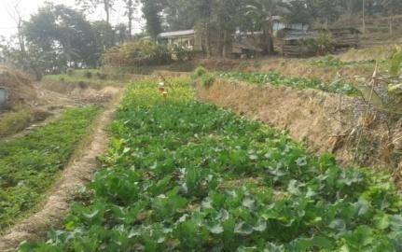

Plate: OFT - Eco-friendly management of diamond back moth in cauliflower grown in Darjeeling Hills

FT-3 (Plant Protection)

|  |  |  |
| --- | --- | --- |
| 1. | Title of On farm Trial | **Integrated disease management strategy of rice blast disease (*Pyriculariaoryzae*)** |
| 2. | Problem diagnosed | Poor yield due to high incidence of blast disease in rice |
| 3. | Details of technologies selected for assessment/refinement  (Mention either Assessed or Refined) | **Technology option-I (TO-I):** Seed treatment with *Pseudomonas fluorescence l*iquid formulation @ 10 ml/kg of seed + Seedling root dipping with *Pseudomonas fluorescence* liquid (500 ml for one hectare) + Foliar spray with *Pseudomonas fluorescence* @ 5ml/l  **Technology option-II (TO-II):** Split application of N2 (Basal + 25 DAP + 45 DAP) + Application of Tricyclazole (15 DAP and 30 DAP) |
| 4. | Source of Technology (ICAR/ AICRP/SAU/other, please specify) | NIPHM |
| 5. | Production system and thematic area | Rice based cropping system and Integrated disease management |
| 6. | Performance of the Technology with performance indicators | Disease incidence, Yield and BC ratio |
| 7. | Final recommendation for micro level situation | The technology option II*i.e.* Split application of N2 (Basal + 25 DAP + 45 DAP) + Application of Tricyclazole (15 DAP and 30 DAP), resulted to produce highest yield (24.67q ha-1) as well as reduces the significant numbers of disease intensity (15.6%), was effectively control the blast disease incidence in rice. |
| 8. | Constraints identified and feedback for research | - |
| 9. | Process of farmers participation and their reaction | For selection of farmers a group meeting was organized from where a few farmers was selected considering the production system and farming situation as per action plan. Ultimately 8 no. of farmers were selected from primary list after in situ visit of the farmers’ field. |

**Results**

|  |  |  |  |  |  |
| --- | --- | --- | --- | --- | --- |
| ***Technology option*** | ***Per cent disease intensity (PDI)*** | ***Yield***  ***(q/ha)*** | ***Yield % increase over Farmer’s practice*** | ***Net return***  ***(Rs./ha)*** | ***BC ratio*** |
| Farmers Practice: No management practices was followed | 59.2 | 18.31 | - | 616 | 1.02:1 |
| TO1: Seed treatment with Pseudomonas fluorescens liquid formulation @ 10 ml/kg of seed + Seedling root dipping with Pseudomonas fluorescens liquid (500 ml for one hectare) + Foliar spray with Pseudomonas fluorescens @ 5ml/l | 33.6 | 19.18 | 4.75 | 1485 | 1.06:1 |
| TO2: Split application of N2 (Basal + 25 DAP + 45 DAP) + Application of Tricyclazole (15 DAP and 30 DAP) | 15.6 | 24.67 | 34.75 | 8875 | 1.35:1 |
| CD (p=0.05) | 3.19 | 2.78 |  |  |  |

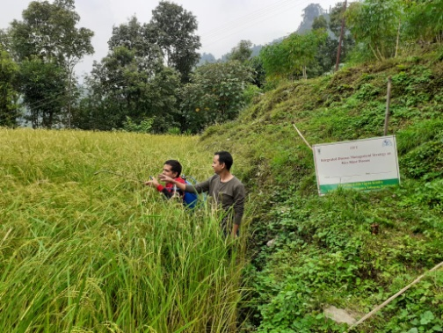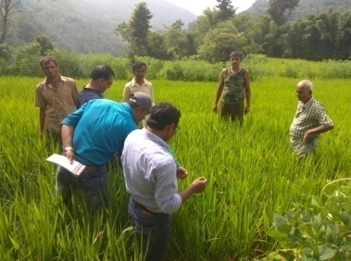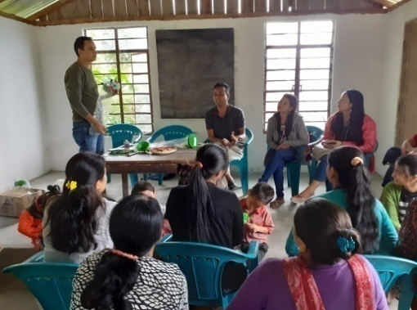

Plate: OFT - Integrated disease management strategy of rice blast disease

OFT-4 (Soil Science)

|  |  |  |
| --- | --- | --- |
| 1. | Title of On farm Trial | **Efficacy of Organic manure, Vermi-compost & bio-product (*Trichoderma viride*) to increase the productivity of Potato & Soil pH in hilly region of West Bengal** |
| 2. | Problem diagnosed | Due to high acidity & low nutrient status cause less productivity |
| 3. | Details of technologies selected for assessment/refinement  (Mention either Assessed or Refined) | |  | | --- | | Farmers Practice: Application of FYM @ 15 t/ha | | T1:Seed treatment with Trichoderma viride @ 5 gm/kg of seed + 675kg FYM/bigha (i.e. 5t/ha) + 335 kg Vermicompost /bigha (i.e 2.5t/ha) in the main field 10 days before sowing of seeds | | T2:Seed treatment with Trichoderma viride @ 5 gm/kg of seed + 675kg FYM/bigha (i.e. 5t/ha) + 675kg vermicompost/ bigha (i.e.5t/ha) 10 days before sowing of seeds | |
| 4. | Source of Technology (ICAR/ AICRP/SAU/other, please specify) | RVKSVV, Gwalior |
| 5. | Production system and thematic area | Vegetable based cropping system  Soil health management |
| 6. | Performance of the Technology with performance indicators | Application of bio-products and vermi-compost increases the pH status of soil and as well as increases the production of potato. |
| 7. | Final recommendation for micro level situation | Technology option2 *i.e.* Seed treatment with *Trichoderma viride* @ 5 gm/kg of seed + 675kg FYM/bigha (i.e. 5t/ha) + 675kg vermicompost/ bigha (i.e.5t/ha) 10 days before sowing of seeds, resulted to produce highest yield 21.44 t/ha as well as the pH range was rises to 6.21. |
| 8. | Constraints identified and feedback for research | Production of potato was hampered to some extent due to scarcity of water. |
| 9. | Process of farmers participation and their reaction | Progressive farmers of selected village were identified and conducted the oft programme. They have appreciated the work after getting result and accepted the technology. |

**Results**

|  |  |  |  |  |  |  |
| --- | --- | --- | --- | --- | --- | --- |
| ***Technology option*** | ***Yield***  ***(t/ha)*** | ***Yield % increase over Farmer’s practice*** | ***Net return***  ***(Rs./ha)*** | ***BC ratio*** | ***Initial Soil pH Status*** | ***After Harvest Soil pH Status*** |
| Farmers Practice: Application of FYM @ 15 t/ha | 17.05 | - | 71651/- | 2.1 | 5.62  to  5.74 | 5.87 |
| T1:Seed treatment with Trichoderma viride @ 5 gm/kg of seed + 675kg FYM/bigha (i.e. 5t/ha) + 335 kg Vermicompost /bigha (i.e 2.5t/ha) in the main field 10 days before sowing of seeds | 18.85 | 10.80% | 86350/- | 2.3 | 6.04 |
| T2:Seed treatment with Trichoderma viride @ 5 gm/kg of seed + 675kg FYM/bigha (i.e. 5t/ha) + 675kg vermicompost/ bigha (i.e.5t/ha) 10 days before sowing of seeds | 21.44 | 26.07% | 106440/- | 2.6 | 6.21 |
| CD (p=0.05) | 0.57 |  |  |  |  |  |

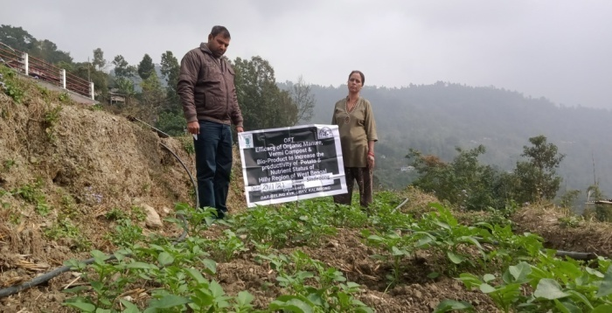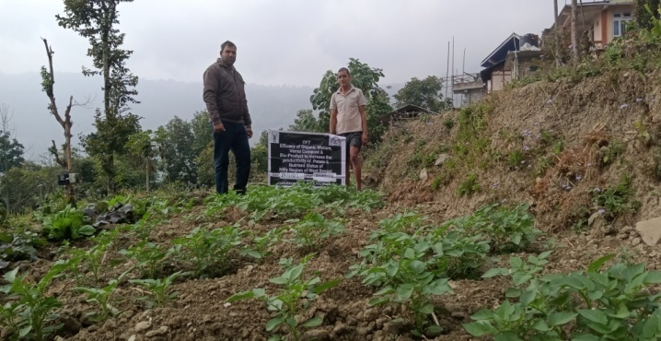

OFT-5 (Home Science)

|  |  |  |
| --- | --- | --- |
| 1. | Title of On farm Trial | **Assessment on storage and shelf life of Soy milk** |
| 2. | Problem diagnosed | **Traditional method of storage of soy milk** |
| 3. | Details of technologies selected for assessment/refinement | Farmers Practice (FP): Boiling process for storage  Technology option-I (TO-I): Boiling and refrigeration  Technology option-II (TO-II): Boiling and addition of preservatives (Sodium benzoate @ 350mg/kg)  Technology option- III (TO- III): Boiling with addition of preservatives (Sodium benzoate @350mg/kg) and refrigeration |
| 4. | Source of Technology (ICAR/ AICRP/SAU/other, please specify) | IFTM University, Moradabad, Uttar Pradesh, India |
| 5. | Production system and thematic area | Value addition |
| 6. | Performance of the Technology with performance indicators | Among the three technology options Tech Option III showed a good result in terms of keeping quality and improved the shelf life of the soy milk. However, spoilage and curdling started after 10 days duration for this option too. Therefore, further more trails are necessary. |
| 7. | Final recommendation for micro level situation | After the SAC meeting this OFT has been recommended to be discontinued |
| 8. | Constraints identified and feedback for research | Irregular current supply and absence of refrigerator |
| 9. | Process of farmers participation and their reaction | Training and demonstration |

*Thematic area: Value addition*

Problem definition: **Traditional method of storage of soy milk**

Technology assessed: **Use of preservative (Sodium benzoate @ 350mg/kg) to enhance the shelf life of soy milk**

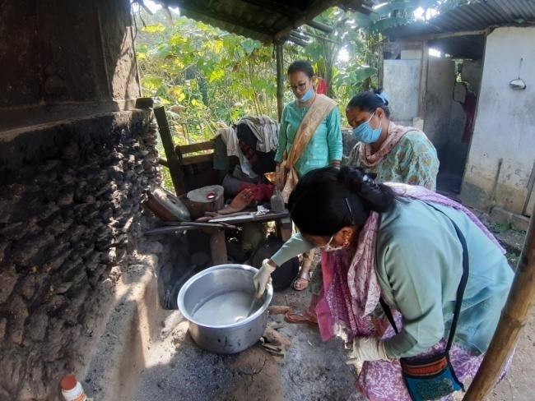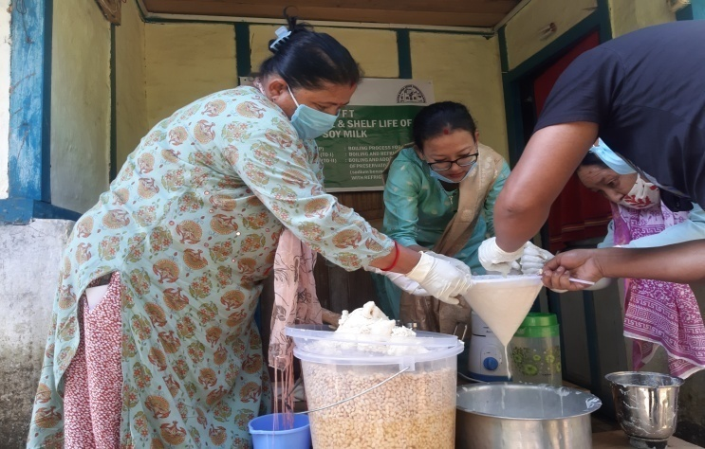

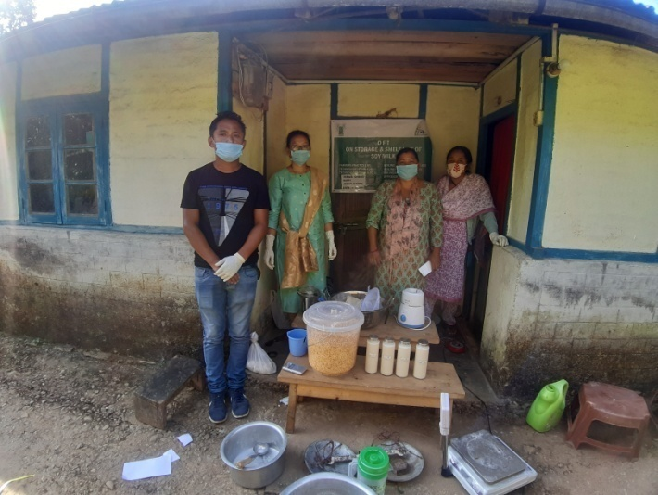

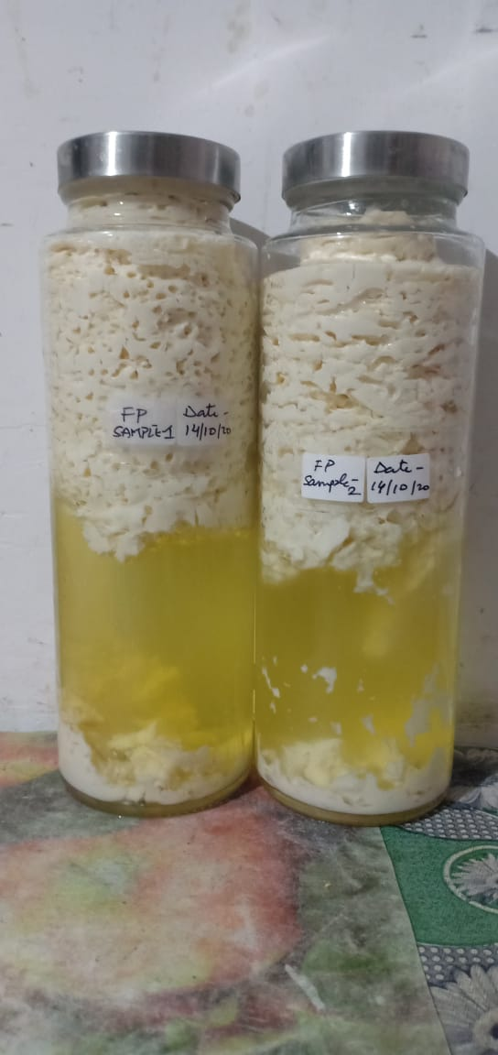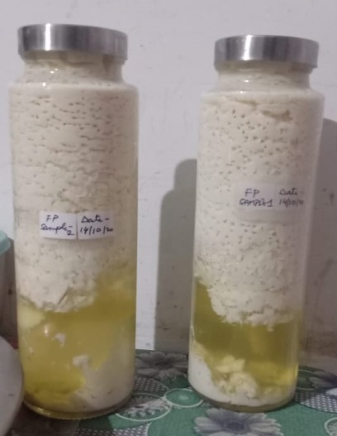

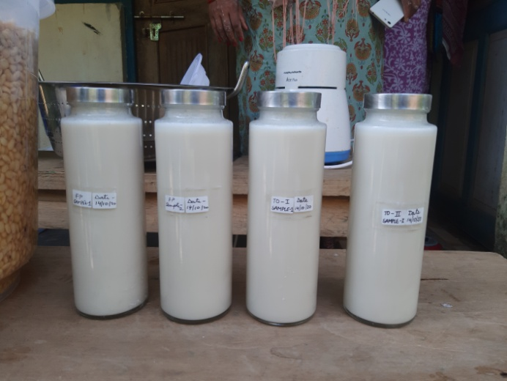**Results: No positive results found in all the samples due to many unavoidable circumstances and constrains**

3.2 Achievements of Frontline Demonstrations

1. Details of FLDs conducted during the year (**Cereals)**

|  |  |  |  |  |  |  |  |  |  |  |  |  |  |  |  |
| --- | --- | --- | --- | --- | --- | --- | --- | --- | --- | --- | --- | --- | --- | --- | --- |
| Sl.  No. | Crop | Thematic area | Technology Demonstrated with detailed treatments | Area (ha) | | No. of farmers/  demonstration | | | | | | | | | Reasons for shortfall in achievement |
| Proposed | Actual | SC | | ST | | Others | | Total | | |
|  |  |  |  |  |  | M | F | M | F | M | F | M | F | T |
| 1. | Paddy  (PP) | Integrated pest management | Pheromone trap @10/ha | 0.5 | 0.5 | 3 | 0 | 4 | 3 | 12 | 3 | 19 | 6 | 25 |  |

Details of farming situation

|  |  |  |  |  |  |  |  |  |  |  |  |
| --- | --- | --- | --- | --- | --- | --- | --- | --- | --- | --- | --- |
| Crop | Season | Farming situation (RF/Irrigated) | Soil type | Status of soil  (Kg/ha) | | | Previous crop | Sowing date | Harvest date | Seasonal rainfall (mm) | No. of rainy days |
| N | P2O5 | K2O |
| Paddy  (PP) | Kharif 2020 | Rainfed | Acidic | 152-235 | 51-78 | 127-174 | Summer vegetable | 26-30.06.20 | 18-24.09.20 | - | - |

Performance of FLD

|  |  |  |  |  |  |  |  |  |  |  |  |  |  |  |  |
| --- | --- | --- | --- | --- | --- | --- | --- | --- | --- | --- | --- | --- | --- | --- | --- |
| Crop | Thematic Area | Name of the technology demonstrated | No. of Farmers | Area  (ha) | Yield (q/ha) | | % Increase | *Economics of demonstration (Rs./ha) | | | | *Economics of check  (Rs./ha) | | | |
| Demo | Check | Gross  Cost | Gross  Return | Net Return | **  BCR | Gross  Cost | Gross  Return | Net Return | **  BCR |
| Paddy  (PP) | Integrated pest management | Pheromone trap @10/ha | 25 | 0.5 | 16.4 | 12.8 | 28.12 | 25334 | 49200 | 23866 | 1.94 | 25012 | 38400 | 13388 | 1.53 |

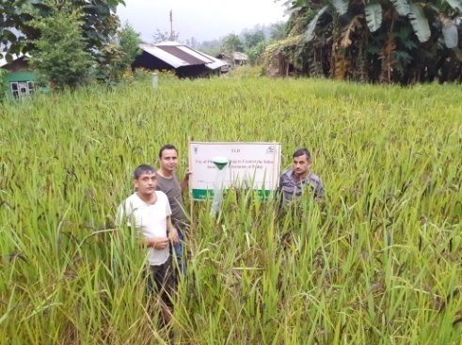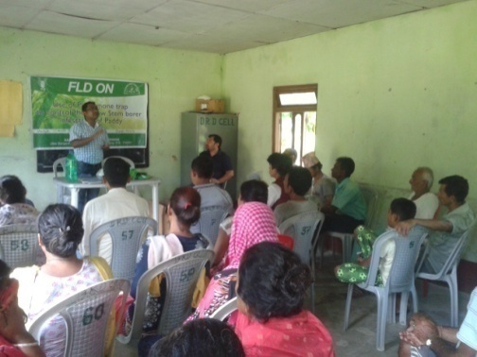

**Demonstration**

**Training**

**Plate: Management of YSB with Pheromone trap**

Crop category: Fruit Crop

|  |  |  |  |  |  |  |  |  |  |  |  |  |  |  |  |
| --- | --- | --- | --- | --- | --- | --- | --- | --- | --- | --- | --- | --- | --- | --- | --- |
| Sl.  No. | Crop | Thematic area | Technology Demonstrated with detailed treatments | Area (ha) | | No. of farmers/  demonstration | | | | | | | | | Reasons for shortfall in achievement |
| Proposed | Actual | SC | | ST | | Others | | Total | | |
| M | F | M | F | M | F | M | F | T |
| 1 | Mandarin | Integrated Pest Management | *Drenching the tree basin with 10 liters of 0.5% Monocrotophos 36 SL | 5 nos. per unit | 5 nos. per unit | 5 | 2 | 0 | 1 | 3 | 4 | 8 | 7 | 15 |  |

Details of farming situation

|  |  |  |  |  |  |  |  |  |  |  |  |
| --- | --- | --- | --- | --- | --- | --- | --- | --- | --- | --- | --- |
| Crop | Season | Farming situation (RF/Irrigated) | Soil type | Status of soil  (Kg/ha) | | | Previous crop | Sowing date | Harvest date | Seasonal rainfall (mm) | No. of rainy days |
| N | P2O5 | K2O |
| Mandarin | Perennial | Rainfed | Acidic | 132-184 | 65-75 | 105-120 | - | 28/02/2020 | 30.12.2020 | - | - |

Performance of FLD

|  |  |  |  |  |  |  |  |  |  |  |  |  |  |  |  |
| --- | --- | --- | --- | --- | --- | --- | --- | --- | --- | --- | --- | --- | --- | --- | --- |
| **Crop** | **Thematic area** | **Name of the technology demonstrated** | **No. of Farmer** | **Area**  **(ha)** | **Yield** | | **% change in yield** | **\*Economics of demonstration (Rs./ha)** | | | | **\*Economics of check**  **(Rs./ha)** | | | |
| Demons  ration | Check | Gross  Cost | Gross  Return | Net Return | **  BCR | Gross  Cost | Gross  Return | Net Return | **  BCR |
| Mandarin | IPM | * | 15 | 5 nos. per unit | 35 fruits/tree | 28 fruits/tree | 25 | 328 | 700 | 372 | 2.13 | 294 | 560 | 266 | 1.90 |

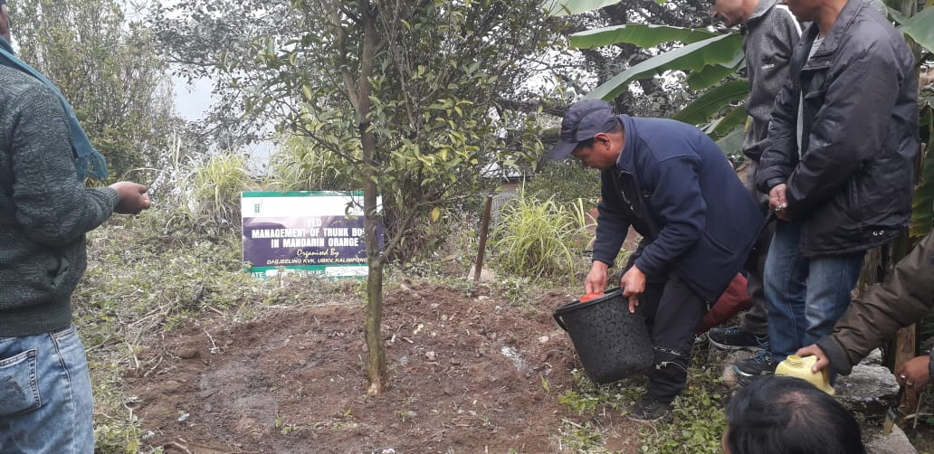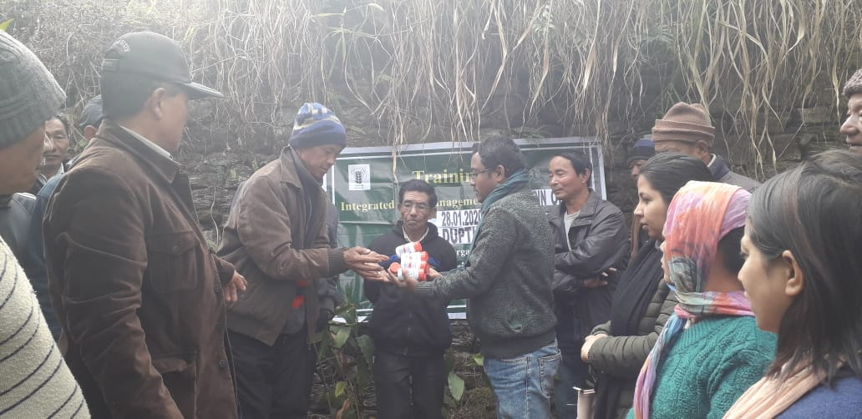

**Input Distribution**

**Demonstration**

**Plate: Management of trunk borer of Mandarin orange**

Fruit Crop : Mandarin Orange

Details of farming situation

|  |  |  |  |  |  |  |  |  |  |  |  |  |  |  |  |
| --- | --- | --- | --- | --- | --- | --- | --- | --- | --- | --- | --- | --- | --- | --- | --- |
| Sl.  No. | Crop | Thematic area | Technology Demonstrated with detailed treatments | Area (ha) | | No. of farmers/  demonstration | | | | | | | | | Reasons for shortfall in achievement |
| Proposed | Actual | SC | | ST | | Others | | Total | | |
| M | F | M | F | M | F | M | F | T |
| 1 | Mandarin | Crop Production | N:P:K@300:250:300 g, B 50 g, Z 250g, Vermicompost 12.5kg,Pig Manure 6.25kg and FYM 25 kg/tree | 0.1 | 0.1 | 0 | 0 | 2 | 0 | 3 | 1 | 5 | 1 | 6 |  |

|  |  |  |  |  |  |  |  |  |  |  |  |
| --- | --- | --- | --- | --- | --- | --- | --- | --- | --- | --- | --- |
| Crop | Season | Farming situation (RF/Irrigated) | Soil type | Status of soil  (Kg/ha) | | | Previous crop | Sowing date | Harvest date | Seasonal rainfall (mm) | No. of rainy days |
| N | P2O5 | K2O |
| Mandarin | Perennial | Rainfed | Acidic | 284.0 | 94.1 | 123.5 | ---- | 07/11/2020 | 25/02/2021 |  |  |

|  |  |  |  |  |  |  |  |  |  |  |  |  |  |  |  |
| --- | --- | --- | --- | --- | --- | --- | --- | --- | --- | --- | --- | --- | --- | --- | --- |
| Crop | Thematic area | Name of the technology demonstrated | No. of Farmer | Area  (ha) | Yield (q/ha) | | % change in yield | *Economics of demonstration (Rs./ha) | | | | *Economics of check  (Rs./ha) | | | |
| Demons  ration | Check | Gross  Cost | Gross  Return | Net Return | **  BCR | Gross  Cost | Gross  Return | Net Return | **  BCR |
| Mandarin | Crop production | N:P:K@300:250:300 g, B 50 g, Z 250g, Vermicompost 12.5kg,Pig Manure 6.25kg and FYM 25 kg/tree | 6 | 0.10 | 559 | 275 fruits/tree) | 50.8 | 2,33,500/- | 5,53,410/- | 3,19,910/- | 2.3:1 | 1,55,600/- | 2,72,250/- | 1,16,650/- | 1.7:1 |

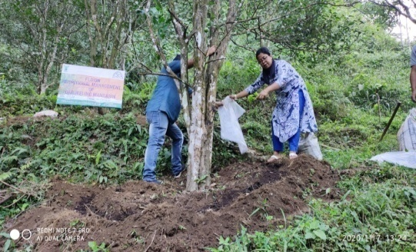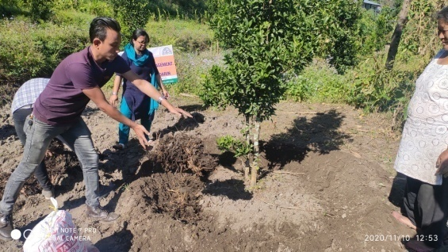

Flower : Gladiolus

Details of farming situation

|  |  |  |  |  |  |  |  |  |  |  |  |  |  |  |  |
| --- | --- | --- | --- | --- | --- | --- | --- | --- | --- | --- | --- | --- | --- | --- | --- |
| Sl.  No. | Crop | Thematic area | Technology Demonstrated with detailed treatments | Area (ha) | | No. of farmers/  demonstration | | | | | | | | | Reasons for shortfall in achievement |
| Proposed | Actual | SC | | ST | | Others | | Total | | |
| M | F | M | F | M | F | M | F | T |
| 1 | Gladiolus | Crop Production | Variety –American Beauty with N:P:K @120:150:150 FYM 10t/ha | 0.1 | 0.1 | 0 | 0 | 0 | 0 | 3 | 3 | 3 | 3 | 6 |  |

|  |  |  |  |  |  |  |  |  |  |  |  |
| --- | --- | --- | --- | --- | --- | --- | --- | --- | --- | --- | --- |
| Crop | Season | Farming situation (RF/Irrigated) | Soil type | Status of soil  (Kg/ha) | | | Previous crop | Sowing date | Harvest date | Seasonal rainfall (mm) | No. of rainy days |
| N | P2O5 | K2O |
| Gladiolus | Rabi | Rainfed | Acidic | 271.4 | 38.4 | 158.6 | Paddy | 17/01/2020 | 11/05/2021 |  |  |

|  |  |  |  |  |  |  |  |  |  |  |  |  |  |  |  |
| --- | --- | --- | --- | --- | --- | --- | --- | --- | --- | --- | --- | --- | --- | --- | --- |
| Crop | Thematic area | Name of the technology demonstrated | No. of Farmer | Area  (ha) | Yield (q/ha) | | % change in yield | *Economics of demonstration (Rs./ha) | | | | *Economics of check  (Rs./ha) | | | |
| Demons  ration | Check | Gross  Cost | Gross  Return | Net Return | **  BCR | Gross  Cost | Gross  Return | Net Return | **  BCR |
| Gladiolus | Crop production | Variety –American Beauty with N:P:K @120:150:150 FYM 10t/ha | 5 | 0.10 | 1,75,167 | 1,15,650  (sticks) | 33 | 2,30,562/- | 5,25,501 | 2,94,939/- | 2.2:1 | 2,10,300/- | 3,46,950/- | 1,36,650/- | 1.6:1 |

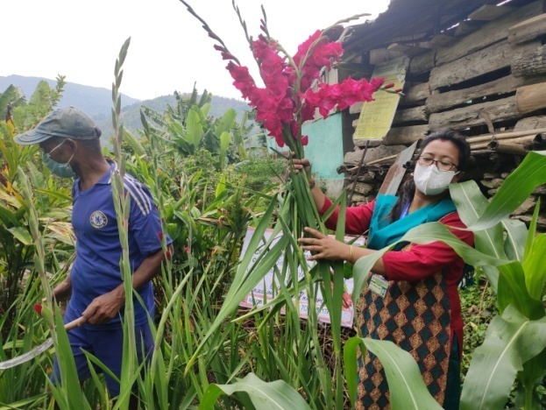

Vegetable: Off-season Cauliflower

Details of farming situation

|  |  |  |  |  |  |  |  |  |  |  |  |  |  |  |  |
| --- | --- | --- | --- | --- | --- | --- | --- | --- | --- | --- | --- | --- | --- | --- | --- |
| Sl.  No. | Crop | Thematic area | Technology Demonstrated with detailed treatments | Area (ha) | | No. of farmers/  demonstration | | | | | | | | | Reasons for shortfall in achievement |
| Proposed | Actual | SC | | ST | | Others | | Total | | |
| M | F | M | F | M | F | M | F | T |
| 1 | Cauliflower | Crop Production | Seedlings on raised bedunder transparent polythene . | 0.1 | 0.1 | 1 | 4 | 0 | 0 | 1 | 0 | 2 | 4 | 6 |  |

|  |  |  |  |  |  |  |  |  |  |  |  |
| --- | --- | --- | --- | --- | --- | --- | --- | --- | --- | --- | --- |
| Crop | Season | Farming situation (RF/Irrigated) | Soil type | Status of soil  (Kg/ha) | | | Previous crop | Sowing date | Harvest date | Seasonal rainfall (mm) | No. of rainy days |
| N | P2O5 | K2O |
| Off season cauliflower | Kharif | Irrigated | Acidic | 381.2 | 28.4 | 121.4 | Round Chillies | 01/9/2020 | 11/11/2020 |  |  |

|  |  |  |  |  |  |  |  |  |  |  |  |  |  |  |  |
| --- | --- | --- | --- | --- | --- | --- | --- | --- | --- | --- | --- | --- | --- | --- | --- |
| Crop | Thematic area | Name of the technology demonstrated | No. of Farmer | Area  (ha) | Yield (q/ha) | | % change in yield | *Economics of demonstration (Rs./ha) | | | | *Economics of check  (Rs./ha) | | | |
| Demons  ration | Check | Gross  Cost | Gross  Return | Net Return | **  BCR | Gross  Cost | Gross  Return | Net Return | **  BCR |
| Off season cauliflower | Crop production | Seedlings on raised bedunder transparent polythene . | 6 | 0.10 | 155.20 | 110.23 |  | 72,500/- | 1,55,200/- | 82,700/- | 2.1:1 | 60,500/- | 1,10,230 | 497301/- | 1.8:1 |

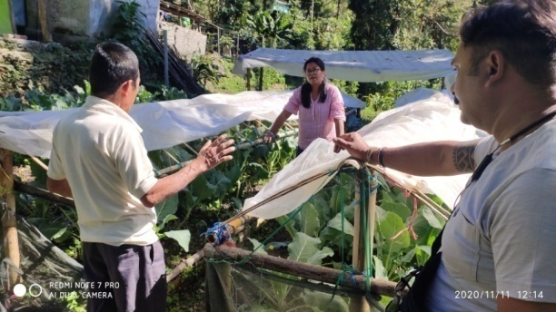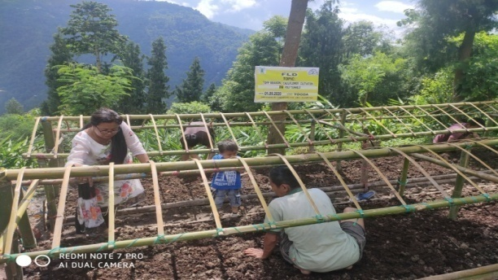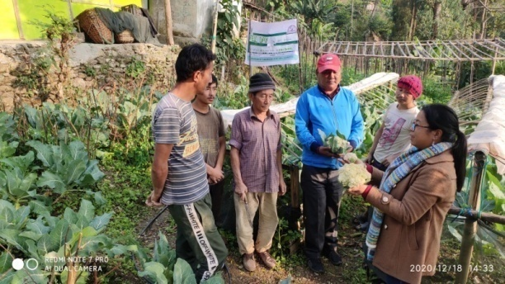

Information of same crop should be provided. For example, if in Table 3.2A crops are mentioned as a,b,c,d etc., in the table for Details of farming situation, the same crop should be mentioned in the identical sequence.

Performance of FLD

**Oilseeds:**

Frontline demonstrations on oilseed crops

|  |  |  |  |  |  |  |  |  |  |  |  |  |  |  |  |
| --- | --- | --- | --- | --- | --- | --- | --- | --- | --- | --- | --- | --- | --- | --- | --- |
| Crop | Thematic Area | Name of the technology demonstrated | No. of Farmers | Area  (ha) | Yield (q/ha) | | % Increase | *Economics of demonstration (Rs./ha) | | | | *Economics of check  (Rs./ha) | | | |
| Demo | Check | Gross  Cost | Gross  Return | Net Return | **  BCR | Gross  Cost | Gross  Return | Net Return | **  BCR |
|  |  |  |  |  |  |  |  |  |  |  |  |  |  |  |  |
|  |  |  |  |  |  |  |  |  |  |  |  |  |  |  |  |
| Total |  |  |  |  |  |  |  |  |  |  |  |  |  |  |  |

* Economics to be worked out based on total cost of production per unit area and not on critical inputs alone.

** BCR= GROSS RETURN/GROSS COST

**Pulses**   
Frontline demonstration on pulse crops

|  |  |  |  |  |  |  |  |  |  |  |  |  |  |  |  |
| --- | --- | --- | --- | --- | --- | --- | --- | --- | --- | --- | --- | --- | --- | --- | --- |
| Crop | Thematic Area | Name of the technology demonstrated | No. of Farmers | Area  (ha) | Yield (q/ha) | | % Increase | *Economics of demonstration (Rs./ha) | | | | *Economics of check  (Rs./ha) | | | |
| Demo | Check | Gross  Cost | Gross  Return | Net Return | **  BCR | Gross  Cost | Gross  Return | Net Return | **  BCR |
|  |  |  |  |  |  |  |  |  |  |  |  |  |  |  |  |
|  |  |  |  |  |  |  |  |  |  |  |  |  |  |  |  |
|  |  |  |  |  |  |  |  |  |  |  |  |  |  |  |  |
|  | Total |  |  |  |  |  |  |  |  |  |  |  |  |  |  |

* Economics to be worked out based on total cost of production per unit area and not on critical inputs alone.

** BCR= GROSS RETURN/GROSS COST

Livestock

|  |  |  |  |  |  |  |  |  |  |  |  |  |  |  |  |  |  |
| --- | --- | --- | --- | --- | --- | --- | --- | --- | --- | --- | --- | --- | --- | --- | --- | --- | --- |
| Category | Thematic  area | Name of the technology demonstrated | No. of Farmer | No. of units | Major parameters | | % change in major parameter | Other parameter | | *Economics of demonstration (Rs.) | | | | *Economics of check  (Rs.) | | | |
| Demons  ration | Check | Demons  ration | Check | Gross  Cost | Gross  Return | Net Return | **  BCR | Gross  Cost | Gross  Return | Net Return | **  BCR |
| Dairy |  |  |  |  |  |  |  |  |  |  |  |  |  |  |  |  |  |
| Cow |  |  |  |  |  |  |  |  |  |  |  |  |  |  |  |  |  |
| Buffalo |  |  |  |  |  |  |  |  |  |  |  |  |  |  |  |  |  |
| Poultry | Nutritional Management | Azolla feeding as low cost protein supplement | 25 | 25 | -- | -- | -- | -- | -- | -- | -- | -- | -- | -- | -- | -- | -- |
| Rabbitry |  |  |  |  |  |  |  |  |  |  |  |  |  |  |  |  |  |
| Pigerry |  |  |  |  |  |  |  |  |  |  |  |  |  |  |  |  |  |
| Sheep and goat |  |  |  |  |  |  |  |  |  |  |  |  |  |  |  |  |  |
| Duckery |  |  |  |  |  |  |  |  |  |  |  |  |  |  |  |  |  |
| Others (pl.specify) |  |  |  |  |  |  |  |  |  |  |  |  |  |  |  |  |  |
| Total |  |  |  |  |  |  |  |  |  |  |  |  |  |  |  |  |  |

* Economics to be worked out based on total cost of production per unit area and not on critical inputs alone.

** BCR= GROSS RETURN/GROSS COST

Fisheries

|  |  |  |  |  |  |  |  |  |  |  |  |  |  |  |  |  |  |
| --- | --- | --- | --- | --- | --- | --- | --- | --- | --- | --- | --- | --- | --- | --- | --- | --- | --- |
| Category | Thematic area | Name of the technology demonstrated | No. of Farmer | No. of units | Major parameters | | % change in major parameter | Other parameter | | *Economics of demonstration (Rs.) | | | | *Economics of check  (Rs.) | | | |
| Demons  ration | Check | Demons  ration | Check | Gross  Cost | Gross  Return | Net Return | **  BCR | Gross  Cost | Gross  Return | Net Return | **  BCR |
| Common carps |  |  |  |  |  |  |  |  |  |  |  |  |  |  |  |  |  |
| Mussels |  |  |  |  |  |  |  |  |  |  |  |  |  |  |  |  |  |
|  |  |  |  |  |  |  |  |  |  |  |  |  |  |  |  |  |  |
| Ornamental fishes |  |  |  |  |  |  |  |  |  |  |  |  |  |  |  |  |  |
| Others (pl.specify) |  |  |  |  |  |  |  |  |  |  |  |  |  |  |  |  |  |
| **Total** |  |  |  |  |  |  |  |  |  |  |  |  |  |  |  |  |  |

* Economics to be worked out based on total cost of production per unit area and not on critical inputs alone.

** BCR= GROSS RETURN/GROSS COST

Other enterprises

|  |  |  |  |  |  |  |  |  |  |  |  |  |  |  |  |  |
| --- | --- | --- | --- | --- | --- | --- | --- | --- | --- | --- | --- | --- | --- | --- | --- | --- |
| Category | Name of the technology demonstrated | No. of Farmer | No. of units | Major parameters | | % change in major parameter | Other parameter | | *Economics of demonstration (Rs.) or Rs./unit | | | | *Economics of check  (Rs.) or Rs./unit | | | |
| Demons  ration | Check | Demons  ration | Check | Gross  Cost | Gross  Return | Net Return | **  BCR | Gross  Cost | Gross  Return | Net Return | **  BCR |
| Oyster mushroom | Enterprise development |  |  |  |  |  |  |  |  |  |  |  |  |  |  |  |
| Button mushroom |  |  |  |  |  |  |  |  |  |  |  |  |  |  |  |  |
| Vermicompost |  |  |  |  |  |  |  |  |  |  |  |  |  |  |  |  |
| Sericulture |  |  |  |  |  |  |  |  |  |  |  |  |  |  |  |  |
| Apiculture |  |  |  |  |  |  |  |  |  |  |  |  |  |  |  |  |
| **Value addition** | **Preservation techniques along with usage of natural preservatives** | **10** | 1 | Value added products | Value added products |  |  |  | 10000 | 16000 | 6000 | 0.6:1 | 10000 | 25000 | 15000 | 1.5:1 |
| Total | |  |  |  | | | | | | | | | | | | |

* Economics to be worked out based on total cost of production per unit area and not on critical inputs alone.

** BCR= GROSS RETURN/GROSS COST

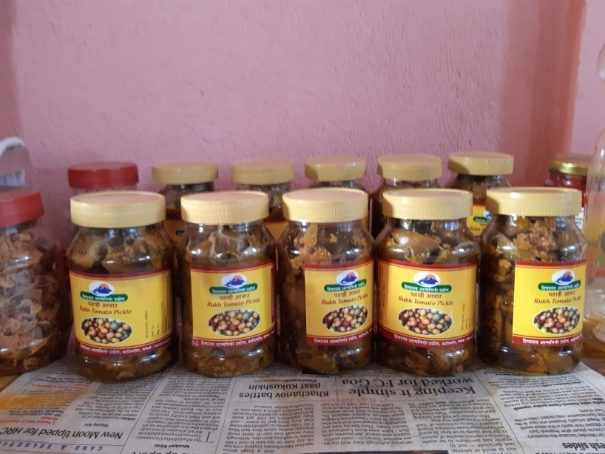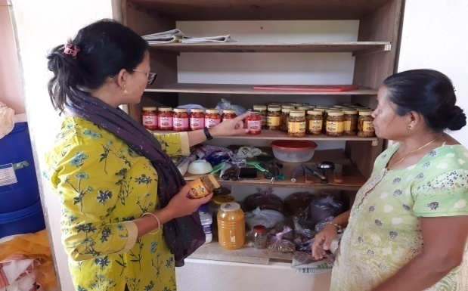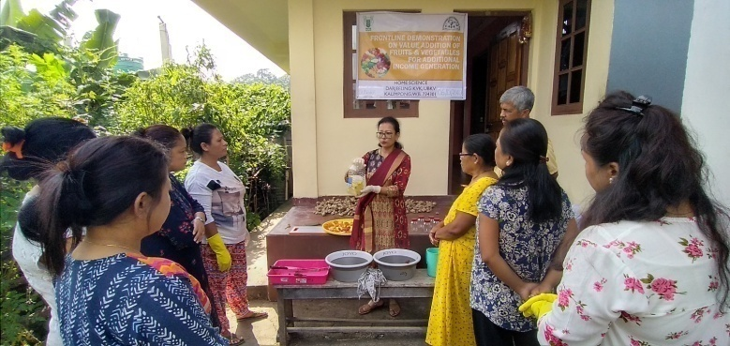

Women empowerment

|  |  |  |  |  |  |
| --- | --- | --- | --- | --- | --- |
| Category | Name of technology | No. of demonstrations | Observations | | Remarks |
| Demonstration | Check |
| Farm Women | Value addition | 2 | Self employment  Income generation | Unemployed and dependent, inactive SHG | Skill development |
| Pregnant women |  |  |  |  |  |
| Adolescent Girl |  |  |  |  |  |
| Other women | Nutri gardening | 4 | Improvement of knowledge | Lack of knowledge | Knowledge level enhanced |
| Children |  |  |  |  |  |
| Neonatal |  |  |  |  |  |
| Infants |  |  |  |  |  |

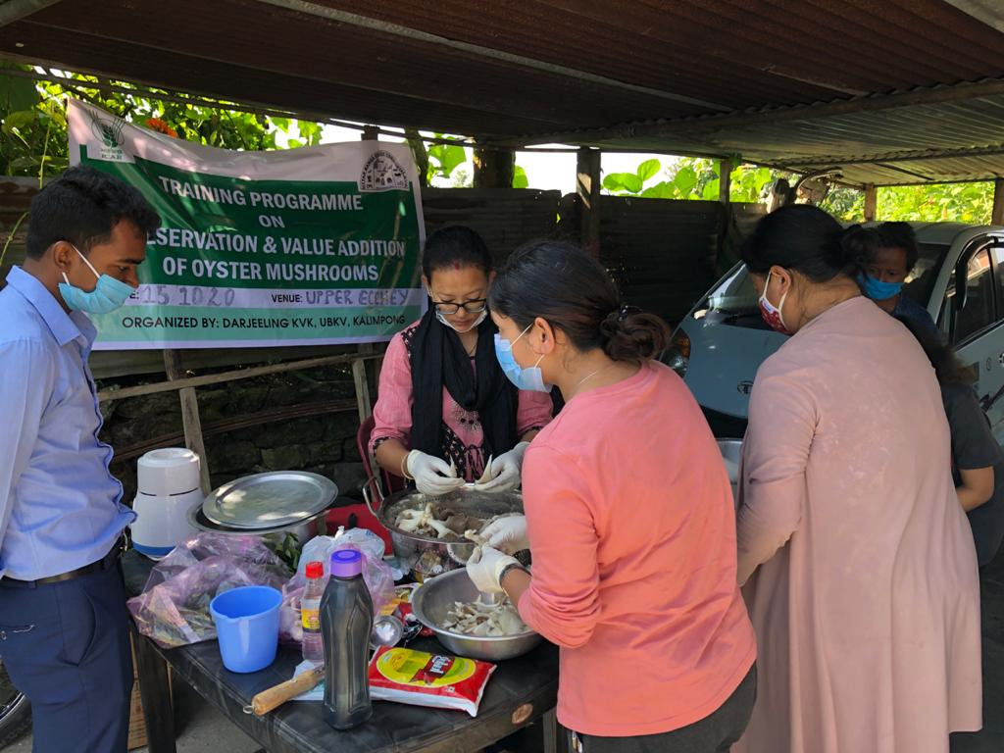

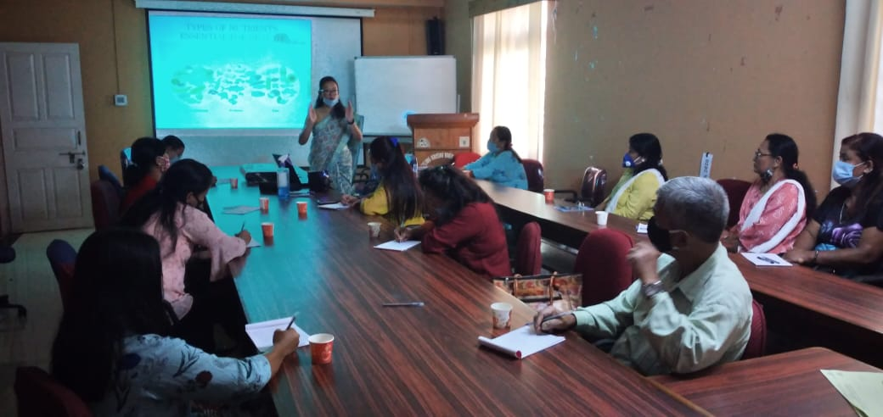

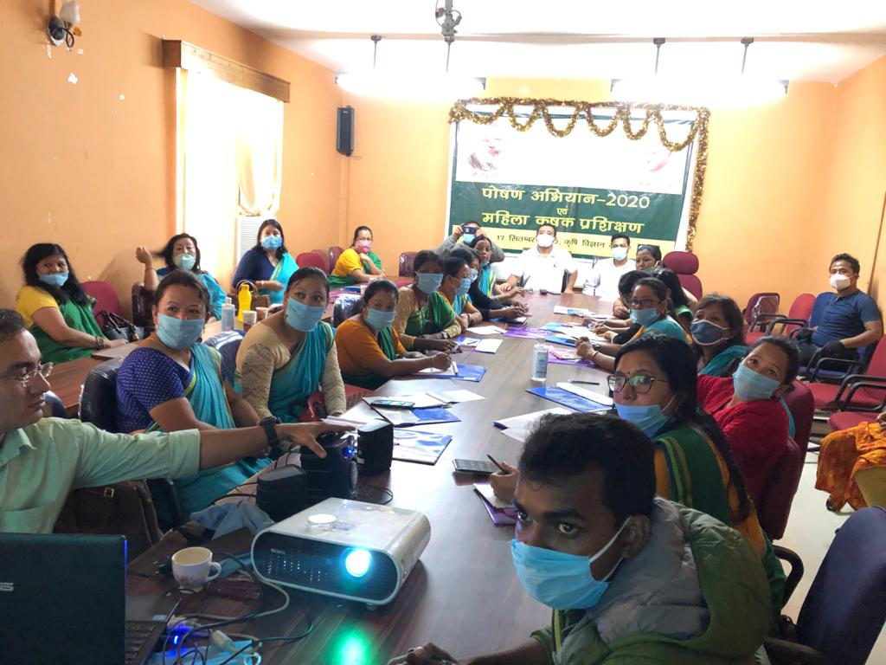

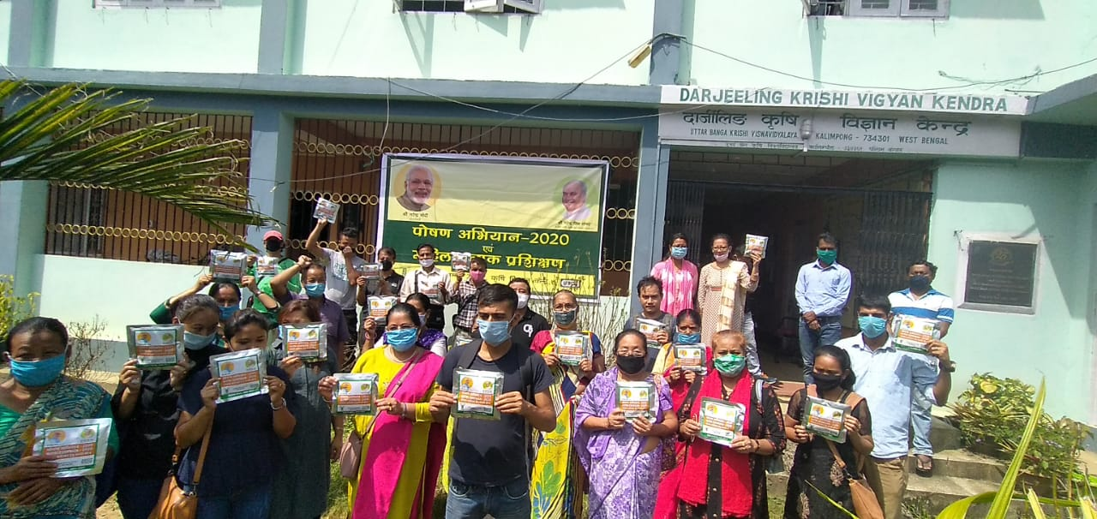

|  |  |  |  |  |  |  |  |  |  |  |  |  |  |  |  |  |
| --- | --- | --- | --- | --- | --- | --- | --- | --- | --- | --- | --- | --- | --- | --- | --- | --- |
| Category | Name of the technology demonstrated | No. of Farmer | No. of units | Major parameters | | % change in major parameter | Other parameter | | *Economics of demonstration (Rs.) or Rs./unit | | | | *Economics of check  (Rs.) or Rs./unit | | | |
| Demons  ration | Check | Demons  ration | Check | Gross  Cost | Gross  Return | Net Return | **  BCR | Gross  Cost | Gross  Return | Net Return | **  BCR |
| Oyster mushroom | Enterprise  development |  |  |  |  |  |  |  |  |  |  |  |  |  |  |  |
| Button mushroom |  |  |  |  |  |  |  |  |  |  |  |  |  |  |  |  |
| Vermicompost |  |  |  |  |  |  |  |  |  |  |  |  |  |  |  |  |
| Sericulture |  |  |  |  |  |  |  |  |  |  |  |  |  |  |  |  |
| Apiculture |  |  |  |  |  |  |  |  |  |  |  |  |  |  |  |  |
| Others (pl.specify) |  |  |  |  |  |  |  |  |  |  |  |  |  |  |  |  |
|  |  |  |  |  |  |  |  |  |  |  |  |  |  |  |  |  |
| Total | |  |  |  | | | | | | | | | | | | |

* Economics to be worked out based on total cost of production per unit area and not on critical inputs alone.

** BCR= GROSS RETURN/GROSS COST

Women empowerment

|  |  |  |  |  |  |
| --- | --- | --- | --- | --- | --- |
| Category | Name of technology | No. of demonstrations | Observations | | Remarks |
| Demonstration | Check |
| Farm Women |  |  |  |  |  |
| Pregnant women |  |  |  |  |  |
| Adolescent Girl |  |  |  |  |  |
| Other women |  |  |  |  |  |
| Children |  |  |  |  |  |
| Neonatal |  |  |  |  |  |
| Infants |  |  |  |  |  |

Farm implements and machinery

|  |  |  |  |  |  |  |  |  |  |
| --- | --- | --- | --- | --- | --- | --- | --- | --- | --- |
| Name of the implement | Crop | Name of the technology demonstrated | No. of Farmer | Area (ha) | Filed observation (output/man hour) | | % change in major parameter | Labor reduction (man days) | Cost reduction (Rs./ha or Rs./Unit) |
| Demons  ration | Check |
|  |  |  |  |  |  |  |  |  |  |

**\* Economics to be worked out based on total cost of production per unit area and not on critical inputs alone.**

**\*\* BCR= GROSS RETURN/GROSS COST**

Demonstration details on crop hybrids

|  |  |  |  |  |  |  |  |  |  |  |
| --- | --- | --- | --- | --- | --- | --- | --- | --- | --- | --- |
| Crop | Name of the Hybrid | No. of  farmers | Area  (ha) | Yield (kg/ha) / major parameter | | | Economics (Rs./ha) | | | |
| Cereals | Demo | Local check | % change | Gross  Cost | Gross  Return | Net  Return | BCR |
|  |  |  |  |  |  |  |  |  |  |  |
| Bajra |  |  |  |  |  |  |  |  |  |  |
| Maize |  |  |  |  |  |  |  |  |  |  |
| Paddy |  |  |  |  |  |  |  |  |  |  |
| Sorghum |  |  |  |  |  |  |  |  |  |  |
| Wheat |  |  |  |  |  |  |  |  |  |  |
| Others (Pl. specify) |  |  |  |  |  |  |  |  |  |  |
| Total |  |  |  |  |  |  |  |  |  |  |
| Oilseeds |  |  |  |  |  |  |  |  |  |  |
| Castor |  |  |  |  |  |  |  |  |  |  |
| Mustard |  |  |  |  |  |  |  |  |  |  |
| Safflower |  |  |  |  |  |  |  |  |  |  |
| Sesame |  |  |  |  |  |  |  |  |  |  |
| Sunflower |  |  |  |  |  |  |  |  |  |  |
| Groundnut |  |  |  |  |  |  |  |  |  |  |
| Soybean |  |  |  |  |  |  |  |  |  |  |
| Others (Pl. specify) |  |  |  |  |  |  |  |  |  |  |
| Total |  |  |  |  |  |  |  |  |  |  |
| Pulses |  |  |  |  |  |  |  |  |  |  |
| Greengram |  |  |  |  |  |  |  |  |  |  |
| Blackgram |  |  |  |  |  |  |  |  |  |  |
| Bengalgram |  |  |  |  |  |  |  |  |  |  |
| Redgram |  |  |  |  |  |  |  |  |  |  |
| Others (Pl. specify) |  |  |  |  |  |  |  |  |  |  |
| Total |  |  |  |  |  |  |  |  |  |  |
| Vegetable crops |  |  |  |  |  |  |  |  |  |  |
| Bottle gourd |  |  |  |  |  |  |  |  |  |  |
| Capsicum |  |  |  |  |  |  |  |  |  |  |
| Cucumber |  |  |  |  |  |  |  |  |  |  |
| Tomato |  |  |  |  |  |  |  |  |  |  |
| Brinjal |  |  |  |  |  |  |  |  |  |  |
| Okra |  |  |  |  |  |  |  |  |  |  |
| Onion |  |  |  |  |  |  |  |  |  |  |
| Potato |  |  |  |  |  |  |  |  |  |  |
| Field bean |  |  |  |  |  |  |  |  |  |  |
| Others (Pl. specify) |  |  |  |  |  |  |  |  |  |  |
| Total |  |  |  |  |  |  |  |  |  |  |
| Commercial crops |  |  |  |  |  |  |  |  |  |  |
| Cotton |  |  |  |  |  |  |  |  |  |  |
| Coconut |  |  |  |  |  |  |  |  |  |  |
| Others (Pl. specify) |  |  |  |  |  |  |  |  |  |  |
|  |  |  |  |  |  |  |  |  |  |  |
| Total |  |  |  |  |  |  |  |  |  |  |
| Fodder crops |  |  |  |  |  |  |  |  |  |  |
| Napier (Fodder) |  |  |  |  |  |  |  |  |  |  |
| Maize (Fodder) |  |  |  |  |  |  |  |  |  |  |
| Sorghum (Fodder) |  |  |  |  |  |  |  |  |  |  |
| Others (Pl. specify) |  |  |  |  |  |  |  |  |  |  |
| Total |  |  |  |  |  |  |  |  |  |  |

Technical Feedback on the demonstrated technologies

|  |  |  |
| --- | --- | --- |
| Sl. No | Crop | Feed Back |
| 1 | Paddy | The technology may reduce the YSB population by trapping the adult moth and can increase the yield up to 28.12% with BC ratio of 1.94 over traditional practice. |
| 2 | Mustard | Variety B-9 with the use of Bio-fertilizer PSB gave higher yield by 49% over the local variety and BC ratio of 1.62 . |
| 3 | Mandarin | Application of Balanced nutrition in Darjeeling Mandarin increased the number of fruits per tree which ultimately increase the crop production per unit area. |
| 4 | Mandarin | The trunk borer population may reduced with the application of Monocrotophos 36SL and may increased the 30-35% yield performance. |
| 5 | Black Pepper | Serpentine method of propagation increases the survival rate of cuttings than the traditional method. |
| 6 | Season based vegetables | Kitchen gardening is very necessary to sensitize women on importance of nutrition and intake of fresh vegetables for good health. Simultaneously it can also serve as an additional source of income. |
| 7 | Low cost cereals and pulses, GLV’s | The various techniques and recipes to prepare low cost nutrient rich supplements were adopted and accepted well by the farmers. It was cost effective compared to the supplements readily available in the market. |
|  |  |  |

**Extension and Training activities under FLD**

|  |  |  |  |  |  |
| --- | --- | --- | --- | --- | --- |
| Sl.No. | Activity | Date | No. of activities organized | Number of participants | Remarks |
| 1. | Field days | 28.09.20 (Paddy) | 1 | 15 |  |
| 2. | Farmers Training | 26.06.20 (Paddy)  28.02.20 (Mandarin) | 1  1 | 25  15 |  |
| 3. | Media coverage |  |  |  |  |
| 4. | Training for extension functionaries |  |  |  |  |

**Performance of the demonstration under CFLD on Pulse and Oilseed Crops during Kharif 2020 and Rabi 2020-21:**

1. **Technical Parameters:**

|  |  |  |  |  |  |  |  |  |  |  |  |  |  |  |  |
| --- | --- | --- | --- | --- | --- | --- | --- | --- | --- | --- | --- | --- | --- | --- | --- |
| Sl.  No. | Crop demonstrated | Existing (Farmer's) variety name | Existing yield  (q/ha) | Yield gap (q/ha)  w.r.to | | | Name of Variety + Technology  demonstrated | Number of farmers | Area in ha | Yield obtained (q/ha) | | | Yield gap minimized  (%) | | |
| District  yield (D) | State  yield (S) | Potential  yield (P) |
| Max. | Min. | Av. | D | S | P |
| 1 | Field Pea | Local | 9.82 | ----- | 11.9 | 22 | Variety –Vikash Seed treatment Rhizobium @25g/kg seed N:P:K @20:40:40 and Soil application of Boron @ 2 kg/ha . | 50 | 10 | 13.15 | 11.03 | 12.52 |  | 4.95 |  |

1. **Economic parameters:**

|  |  |  |  |  |  |  |  |  |  |
| --- | --- | --- | --- | --- | --- | --- | --- | --- | --- |
| Sl.  No. | Variety demonstrated & Technology demonstrated | Farmer’s Existing plot | | | | Demonstration plot | | | |
| Gross Cost  (Rs/ha) | Gross return  (Rs/ha) | Net Return  (Rs/ha) | B:C  ratio | Gross Cost  (Rs/ha) | Gross return  (Rs/ha) | Net Return  (Rs/ha) | B:C  ratio |
| 1 | Variety Vikash  Seed treatment Rhizobium @25g/kg seed. N:P:K @20:40:40 and Soil application of Boron @ 2 kg/ha . | 31,630/- | 49,200/- | 17,570/- | 1.55 | 33,430/- | 62,600/- | 29,170/- | 1.87 |

1. **Socio-economic impact parameters:**

|  |  |  |  |  |  |  |  |  |
| --- | --- | --- | --- | --- | --- | --- | --- | --- |
| Sl.  No. | Crop and variety  Demonstrated | Total Produce  Obtained (kg) | Produce sold  (Kg/household) | Selling  Rate  (Rs/Kg) | Produce used for own sowing (Kg) | Produce distributed to other farmers (Kg) | Purpose for which income gained was utilized | Employment Generated (Mandays/house hold) |
| 1 | Variety Vikash .Seed treatment Rhizobium @25g/kg seed . N:P:K @20:40:40 and Soil application of Boron @ 2 kg/ha . | 12520 | 250.40 | 50 | 30 | 60 | Household activity and Children education | 12 |

1. **Pulse Farmers’ perception of the intervention demonstrated :**

|  |  |  |  |  |  |  |  |
| --- | --- | --- | --- | --- | --- | --- | --- |
| Sl.  No. | Technologies demonstrated  (with name) | Farmers’ Perception parameters | | | | | |
| Suitability to their farming system | Likings  (Preference) | Affordability | Any negative effect | Is Technology acceptable to all in the group/village | Suggestions, for change/improvement, if any |
| 1 | Variety Vikash Seed treatment Rhizobium @25g/kg seed . N:P:K @20:40:40 and Soil application of Boron @ 2 kg/ha . | Yes | Good | Affordable | No | Yes | Availability of these type of seeds are required for better production |

1. **Specific Characteristics of Technology and Performance :**

|  |  |  |  |
| --- | --- | --- | --- |
| Specific Characteristic | Performance | Performance of Technology vis-a vis Local Check | Farmers Feedback |
| Variety Vikash | Pod formation and seed per pod is higher. Dwarf Variety and Resistant to powdery mildew | Seed treatment Rhizobium @25g/kg seed . N:P:K @20:40:40 and Soil application of Boron @ 2 kg/ha . | Produce higher yield than the local one. |

1. **Extension activities under FLD conducted till dates:**

|  |  |  |
| --- | --- | --- |
| **Extension Activities organized** | **Date and place of activity** | **Number of farmer attended** |
| Training | 18/12/2020 Yogda Village | 25 |
|  | 29/12/2020Yok villge | 25 |
| Demonstration | 18/12/2020 Yogda Village | 25 |
|  | 29/12/2020Yok villge | 25 |
| Field Visit | 18/02/2021 Yok Busty | 5 |
|  | 22/02/2021 Yogda Busty | 5 |
| Field Day | 23/03/2021 Yogda Village | 10 |

1. **Sequential good quality photographs (as per crop stages i.e. growth & development) and field visit**
2. **Farmers' training photographs**

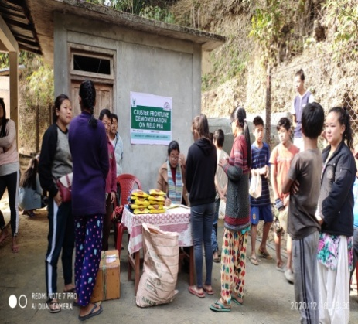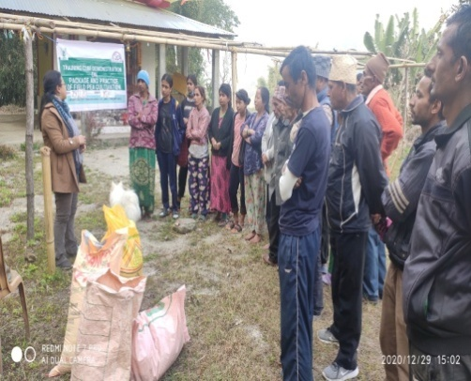

1. **Quality Action Photographs of field visits/field days and technology demonstrated.**

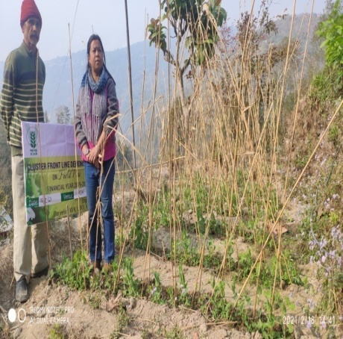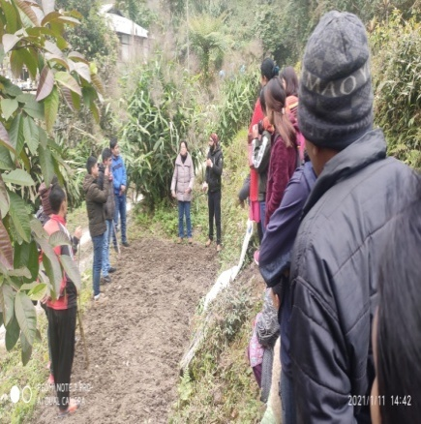

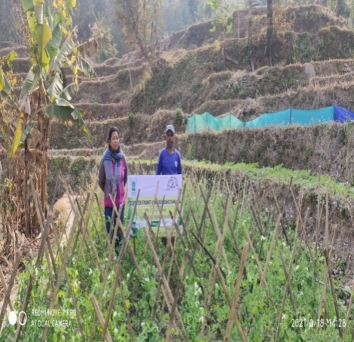

**J. Details of budget utilization**

|  |  |  |  |  |  |
| --- | --- | --- | --- | --- | --- |
| Crop  (provide crop wise information ) | Items | | Budget  Received  (Rs.) | Budget  Utilization  (Rs.) | Balance  (Rs.) |
|  | i) Critical input | | 54,000 | 54,000 | 0 |
|  | | ii) TA/DA/POL etc. for monitoring | 13,500 | 13500 | 0 | |
| iii) Extension Activities (Field day) | 13,500 | 13500 | 0 | |
| iv)Publication of literature | 9,000 | 8678 | 322 | |
|  | Total | | 90,000/- | 89678 | 322 |

**List of Farmers**

|  |  |  |  |  |  |
| --- | --- | --- | --- | --- | --- |
| l. No. | Name of cluster FLD farmer | Category (Gen/OBC/  SC/ST) | Village | Block | Variety |
| 1 | Marsang Rai | Gen | Yogda | Kpg II | Vikash |
| 2 | Sujata Rai | Gen | Yogda | -do- | do |
| 3 | Sabita Rai | Gen | Yogda | -do- | -do- |
| 4 | Evena Lepcha | ST | -do- | -do- | -do- |
| 5 | Rebika Rai | Gen | -do- | -do- | -do- |
| 6 | Bibi Lepcha | ST | -do- | -do- | -do- |
| 7 | Pemlal Lepcha | ST | -do- | -do- | -do- |
| 8 | Buddha maya Rai | Gen | -do- | -do- | -do- |
| 9 | Munna Rai | Gen | -do- | -do- | -do- |
| 10 | Chhimit Lepcha | ST | -do- | -do- | -do- |
| 11 | Ongmit Lepcha | ST | -do- | -do- | -do- |
| 12 | Sailesh Rai | Gen | -do- | -do- | -do- |
| 13 | Suku Tshering Lepcha | ST | -do- | -do- | -do- |
| 14 | Sarathi Chettri | Gen | -do- | -do- | -do- |
| 15 | Sundari Rai | -do- | -do- | -do- | -do- |
| 16 | Ongdup Lepcha | ST | -do- | -do- | -do- |
| 17 | Ganga Devi Rai | Gen | -do- | -do- | -do- |
| 18 | Sunita Rai | -do- | -do- | -do- | -do- |
| 19 | Mutan Rai | -do | -do- | -do- | -do- |
| 20 | Rajani Rai | -do- | -do- | -do- | -do- |

|  |  |  |  |  |  |
| --- | --- | --- | --- | --- | --- |
| l. No. | Name of cluster FLD farmer | Category (Gen/OBC/  SC/ST) | Village | Block | Variety |
| 21 | Meena Rai | -do- | -do- | -do- | -do- |
| 22 | Rupa Rai | -do- | -do- | -do- | -do- |
| 23 | Sarita Rai | -do- | -do- | -do- | -do- |
| 24 | Renuka Rai | -do- | -do- | -do- | -do- |
| 25 | Laxmi Rai | -do- | -do- | -do- | -do- |
| 26 | Anya Prasad Acharya | -do- | Yok Busty | -do- | -do- |
| 27 | Kasananda Acharya | -do- | -do- | -do- | -do- |
| 28 | Bhakti Prasad Acharya | -do- | -do- | -do- | -do- |
| 29 | Bishnu Prasad Acharya | -do- | -do- | -do- | -do- |
| 30 | Nandi Kishore Luitel | -do- | -do- | -do- | -do- |
| 31 | Diliram Kahtel | -do- | -do- | -do- | -do- |
| 32 | Devi Bhakta Acharya | -do- | -do- | -do- | -do- |
| 33 | Tikaram Acharya | -do- | -do- | -do- | -do- |
| 34 | Diliram Dhulal | -do- | -do- | -do- | -do- |
| 35 | Dhan Bdr Subba | ST | -do- | -do- | -do- |
| 36 | Dhan Bdr Subba | ST | -do- | -do- | -do- |
| 37 | Ramlal Acharya | -do- | -do- | -do- | -do- |
| 38 | Kharananda Acharya | -do- | -do- | -do- | -do- |
| 39 | Yug Bahadur Subba | ST | -do- | -do- | -do- |
| 40 | Basant Kumar Subba | ST | -do- | -do- | -do- |
| 41 | Kedarnath Parajuli | -do- | -do- | -do- | -do- |
| 42 | Bhumi Sankar Ghimiray | -do- | -do- | -do- | -do- |
| 43 | Dhanabati Acharya | -do- | -do- | -do- | -do- |
| 44 | Phuna Prasad Luitel | -do- | -do- | -do- | -do- |
| 45 | Phip Raj Subba | ST | -do- | -do- | -do- |
| 46 | Laxnath Dulal | -do- | -do- | -do- | -do- |
| 47 | Biraspati Bajgai | -do- | -do- | -do- | -do- |
| 48 | Goma Devi Sharma | -do- | -do- | -do- | -do- |
| 49 | Bhawani Shankar Ghimiray | -do- | -do- | -do- | -do- |
| 50 | Laxmi Kantha Dulal | -do- | -do- | -do- | -do- |

* 1. **Achievements on Training (Including the sponsored and FLD training programmes):**

1. **Farmers and farm women (on campus)**

| Thematic Area | No. of Courses | No. of Participants | | | | | | | | | | Grand Total | | |
| --- | --- | --- | --- | --- | --- | --- | --- | --- | --- | --- | --- | --- | --- | --- |
| Other | | | SC | | | | ST | | |
|  | M | F | T | M | F | | T | M | F | T | M | F | T |
| **I. Crop Production** |  |  |  |  |  |  | |  |  |  |  |  |  |  |
| Weed Management |  |  |  |  |  |  | |  |  |  |  |  |  |  |
| Resource Conservation Technologies |  |  |  |  |  |  | |  |  |  |  |  |  |  |
| Cropping Systems |  |  |  |  |  |  | |  |  |  |  |  |  |  |
| Crop Diversification |  |  |  |  |  |  | |  |  |  |  |  |  |  |
| Integrated Farming |  |  |  |  |  |  | |  |  |  |  |  |  |  |
| Water management |  |  |  |  |  |  | |  |  |  |  |  |  |  |
| Seed production |  |  |  |  |  |  | |  |  |  |  |  |  |  |
| Nursery management |  |  |  |  |  |  | |  |  |  |  |  |  |  |
| Integrated Crop Management |  |  |  |  |  |  | |  |  |  |  |  |  |  |
| Fodder production |  |  |  |  |  |  | |  |  |  |  |  |  |  |
| Production of organic inputs |  |  |  |  |  |  | |  |  |  |  |  |  |  |
| Others, (cultivation of crops ) |  |  |  |  |  |  | |  |  |  |  |  |  |  |
| **II. Horticulture** |  |  |  |  |  |  | |  |  |  |  |  |  |  |
| **a) Vegetable Crops** |  |  |  |  |  |  | |  |  |  |  |  |  |  |
| Integrated nutrient management |  |  |  |  |  |  | |  |  |  |  |  |  |  |
| Water management |  |  |  |  |  |  | |  |  |  |  |  |  |  |
| Enterprise development |  |  |  |  |  |  | |  |  |  |  |  |  |  |
| Skill development |  |  |  |  |  |  | |  |  |  |  |  |  |  |
| Yield increment |  |  |  |  |  |  | |  |  |  |  |  |  |  |
| Production of low volume and high value crops |  |  |  |  |  |  | |  |  |  |  |  |  |  |
| Off-season vegetables |  |  |  |  |  |  | |  |  |  |  |  |  |  |
| Nursery raising |  |  |  |  |  |  | |  |  |  |  |  |  |  |
| Export potential vegetables |  |  |  |  |  |  | |  |  |  |  |  |  |  |
| Grading and standardization |  |  |  |  |  |  | |  |  |  |  |  |  |  |
| Protective cultivation (Green Houses, Shade Net etc.) |  |  |  |  |  |  | |  |  |  |  |  |  |  |
| Others, if any (Cultivation of Vegetable) |  |  |  |  |  |  | |  |  |  |  |  |  |  |
| Training and Pruning |  |  |  |  |  |  | |  |  |  |  |  |  |  |
| **b) Fruits** |  |  |  |  |  |  | |  |  |  |  |  |  |  |
| Layout and Management of Orchards |  |  |  |  |  |  | |  |  |  |  |  |  |  |
| Cultivation of Fruit |  |  |  |  |  |  | |  |  |  |  |  |  |  |
| Management of young plants/orchards |  |  |  |  |  |  | |  |  |  |  |  |  |  |
| Rejuvenation of old orchards |  |  |  |  |  |  | |  |  |  |  |  |  |  |
| Export potential fruits |  |  |  |  |  |  | |  |  |  |  |  |  |  |
| Micro irrigation systems of orchards |  |  |  |  |  |  | |  |  |  |  |  |  |  |
| Plant propagation techniques |  |  |  |  |  |  | |  |  |  |  |  |  |  |
| Others, if any(INM) |  |  |  |  |  |  | |  |  |  |  |  |  |  |
| **c) Ornamental Plants** |  |  |  |  |  |  | |  |  |  |  |  |  |  |
| Nursery Management |  |  |  |  |  |  | |  |  |  |  |  |  |  |
| Management of potted plants |  |  |  |  |  |  | |  |  |  |  |  |  |  |
| Export potential of ornamental plants |  |  |  |  |  |  | |  |  |  |  |  |  |  |
| Propagation techniques of Ornamental Plants |  |  |  |  |  |  | |  |  |  |  |  |  |  |
| Others, if any |  |  |  |  |  |  | |  |  |  |  |  |  |  |
| **d) Plantation crops** |  |  |  |  |  |  | |  |  |  |  |  |  |  |
| Production and Management technology |  |  |  |  |  |  | |  |  |  |  |  |  |  |
| Processing and value addition |  |  |  |  |  |  | |  |  |  |  |  |  |  |
| Others, if any |  |  |  |  |  |  | |  |  |  |  |  |  |  |
| **e) Tuber crops** |  |  |  |  |  |  | |  |  |  |  |  |  |  |
| Production and Management technology |  |  |  |  |  |  | |  |  |  |  |  |  |  |
| Processing and value addition |  |  |  |  |  |  | |  |  |  |  |  |  |  |
| Others, if any |  |  |  |  |  |  | |  |  |  |  |  |  |  |
| **f) Spices** |  |  |  |  |  |  | |  |  |  |  |  |  |  |
| Production and Management technology | 1 | 10 | 4 | 14 | 0 | 0 | | 0 | 9 | 2 | 11 | 19 | 6 | 25 |
| Processing and value addition |  |  |  |  |  |  | |  |  |  |  |  |  |  |
| Others, if any |  |  |  |  |  |  | |  |  |  |  |  |  |  |
| **g) Medicinal and Aromatic Plants** |  |  |  |  |  |  | |  |  |  |  |  |  |  |
| Nursery management |  |  |  |  |  |  | |  |  |  |  |  |  |  |
| Production and management technology |  |  |  |  |  |  | |  |  |  |  |  |  |  |
| Post harvest technology and value addition |  |  |  |  |  |  | |  |  |  |  |  |  |  |
| Others, if any |  |  |  |  |  |  | |  |  |  |  |  |  |  |
| **III. Soil Health and Fertility Management** |  |  |  |  |  |  | |  |  |  |  |  |  |  |
| Soil fertility management |  |  |  |  |  |  | |  |  |  |  |  |  |  |
| Soil and Water Conservation |  |  |  |  |  |  | |  |  |  |  |  |  |  |
| Integrated Nutrient Management |  |  |  |  |  |  | |  |  |  |  |  |  |  |
| Production and use of organic inputs | 1 | 0 | 8 | 8 | 1 | 1 | | 2 | 8 | 7 | 15 | 9 | 16 | 25 |
| Management of Problematic soils |  |  |  |  |  |  | |  |  |  |  |  |  |  |
| Micro nutrient deficiency in crops |  |  |  |  |  |  | |  |  |  |  |  |  |  |
| Nutrient Use Efficiency |  |  |  |  |  |  | |  |  |  |  |  |  |  |
| Soil and Water Testing |  |  |  |  |  |  | |  |  |  |  |  |  |  |
| Others, if any |  |  |  |  |  |  | |  |  |  |  |  |  |  |
| **IV. Livestock Production and Management** |  |  |  |  |  |  | |  |  |  |  |  |  |  |
| Dairy Management |  |  |  |  |  |  | |  |  |  |  |  |  |  |
| Poultry Management | 1 | 0 | 13 | 13 | 0 | 0 | | 0 | 0 | 13 | 13 | 0 | 26 | 26 |
| Piggery Management | 1 | 23 | 30 | 53 | 8 | 11 | | 19 | 5 | 7 | 12 | 36 | 48 | 84 |
| Rabbit Management |  |  |  |  |  |  | |  |  |  |  |  |  |  |
| Disease Management |  |  |  |  |  |  | |  |  |  |  |  |  |  |
| Feed management |  |  |  |  |  |  | |  |  |  |  |  |  |  |
| Production of quality animal products |  |  |  |  |  |  | |  |  |  |  |  |  |  |
| Others, if any Goat farming |  |  |  |  |  |  | |  |  |  |  |  |  |  |
| **V. Home Science/Women empowerment** |  |  |  |  |  |  | |  |  |  |  |  |  |  |
| Household food security by kitchen gardening and nutrition gardening |  |  |  |  |  |  | |  |  |  |  |  |  |  |
| Design and development of low/minimum cost diet |  |  |  |  |  |  | |  |  |  |  |  |  |  |
| Designing and development for high nutrient efficiency diet |  |  |  |  |  |  | |  |  |  |  |  |  |  |
| Minimization of nutrient loss in processing |  |  |  |  |  |  | |  |  |  |  |  |  |  |
| Gender mainstreaming through SHGs |  |  |  |  |  |  | |  |  |  |  |  |  |  |
| Storage loss minimization techniques |  |  |  |  |  |  | |  |  |  |  |  |  |  |
| Enterprise development |  |  |  |  |  |  | |  |  |  |  |  |  |  |
| Value addition | 1 | 0 | 7 | 7 | 0 | 1 | | 1 | 0 | 2 | 2 | 0 | 10 | 10 |
| Income generation activities for empowerment of rural Women |  |  |  |  |  |  | |  |  |  |  |  |  |  |
| Location specific drudgery reduction technologies |  |  |  |  |  |  | |  |  |  |  |  |  |  |
| Rural Crafts |  |  |  |  |  |  | |  |  |  |  |  |  |  |
| Capacity building |  |  |  |  |  |  | |  |  |  |  |  |  |  |
| Women and child care |  |  |  |  |  |  | |  |  |  |  |  |  |  |
| Others, if any |  |  |  |  |  |  | |  |  |  |  |  |  |  |
| **VI.Agril. Engineering** |  |  |  |  |  |  | |  |  |  |  |  |  |  |
| Installation and maintenance of micro irrigation systems |  |  |  |  |  |  | |  |  |  |  |  |  |  |
| Use of Plastics in farming practices |  |  |  |  |  |  | |  |  |  |  |  |  |  |
| Production of small tools and implements |  |  |  |  |  |  | |  |  |  |  |  |  |  |
| Repair and maintenance of farm machinery and implements |  |  |  |  |  |  | |  |  |  |  |  |  |  |
| Small scale processing and value addition |  |  |  |  |  |  | |  |  |  |  |  |  |  |
| Post Harvest Technology |  |  |  |  |  |  | |  |  |  |  |  |  |  |
| Others, if any |  |  |  |  |  |  | |  |  |  |  |  |  |  |
| **VII. Plant Protection** |  |  |  |  |  |  | |  |  |  |  |  |  |  |
| Integrated Pest Management | 1 | 20 | 2 | 22 | 10 | 1 | | 11 | 0 | 0 | 0 | 30 | 3 | 33 |
| Integrated Disease Management | 1 | 0 | 13 | 13 | 0 | 0 | | 0 | 0 | 13 | 13 | 0 | 26 | 26 |
| Bio-control of pests and diseases |  |  |  |  |  |  | |  |  |  |  |  |  |  |
| Production of bio control agents and bio pesticides |  |  |  |  |  | |  |  |  |  |  |  |  |  |
| Others, if any |  |  |  |  |  | |  |  |  |  |  |  |  |  |
| **VIII. Fisheries** |  |  |  |  |  | |  |  |  |  |  |  |  |  |
| Integrated fish farming |  |  |  |  |  | |  |  |  |  |  |  |  |  |
| Carp breeding and hatchery management |  |  |  |  |  | |  |  |  |  |  |  |  |  |
| Carp fry and fingerling rearing |  |  |  |  |  | |  |  |  |  |  |  |  |  |
| Composite fish culture & fish disease |  |  |  |  |  | |  |  |  |  |  |  |  |  |
| Fish feed preparation & its application to fish pond, like nursery, rearing & stocking pond |  |  |  |  |  | |  |  |  |  |  |  |  |  |
| Hatchery management and culture of freshwater prawn |  |  |  |  |  | |  |  |  |  |  |  |  |  |
| Breeding and culture of ornamental fishes |  |  |  |  |  | |  |  |  |  |  |  |  |  |
| Portable plastic carp hatchery |  |  |  |  |  | |  |  |  |  |  |  |  |  |
| Pen culture of fish and prawn |  |  |  |  |  | |  |  |  |  |  |  |  |  |
| Shrimp farming |  |  |  |  |  | |  |  |  |  |  |  |  |  |
| Edible oyster farming |  |  |  |  |  | |  |  |  |  |  |  |  |  |
| Pearl culture |  |  |  |  |  | |  |  |  |  |  |  |  |  |
| Fish processing and value addition |  |  |  |  |  | |  |  |  |  |  |  |  |  |
| Others, if any |  |  |  |  |  | |  |  |  |  |  |  |  |  |
| **IX. Production of Inputs at site** |  |  |  |  |  | |  |  |  |  |  |  |  |  |
| Seed Production |  |  |  |  |  | |  |  |  |  |  |  |  |  |
| Planting material production |  |  |  |  |  | |  |  |  |  |  |  |  |  |
| Bio-agents production |  |  |  |  |  | |  |  |  |  |  |  |  |  |
| Bio-pesticides production |  |  |  |  |  | |  |  |  |  |  |  |  |  |
| Bio-fertilizer production |  |  |  |  |  | |  |  |  |  |  |  |  |  |
| Vermi-compost production |  |  |  |  |  | |  |  |  |  |  |  |  |  |
| Organic manures production |  |  |  |  |  | |  |  |  |  |  |  |  |  |
| Production of fry and fingerlings |  |  |  |  |  | |  |  |  |  |  |  |  |  |
| Production of Bee-colonies and wax sheets |  |  |  |  |  | |  |  |  |  |  |  |  |  |
| Small tools and implements |  |  |  |  |  | |  |  |  |  |  |  |  |  |
| Production of livestock feed and fodder |  |  |  |  |  | |  |  |  |  |  |  |  |  |
| Production of Fish feed |  |  |  |  |  | |  |  |  |  |  |  |  |  |
| Others, if any |  |  |  |  |  | |  |  |  |  |  |  |  |  |
| **X. Capacity Building and Group Dynamics** |  |  |  |  |  | |  |  |  |  |  |  |  |  |
| Leadership development |  |  |  |  |  | |  |  |  |  |  |  |  |  |
| Group dynamics |  |  |  |  |  | |  |  |  |  |  |  |  |  |
| Formation and Management of SHGs |  |  |  |  |  | |  |  |  |  |  |  |  |  |
| Mobilization of social capital |  |  |  |  |  | |  |  |  |  |  |  |  |  |
| Entrepreneurial development of farmers/youths |  |  |  |  |  | |  |  |  |  |  |  |  |  |
| WTO and IPR issues |  |  |  |  |  | |  |  |  |  |  |  |  |  |
| Others, if any |  |  |  |  |  | |  |  |  |  |  |  |  |  |
| XI Agro-forestry |  |  |  |  |  | |  |  |  |  |  |  |  |  |
| Production technologies |  |  |  |  |  | |  |  |  |  |  |  |  |  |
| Nursery management |  |  |  |  |  | |  |  |  |  |  |  |  |  |
| Integrated Farming Systems |  |  |  |  |  | |  |  |  |  |  |  |  |  |
| **XII. Others (Pl. Specify)** |  |  |  |  |  | |  |  |  |  |  |  |  |  |
| **TOTAL** | **7** | **53** | **77** | **130** | **19** | | **14** | **33** | **22** | **44** | **66** | **94** | **135** | **229** |

**B) Rural Youth (on campus)**

| Thematic Area | No. of Courses | No. of Participants | | | | | | | | | | Grand Total | | |
| --- | --- | --- | --- | --- | --- | --- | --- | --- | --- | --- | --- | --- | --- | --- |
| Other | | | SC | | | | ST | | |
|  | M | F | T | M | F | | T | M | F | T | M | F | T |
| Mushroom Production | 1 | 0 | 2 | 2 | 4 | | 7 | 11 | 2 | 6 | 8 | 6 | 15 | 21 |
| Bee-keeping | 1 | 7 | 1 | 8 | 0 | | 0 | 0 | 5 | 2 | 7 | 12 | 3 | 15 |
| Integrated farming |  |  |  |  |  | |  |  |  |  |  |  |  |  |
| Seed production |  |  |  |  |  | |  |  |  |  |  |  |  |  |
| Production of organic inputs |  |  |  |  |  | |  |  |  |  |  |  |  |  |
| Integrated Farming |  |  |  |  |  | |  |  |  |  |  |  |  |  |
| Planting material production |  |  |  |  |  | |  |  |  |  |  |  |  |  |
| Vermi-culture | 1 | 4 | 9 | 13 | 1 | | 0 | 1 | 11 | 4 | 15 | 21 | 5 | 26 |
| Sericulture |  |  |  |  |  | |  |  |  |  |  |  |  |  |
| Protected cultivation of vegetable crops |  |  |  |  |  | |  |  |  |  |  |  |  |  |
| Commercial fruit production |  |  |  |  |  | |  |  |  |  |  |  |  |  |
| Repair and maintenance of farm machinery and implements |  |  |  |  |  | |  |  |  |  |  |  |  |  |
| Nursery Management of Horticulture crops |  |  |  |  |  | |  |  |  |  |  |  |  |  |
| Training and pruning of orchards |  |  |  |  |  | |  |  |  |  |  |  |  |  |
| Value addition |  |  |  |  |  | |  |  |  |  |  |  |  |  |
| Production of quality animal products |  |  |  |  |  | |  |  |  |  |  |  |  |  |
| Dairying |  |  |  |  |  | |  |  |  |  |  |  |  |  |
| Sheep and goat rearing |  |  |  |  |  | |  |  |  |  |  |  |  |  |
| Quail farming |  |  |  |  |  | |  |  |  |  |  |  |  |  |
| Piggery |  |  |  |  |  | |  |  |  |  |  |  |  |  |
| Rabbit farming |  |  |  |  |  | |  |  |  |  |  |  |  |  |
| Poultry production |  |  |  |  |  | |  |  |  |  |  |  |  |  |
| Ornamental fisheries |  |  |  |  |  | |  |  |  |  |  |  |  |  |
| Enterprise development |  |  |  |  |  | |  |  |  |  |  |  |  |  |
| Para vets |  |  |  |  |  | |  |  |  |  |  |  |  |  |
| Para extension workers |  |  |  |  |  | |  |  |  |  |  |  |  |  |
| Composite fish culture |  |  |  |  |  | |  |  |  |  |  |  |  |  |
| Freshwater prawn culture |  |  |  |  |  | |  |  |  |  |  |  |  |  |
| Shrimp farming |  |  |  |  |  | |  |  |  |  |  |  |  |  |
| Pearl culture |  |  |  |  |  | |  |  |  |  |  |  |  |  |
| Cold water fisheries |  |  |  |  |  | |  |  |  |  |  |  |  |  |
| Fish harvest and processing technology |  |  |  |  |  | |  |  |  |  |  |  |  |  |
| Fry and fingerling rearing |  |  |  |  |  | |  |  |  |  |  |  |  |  |
| Small scale processing |  |  |  |  |  | |  |  |  |  |  |  |  |  |
| Post Harvest Technology |  |  |  |  |  | |  |  |  |  |  |  |  |  |
| Tailoring and Stitching |  |  |  |  |  | |  |  |  |  |  |  |  |  |
| Rural Crafts |  |  |  |  |  | |  |  |  |  |  |  |  |  |
| TOTAL | **3** | **11** | **12** | **23** | **5** | | **7** | **12** | **18** | **12** | **30** | **39** | **23** | **62** |

**C) Extension Personnel (on campus)**

| Thematic Area | No. of Courses | No. of Participants | | | | | | | | | | Grand Total | | |
| --- | --- | --- | --- | --- | --- | --- | --- | --- | --- | --- | --- | --- | --- | --- |
| Other | | | SC | | | | ST | | |
|  | M | F | T | M | F | | T | M | F | T | M | F | T |
| Productivity enhancement in field crops |  |  |  |  |  | |  |  |  |  |  |  |  |  |
| Value addition |  |  |  |  |  | |  |  |  |  |  |  |  |  |
| Integrated Pest Management |  |  |  |  |  | |  |  |  |  |  |  |  |  |
| Integrated Nutrient management |  |  |  |  |  | |  |  |  |  |  |  |  |  |
| Rejuvenation of old orchards |  |  |  |  |  | |  |  |  |  |  |  |  |  |
| Protected cultivation technology |  |  |  |  |  | |  |  |  |  |  |  |  |  |
| Formation and Management of SHGs |  |  |  |  |  | |  |  |  |  |  |  |  |  |
| Group Dynamics and farmers organization |  |  |  |  |  | |  |  |  |  |  |  |  |  |
| Information networking among farmers |  |  |  |  |  | |  |  |  |  |  |  |  |  |
| Capacity building for ICT application |  |  |  |  |  | |  |  |  |  |  |  |  |  |
| Care and maintenance of farm machinery and implements |  |  |  |  |  | |  |  |  |  |  |  |  |  |
| WTO and IPR issues |  |  |  |  |  | |  |  |  |  |  |  |  |  |
| Management in farm animals |  |  |  |  |  | |  |  |  |  |  |  |  |  |
| Livestock feed and fodder production |  |  |  |  |  | |  |  |  |  |  |  |  |  |
| Household food security |  |  |  |  |  | |  |  |  |  |  |  |  |  |
| Women and Child care |  |  |  |  |  | |  |  |  |  |  |  |  |  |
| Low cost and nutrient efficient diet designing |  |  |  |  |  | |  |  |  |  |  |  |  |  |
| Production and use of organic inputs |  |  |  |  |  | |  |  |  |  |  |  |  |  |
| Gender mainstreaming through SHGs |  |  |  |  |  | |  |  |  |  |  |  |  |  |
| TOTAL |  |  |  |  |  | |  |  |  |  |  |  |  |  |

**D) Farmers and farm women (off campus)**

| Thematic Area | No. of Courses | No. of Participants | | | | | | | | | | Grand Total | | |
| --- | --- | --- | --- | --- | --- | --- | --- | --- | --- | --- | --- | --- | --- | --- |
| Other | | | SC | | | | ST | | |
|  | M | F | T | M | F | | T | M | F | T | M | F | T |
| **I. Crop Production** |  |  |  |  |  |  | |  |  |  |  |  |  |  |
| Weed Management |  |  |  |  |  |  | |  |  |  |  |  |  |  |
| Resource Conservation Technologies |  |  |  |  |  |  | |  |  |  |  |  |  |  |
| Cropping Systems |  |  |  |  |  |  | |  |  |  |  |  |  |  |
| Crop Diversification |  |  |  |  |  |  | |  |  |  |  |  |  |  |
| Integrated Farming |  |  |  |  |  |  | |  |  |  |  |  |  |  |
| Water management |  |  |  |  |  |  | |  |  |  |  |  |  |  |
| Seed production |  |  |  |  |  |  | |  |  |  |  |  |  |  |
| Nursery management |  |  |  |  |  |  | |  |  |  |  |  |  |  |
| Integrated Crop Management |  |  |  |  |  |  | |  |  |  |  |  |  |  |
| Fodder production |  |  |  |  |  |  | |  |  |  |  |  |  |  |
| Production of organic inputs |  |  |  |  |  |  | |  |  |  |  |  |  |  |
| Others, (cultivation of crops ) |  |  |  |  |  |  | |  |  |  |  |  |  |  |
| **II. Horticulture** |  |  |  |  |  |  | |  |  |  |  |  |  |  |
| **a) Vegetable Crops** |  |  |  |  |  |  | |  |  |  |  |  |  |  |
| Integrated nutrient management | 1 | 2 | 19 | 21 | 0 | 0 | | 0 | 4 | 4 | 8 | 6 | 23 | 29 |
| Water management | 1 | 2 | 1 | 3 | 3 | 19 | | 22 | 0 | 1 | 1 | 5 | 21 | 26 |
| Enterprise development |  |  |  |  |  |  | |  |  |  |  |  |  |  |
| Skill development |  |  |  |  |  |  | |  |  |  |  |  |  |  |
| Yield increment |  |  |  |  |  |  | |  |  |  |  |  |  |  |
| Production of low volume and high value crops |  |  |  |  |  |  | |  |  |  |  |  |  |  |
| Off-season vegetables | 1 | 0 | 0 | 0 | 0 | 20 | | 20 | 0 | 0 | 0 | 0 | 20 | 20 |
| Nursery raising |  |  |  |  |  |  | |  |  |  |  |  |  |  |
| Export potential vegetables |  |  |  |  |  |  | |  |  |  |  |  |  |  |
| Grading and standardization |  |  |  |  |  |  | |  |  |  |  |  |  |  |
| Protective cultivation (Green Houses, Shade Net etc.) |  |  |  |  |  |  | |  |  |  |  |  |  |  |
| Others, if any (Cultivation of Vegetable) |  |  |  |  |  |  | |  |  |  |  |  |  |  |
| Training and Pruning |  |  |  |  |  |  | |  |  |  |  |  |  |  |
| **b) Fruits** |  |  |  |  |  |  | |  |  |  |  |  |  |  |
| Layout and Management of Orchards | 1 | 10 | 5 | 15 | 0 | 1 | | 1 | 5 | 6 | 11 | 15 | 12 | 27 |
| Cultivation of Fruit | 1 | 4 | 4 | 8 | 4 | 9 | | 13 | 0 | 0 | 0 | 8 | 13 | 21 |
| Management of young plants/orchards | 1 | 4 | 5 | 9 | 3 | 14 | | 17 | 0 | 0 | 0 | 7 | 19 | 26 |
| Rejuvenation of old orchards |  |  |  |  |  |  | |  |  |  |  |  |  |  |
| Export potential fruits |  |  |  |  |  |  | |  |  |  |  |  |  |  |
| Micro irrigation systems of orchards |  |  |  |  |  |  | |  |  |  |  |  |  |  |
| Plant propagation techniques |  |  |  |  |  |  | |  |  |  |  |  |  |  |
| Others, if any(INM) |  |  |  |  |  |  | |  |  |  |  |  |  |  |
| **c) Ornamental Plants** |  |  |  |  |  |  | |  |  |  |  |  |  |  |
| Nursery Management |  |  |  |  |  |  | |  |  |  |  |  |  |  |
| Management of potted plants |  |  |  |  |  |  | |  |  |  |  |  |  |  |
| Export potential of ornamental plants |  |  |  |  |  |  | |  |  |  |  |  |  |  |
| Propagation techniques of Ornamental Plants |  |  |  |  |  |  | |  |  |  |  |  |  |  |
| Others, if any |  |  |  |  |  |  | |  |  |  |  |  |  |  |
| **d) Plantation crops** |  |  |  |  |  |  | |  |  |  |  |  |  |  |
| Production and Management technology |  |  |  |  |  |  | |  |  |  |  |  |  |  |
| Processing and value addition |  |  |  |  |  |  | |  |  |  |  |  |  |  |
| Others, if any |  |  |  |  |  |  | |  |  |  |  |  |  |  |
| **e) Tuber crops** |  |  |  |  |  |  | |  |  |  |  |  |  |  |
| Production and Management technology |  |  |  |  |  |  | |  |  |  |  |  |  |  |
| Processing and value addition |  |  |  |  |  |  | |  |  |  |  |  |  |  |
| Others, if any |  |  |  |  |  |  | |  |  |  |  |  |  |  |
| **f) Spices** |  |  |  |  |  |  | |  |  |  |  |  |  |  |
| Production and Management technology | 4 | 1 | 7 | 12 | 25 | 47 | | 37 | 2 | 8 | 16 | 28 | 61 | 49 |
| Processing and value addition |  |  |  |  |  |  | |  |  |  |  |  |  |  |
| Others, if any |  |  |  |  |  |  | |  |  |  |  |  |  |  |
| **g) Medicinal and Aromatic Plants** |  |  |  |  |  |  | |  |  |  |  |  |  |  |
| Nursery management |  |  |  |  |  |  | |  |  |  |  |  |  |  |
| Production and management technology |  |  |  |  |  |  | |  |  |  |  |  |  |  |
| Post harvest technology and value addition |  |  |  |  |  |  | |  |  |  |  |  |  |  |
| Others, if any |  |  |  |  |  |  | |  |  |  |  |  |  |  |
| **III. Soil Health and Fertility Management** |  |  |  |  |  |  | |  |  |  |  |  |  |  |
| Soil fertility management | 1 | 7 | 8 | 15 | 1 | 1 | | 2 | 2 | 7 | 9 | 10 | 16 | 26 |
| Soil and Water Conservation |  |  |  |  |  |  | |  |  |  |  |  |  |  |
| Integrated Nutrient Management |  |  |  |  |  |  | |  |  |  |  |  |  |  |
| Production and use of organic inputs | 1 | 2 | 2 | 4 | 12 | 16 | | 28 | 0 | 0 | 0 | 14 | 18 | 32 |
| Management of Problematic soils |  |  |  |  |  |  | |  |  |  |  |  |  |  |
| Micro nutrient deficiency in crops |  |  |  |  |  |  | |  |  |  |  |  |  |  |
| Nutrient Use Efficiency |  |  |  |  |  |  | |  |  |  |  |  |  |  |
| Soil and Water Testing | 1 | 11 | 10 | 21 | 0 | 0 | | 0 | 3 | 2 | 5 | 14 | 12 | 26 |
| Others, if any |  |  |  |  |  |  | |  |  |  |  |  |  |  |
| **IV. Livestock Production and Management** |  |  |  |  |  |  | |  |  |  |  |  |  |  |
| Dairy Management |  |  |  |  |  |  | |  |  |  |  |  |  |  |
| Poultry Management | 4 | 11 | 16 | 26 | 17 | 40 | | 15 | 4 | 3 | 20 | 32 | 59 | 33 |
| Piggery Management |  |  |  |  |  |  | |  |  |  |  |  |  |  |
| Rabbit Management |  |  |  |  |  |  | |  |  |  |  |  |  |  |
| Disease Management |  |  |  |  |  |  | |  |  |  |  |  |  |  |
| Feed management |  |  |  |  |  |  | |  |  |  |  |  |  |  |
| Production of quality animal products |  |  |  |  |  |  | |  |  |  |  |  |  |  |
| Others, if any Goat farming |  |  |  |  |  |  | |  |  |  |  |  |  |  |
| **V. Home Science/Women empowerment** |  |  |  |  |  |  | |  |  |  |  |  |  |  |
| Household food security by kitchen gardening and nutrition gardening |  |  |  |  |  |  | |  |  |  |  |  |  |  |
| Design and development of low/minimum cost diet | 1 | 7 | 7 | 14 | 2 | 11 | | 13 | 2 | 2 | 4 | 11 | 20 | 31 |
| Designing and development for high nutrient efficiency diet | 1 | 0 | 6 | 6 | 0 | 9 | | 9 | 0 | 4 | 4 | 0 | 19 | 19 |
| Minimization of nutrient loss in processing |  |  |  |  |  |  | |  |  |  |  |  |  |  |
| Gender mainstreaming through SHGs |  |  |  |  |  |  | |  |  |  |  |  |  |  |
| Storage loss minimization techniques |  |  |  |  |  |  | |  |  |  |  |  |  |  |
| Enterprise development |  |  |  |  |  |  | |  |  |  |  |  |  |  |
| Value addition | 1 | 3 | 5 | 8 | 0 | 0 | | 0 | 0 | 1 | 1 | 3 | 6 | 9 |
| Income generation activities for empowerment of rural Women |  |  |  |  |  |  | |  |  |  |  |  |  |  |
| Location specific drudgery reduction technologies |  |  |  |  |  |  | |  |  |  |  |  |  |  |
| Rural Crafts |  |  |  |  |  |  | |  |  |  |  |  |  |  |
| Capacity building |  |  |  |  |  |  | |  |  |  |  |  |  |  |
| Women and child care |  |  |  |  |  |  | |  |  |  |  |  |  |  |
| Others, if any |  |  |  |  |  |  | |  |  |  |  |  |  |  |
| **VI.Agril. Engineering** |  |  |  |  |  |  | |  |  |  |  |  |  |  |
| Installation and maintenance of micro irrigation systems |  |  |  |  |  |  | |  |  |  |  |  |  |  |
| Use of Plastics in farming practices |  |  |  |  |  |  | |  |  |  |  |  |  |  |
| Production of small tools and implements |  |  |  |  |  |  | |  |  |  |  |  |  |  |
| Repair and maintenance of farm machinery and implements |  |  |  |  |  |  | |  |  |  |  |  |  |  |
| Small scale processing and value addition |  |  |  |  |  |  | |  |  |  |  |  |  |  |
| Post Harvest Technology |  |  |  |  |  |  | |  |  |  |  |  |  |  |
| Others, if any |  |  |  |  |  |  | |  |  |  |  |  |  |  |
| **VII. Plant Protection** |  |  |  |  |  |  | |  |  |  |  |  |  |  |
| Integrated Pest Management | 1 | 12 | 3 | 15 | 1 | 0 | | 1 | 18 | 2 | 20 | 31 | 5 | 36 |
| Integrated Disease Management |  |  |  |  |  |  | |  |  |  |  |  |  |  |
| Bio-control of pests and diseases |  |  |  |  |  |  | |  |  |  |  |  |  |  |
| Production of bio control agents and bio pesticides | 1 | 1 | 12 | 13 | 0 | | 1 | 1 | 0 | 27 | 27 | 1 | 40 | 41 |
| Others, if any |  |  |  |  |  | |  |  |  |  |  |  |  |  |
| **VIII. Fisheries** |  |  |  |  |  | |  |  |  |  |  |  |  |  |
| Integrated fish farming |  |  |  |  |  | |  |  |  |  |  |  |  |  |
| Carp breeding and hatchery management |  |  |  |  |  | |  |  |  |  |  |  |  |  |
| Carp fry and fingerling rearing |  |  |  |  |  | |  |  |  |  |  |  |  |  |
| Composite fish culture & fish disease |  |  |  |  |  | |  |  |  |  |  |  |  |  |
| Fish feed preparation & its application to fish pond, like nursery, rearing & stocking pond |  |  |  |  |  | |  |  |  |  |  |  |  |  |
| Hatchery management and culture of freshwater prawn |  |  |  |  |  | |  |  |  |  |  |  |  |  |
| Breeding and culture of ornamental fishes |  |  |  |  |  | |  |  |  |  |  |  |  |  |
| Portable plastic carp hatchery |  |  |  |  |  | |  |  |  |  |  |  |  |  |
| Pen culture of fish and prawn |  |  |  |  |  | |  |  |  |  |  |  |  |  |
| Shrimp farming |  |  |  |  |  | |  |  |  |  |  |  |  |  |
| Edible oyster farming |  |  |  |  |  | |  |  |  |  |  |  |  |  |
| Pearl culture |  |  |  |  |  | |  |  |  |  |  |  |  |  |
| Fish processing and value addition |  |  |  |  |  | |  |  |  |  |  |  |  |  |
| Others, if any |  |  |  |  |  | |  |  |  |  |  |  |  |  |
| **IX. Production of Inputs at site** |  |  |  |  |  | |  |  |  |  |  |  |  |  |
| Seed Production |  |  |  |  |  | |  |  |  |  |  |  |  |  |
| Planting material production |  |  |  |  |  | |  |  |  |  |  |  |  |  |
| Bio-agents production |  |  |  |  |  | |  |  |  |  |  |  |  |  |
| Bio-pesticides production |  |  |  |  |  | |  |  |  |  |  |  |  |  |
| Bio-fertilizer production |  |  |  |  |  | |  |  |  |  |  |  |  |  |
| Vermi-compost production |  |  |  |  |  | |  |  |  |  |  |  |  |  |
| Organic manures production |  |  |  |  |  | |  |  |  |  |  |  |  |  |
| Production of fry and fingerlings |  |  |  |  |  | |  |  |  |  |  |  |  |  |
| Production of Bee-colonies and wax sheets |  |  |  |  |  | |  |  |  |  |  |  |  |  |
| Small tools and implements |  |  |  |  |  | |  |  |  |  |  |  |  |  |
| Production of livestock feed and fodder |  |  |  |  |  | |  |  |  |  |  |  |  |  |
| Production of Fish feed |  |  |  |  |  | |  |  |  |  |  |  |  |  |
| Others, if any |  |  |  |  |  | |  |  |  |  |  |  |  |  |
| **X. Capacity Building and Group Dynamics** |  |  |  |  |  | |  |  |  |  |  |  |  |  |
| Leadership development |  |  |  |  |  | |  |  |  |  |  |  |  |  |
| Group dynamics |  |  |  |  |  | |  |  |  |  |  |  |  |  |
| Formation and Management of SHGs |  |  |  |  |  | |  |  |  |  |  |  |  |  |
| Mobilization of social capital |  |  |  |  |  | |  |  |  |  |  |  |  |  |
| Entrepreneurial development of farmers/youths |  |  |  |  |  | |  |  |  |  |  |  |  |  |
| WTO and IPR issues |  |  |  |  |  | |  |  |  |  |  |  |  |  |
| Others, if any |  |  |  |  |  | |  |  |  |  |  |  |  |  |
| XI Agro-forestry |  |  |  |  |  | |  |  |  |  |  |  |  |  |
| Production technologies |  |  |  |  |  | |  |  |  |  |  |  |  |  |
| Nursery management |  |  |  |  |  | |  |  |  |  |  |  |  |  |
| Integrated Farming Systems |  |  |  |  |  | |  |  |  |  |  |  |  |  |
| **XII. Others (Pl. Specify)** |  |  |  |  |  | |  |  |  |  |  |  |  |  |
| **TOTAL** | **22** | **77** | **110** | **190** | **68** | | **188** | **179** | **40** | **67** | **126** | **185** | **364** | **451** |

**E) RURAL YOUTH (Off Campus)**

| Thematic Area | No. of Courses | No. of Participants | | | | | | | | | Grand Total | | |
| --- | --- | --- | --- | --- | --- | --- | --- | --- | --- | --- | --- | --- | --- |
| Other | | | SC | | | ST | | |
|  | M | F | T | M | F | T | M | F | T | M | F | T |
| Mushroom Production | 1 | 10 | 6 | 16 | 0 | 0 | 0 | 3 | 1 | 4 | 13 | 7 | 20 |
| Bee-keeping | 1 | 8 | 0 | 8 | 5 | 0 | 5 | 12 | 0 | 12 | 25 | 0 | 25 |
| Integrated farming |  |  |  |  |  |  |  |  |  |  |  |  |  |
| Seed production |  |  |  |  |  |  |  |  |  |  |  |  |  |
| Production of organic inputs |  |  |  |  |  |  |  |  |  |  |  |  |  |
| Integrated Farming |  |  |  |  |  |  |  |  |  |  |  |  |  |
| Planting material production |  |  |  |  |  |  |  |  |  |  |  |  |  |
| Vermi-culture |  |  |  |  |  |  |  |  |  |  |  |  |  |
| Sericulture |  |  |  |  |  |  |  |  |  |  |  |  |  |
| Protected cultivation of vegetable crops |  |  |  |  |  |  |  |  |  |  |  |  |  |
| Commercial fruit production |  |  |  |  |  |  |  |  |  |  |  |  |  |
| Repair and maintenance of farm machinery and implements |  |  |  |  |  |  |  |  |  |  |  |  |  |
| Nursery Management of Horticulture crops |  |  |  |  |  |  |  |  |  |  |  |  |  |
| Training and pruning of orchards |  |  |  |  |  |  |  |  |  |  |  |  |  |
| Value addition | 1 | 0 | 0 | 0 | 6 | 15 | 21 | 0 | 0 | 0 | 6 | 15 | 21 |
| Production of quality animal products |  |  |  |  |  |  |  |  |  |  |  |  |  |
| Dairying |  |  |  |  |  |  |  |  |  |  |  |  |  |
| Sheep and goat rearing |  |  |  |  |  |  |  |  |  |  |  |  |  |
| Quail farming |  |  |  |  |  |  |  |  |  |  |  |  |  |
| Piggery |  |  |  |  |  |  |  |  |  |  |  |  |  |
| Rabbit farming |  |  |  |  |  |  |  |  |  |  |  |  |  |
| Poultry production |  |  |  |  |  |  |  |  |  |  |  |  |  |
| Ornamental fisheries |  |  |  |  |  |  |  |  |  |  |  |  |  |
| Para vets |  |  |  |  |  |  |  |  |  |  |  |  |  |
| Para extension workers |  |  |  |  |  |  |  |  |  |  |  |  |  |
| Composite fish culture |  |  |  |  |  |  |  |  |  |  |  |  |  |
| Freshwater prawn culture |  |  |  |  |  |  |  |  |  |  |  |  |  |
| Shrimp farming |  |  |  |  |  |  |  |  |  |  |  |  |  |
| Pearl culture |  |  |  |  |  |  |  |  |  |  |  |  |  |
| Cold water fisheries |  |  |  |  |  |  |  |  |  |  |  |  |  |
| Fish harvest and processing technology |  |  |  |  |  |  |  |  |  |  |  |  |  |
| Fry and fingerling rearing |  |  |  |  |  |  |  |  |  |  |  |  |  |
| Small scale processing |  |  |  |  |  |  |  |  |  |  |  |  |  |
| Post Harvest Technology |  |  |  |  |  |  |  |  |  |  |  |  |  |
| Tailoring and Stitching |  |  |  |  |  |  |  |  |  |  |  |  |  |
| Rural Crafts |  |  |  |  |  |  |  |  |  |  |  |  |  |
| Others, if any |  |  |  |  |  |  |  |  |  |  |  |  |  |
| TOTAL | **3** | **18** | **6** | **24** | **11** | **15** | **26** | **15** | **1** | **16** | **44** | **22** | **66** |

**F) Extension Personnel (Off Campus)**

| Thematic Area | No. of Courses | No. of Participants | | | | | | | | | Grand Total | | |
| --- | --- | --- | --- | --- | --- | --- | --- | --- | --- | --- | --- | --- | --- |
| Other | | | SC | | | ST | | |
|  | M | F | T | M | F | T | M | F | T | M | F | T |
| Productivity enhancement in field crops |  |  |  |  |  |  |  |  |  |  |  |  |  |
| Integrated Pest Management |  |  |  |  |  |  |  |  |  |  |  |  |  |
| Integrated Nutrient management |  |  |  |  |  |  |  |  |  |  |  |  |  |
| Rejuvenation of old orchards |  |  |  |  |  |  |  |  |  |  |  |  |  |
| Protected cultivation technology |  |  |  |  |  |  |  |  |  |  |  |  |  |
| Formation and Management of SHGs |  |  |  |  |  |  |  |  |  |  |  |  |  |
| Group Dynamics and farmers organization |  |  |  |  |  |  |  |  |  |  |  |  |  |
| Information networking among farmers |  |  |  |  |  |  |  |  |  |  |  |  |  |
| Capacity building for ICT application |  |  |  |  |  |  |  |  |  |  |  |  |  |
| Care and maintenance of farm machinery and implements |  |  |  |  |  |  |  |  |  |  |  |  |  |
| WTO and IPR issues |  |  |  |  |  |  |  |  |  |  |  |  |  |
| Management in farm animals |  |  |  |  |  |  |  |  |  |  |  |  |  |
| Livestock feed and fodder production |  |  |  |  |  |  |  |  |  |  |  |  |  |
| Household food security |  |  |  |  |  |  |  |  |  |  |  |  |  |
| Women and Child care |  |  |  |  |  |  |  |  |  |  |  |  |  |
| Low cost and nutrient efficient diet designing |  |  |  |  |  |  |  |  |  |  |  |  |  |
| Production and use of organic inputs |  |  |  |  |  |  |  |  |  |  |  |  |  |
| Gender mainstreaming through SHGs |  |  |  |  |  |  |  |  |  |  |  |  |  |
| Crop intensification |  |  |  |  |  |  |  |  |  |  |  |  |  |
| **TOTAL** |  |  |  |  |  |  |  |  |  |  |  |  |  |

**G) Consolidated table (ON and OFF Campus)**

**i. Farmers & Farm Women**

| Thematic Area | No. of Courses | No. of Participants | | | | | | | | | | Grand Total | | |
| --- | --- | --- | --- | --- | --- | --- | --- | --- | --- | --- | --- | --- | --- | --- |
| Other | | | SC | | | | ST | | |
|  | M | F | T | M | F | | T | M | F | T | M | F | T |
| **I. Crop Production** |  |  |  |  |  |  | |  |  |  |  |  |  |  |
| Weed Management |  |  |  |  |  |  | |  |  |  |  |  |  |  |
| Resource Conservation Technologies |  |  |  |  |  |  | |  |  |  |  |  |  |  |
| Cropping Systems |  |  |  |  |  |  | |  |  |  |  |  |  |  |
| Crop Diversification |  |  |  |  |  |  | |  |  |  |  |  |  |  |
| Integrated Farming |  |  |  |  |  |  | |  |  |  |  |  |  |  |
| Water management |  |  |  |  |  |  | |  |  |  |  |  |  |  |
| Seed production |  |  |  |  |  |  | |  |  |  |  |  |  |  |
| Nursery management |  |  |  |  |  |  | |  |  |  |  |  |  |  |
| Integrated Crop Management |  |  |  |  |  |  | |  |  |  |  |  |  |  |
| Fodder production |  |  |  |  |  |  | |  |  |  |  |  |  |  |
| Production of organic inputs |  |  |  |  |  |  | |  |  |  |  |  |  |  |
| Others, (cultivation of crops ) |  |  |  |  |  |  | |  |  |  |  |  |  |  |
| **II. Horticulture** |  |  |  |  |  |  | |  |  |  |  |  |  |  |
| **a) Vegetable Crops** |  |  |  |  |  |  | |  |  |  |  |  |  |  |
| Integrated nutrient management | 1 | 2 | 19 | 21 | 0 | 0 | | 0 | 4 | 4 | 8 | 6 | 23 | 29 |
| Water management | 1 | 2 | 1 | 3 | 3 | 19 | | 22 | 0 | 1 | 1 | 5 | 21 | 26 |
| Enterprise development |  |  |  |  |  |  | |  |  |  |  |  |  |  |
| Skill development |  |  |  |  |  |  | |  |  |  |  |  |  |  |
| Yield increment |  |  |  |  |  |  | |  |  |  |  |  |  |  |
| Production of low volume and high value crops |  |  |  |  |  |  | |  |  |  |  |  |  |  |
| Off-season vegetables | 1 | 0 | 0 | 0 | 0 | 20 | | 20 | 0 | 0 | 0 | 0 | 20 | 20 |
| Nursery raising |  |  |  |  |  |  | |  |  |  |  |  |  |  |
| Export potential vegetables |  |  |  |  |  |  | |  |  |  |  |  |  |  |
| Grading and standardization |  |  |  |  |  |  | |  |  |  |  |  |  |  |
| Protective cultivation (Green Houses, Shade Net etc.) |  |  |  |  |  |  | |  |  |  |  |  |  |  |
| Others, if any (Cultivation of Vegetable) |  |  |  |  |  |  | |  |  |  |  |  |  |  |
| Training and Pruning |  |  |  |  |  |  | |  |  |  |  |  |  |  |
| **b) Fruits** |  |  |  |  |  |  | |  |  |  |  |  |  |  |
| Layout and Management of Orchards | 1 | 10 | 5 | 15 | 0 | 1 | | 1 | 5 | 6 | 11 | 15 | 12 | 27 |
| Cultivation of Fruit | 1 | 4 | 4 | 8 | 4 | 9 | | 13 | 0 | 0 | 0 | 8 | 13 | 21 |
| Management of young plants/orchards | 1 | 4 | 5 | 9 | 3 | 14 | | 17 | 0 | 0 | 0 | 7 | 19 | 26 |
| Rejuvenation of old orchards |  |  |  |  |  |  | |  |  |  |  |  |  |  |
| Export potential fruits |  |  |  |  |  |  | |  |  |  |  |  |  |  |
| Micro irrigation systems of orchards |  |  |  |  |  |  | |  |  |  |  |  |  |  |
| Plant propagation techniques |  |  |  |  |  |  | |  |  |  |  |  |  |  |
| Others, if any(INM) |  |  |  |  |  |  | |  |  |  |  |  |  |  |
| **c) Ornamental Plants** |  |  |  |  |  |  | |  |  |  |  |  |  |  |
| Nursery Management |  |  |  |  |  |  | |  |  |  |  |  |  |  |
| Management of potted plants |  |  |  |  |  |  | |  |  |  |  |  |  |  |
| Export potential of ornamental plants |  |  |  |  |  |  | |  |  |  |  |  |  |  |
| Propagation techniques of Ornamental Plants |  |  |  |  |  |  | |  |  |  |  |  |  |  |
| Others, if any |  |  |  |  |  |  | |  |  |  |  |  |  |  |
| **d) Plantation crops** |  |  |  |  |  |  | |  |  |  |  |  |  |  |
| Production and Management technology |  |  |  |  |  |  | |  |  |  |  |  |  |  |
| Processing and value addition |  |  |  |  |  |  | |  |  |  |  |  |  |  |
| Others, if any |  |  |  |  |  |  | |  |  |  |  |  |  |  |
| **e) Tuber crops** |  |  |  |  |  |  | |  |  |  |  |  |  |  |
| Production and Management technology |  |  |  |  |  |  | |  |  |  |  |  |  |  |
| Processing and value addition |  |  |  |  |  |  | |  |  |  |  |  |  |  |
| Others, if any |  |  |  |  |  |  | |  |  |  |  |  |  |  |
| **f) Spices** |  |  |  |  |  |  | |  |  |  |  |  |  |  |
| Production and Management technology | 5 | 11 | 11 | 26 | 25 | 47 | | 37 | 11 | 10 | 27 | 47 | 67 | 74 |
| Processing and value addition |  |  |  |  |  |  | |  |  |  |  |  |  |  |
| Others, if any |  |  |  |  |  |  | |  |  |  |  |  |  |  |
| **g) Medicinal and Aromatic Plants** |  |  |  |  |  |  | |  |  |  |  |  |  |  |
| Nursery management |  |  |  |  |  |  | |  |  |  |  |  |  |  |
| Production and management technology |  |  |  |  |  |  | |  |  |  |  |  |  |  |
| Post harvest technology and value addition |  |  |  |  |  |  | |  |  |  |  |  |  |  |
| Others, if any |  |  |  |  |  |  | |  |  |  |  |  |  |  |
| **III. Soil Health and Fertility Management** |  |  |  |  |  |  | |  |  |  |  |  |  |  |
| Soil fertility management | 1 | 7 | 8 | 15 | 1 | 1 | | 2 | 2 | 7 | 9 | 10 | 16 | 26 |
| Soil and Water Conservation |  |  |  |  |  |  | |  |  |  |  |  |  |  |
| Integrated Nutrient Management |  |  |  |  |  |  | |  |  |  |  |  |  |  |
| Production and use of organic inputs | 2 | 2 | 10 | 12 | 13 | 17 | | 30 | 8 | 7 | 15 | 23 | 34 | 57 |
| Management of Problematic soils |  |  |  |  |  |  | |  |  |  |  |  |  |  |
| Micro nutrient deficiency in crops |  |  |  |  |  |  | |  |  |  |  |  |  |  |
| Nutrient Use Efficiency |  |  |  |  |  |  | |  |  |  |  |  |  |  |
| Soil and Water Testing | 1 | 11 | 10 | 21 | 0 | 0 | | 0 | 3 | 2 | 5 | 14 | 12 | 26 |
| Others, if any |  |  |  |  |  |  | |  |  |  |  |  |  |  |
| **IV. Livestock Production and Management** |  |  |  |  |  |  | |  |  |  |  |  |  |  |
| Dairy Management |  |  |  |  |  |  | |  |  |  |  |  |  |  |
| Poultry Management | 5 | 11 | 29 | 39 | 17 | 40 | | 15 | 4 | 16 | 33 | 32 | 85 | 59 |
| Piggery Management | 1 | 23 | 30 | 53 | 8 | 11 | | 19 | 5 | 7 | 12 | 36 | 48 | 84 |
| Rabbit Management |  |  |  |  |  |  | |  |  |  |  |  |  |  |
| Disease Management |  |  |  |  |  |  | |  |  |  |  |  |  |  |
| Feed management |  |  |  |  |  |  | |  |  |  |  |  |  |  |
| Production of quality animal products |  |  |  |  |  |  | |  |  |  |  |  |  |  |
| Others, if any Goat farming |  |  |  |  |  |  | |  |  |  |  |  |  |  |
| **V. Home Science/Women empowerment** |  |  |  |  |  |  | |  |  |  |  |  |  |  |
| Household food security by kitchen gardening and nutrition gardening |  |  |  |  |  |  | |  |  |  |  |  |  |  |
| Design and development of low/minimum cost diet | 1 | 7 | 7 | 14 | 2 | 11 | | 13 | 2 | 2 | 4 | 11 | 20 | 31 |
| Designing and development for high nutrient efficiency diet | 1 | 0 | 6 | 6 | 0 | 9 | | 9 | 0 | 4 | 4 | 0 | 19 | 19 |
| Minimization of nutrient loss in processing |  |  |  |  |  |  | |  |  |  |  |  |  |  |
| Gender mainstreaming through SHGs |  |  |  |  |  |  | |  |  |  |  |  |  |  |
| Storage loss minimization techniques |  |  |  |  |  |  | |  |  |  |  |  |  |  |
| Enterprise development |  |  |  |  |  |  | |  |  |  |  |  |  |  |
| Value addition | 2 | 3 | 12 | 15 | 0 | 1 | | 1 | 0 | 3 | 3 | 3 | 16 | 19 |
| Income generation activities for empowerment of rural Women |  |  |  |  |  |  | |  |  |  |  |  |  |  |
| Location specific drudgery reduction technologies |  |  |  |  |  |  | |  |  |  |  |  |  |  |
| Rural Crafts |  |  |  |  |  |  | |  |  |  |  |  |  |  |
| Capacity building |  |  |  |  |  |  | |  |  |  |  |  |  |  |
| Women and child care |  |  |  |  |  |  | |  |  |  |  |  |  |  |
| Others, if any |  |  |  |  |  |  | |  |  |  |  |  |  |  |
| **VI.Agril. Engineering** |  |  |  |  |  |  | |  |  |  |  |  |  |  |
| Installation and maintenance of micro irrigation systems |  |  |  |  |  |  | |  |  |  |  |  |  |  |
| Use of Plastics in farming practices |  |  |  |  |  |  | |  |  |  |  |  |  |  |
| Production of small tools and implements |  |  |  |  |  |  | |  |  |  |  |  |  |  |
| Repair and maintenance of farm machinery and implements |  |  |  |  |  |  | |  |  |  |  |  |  |  |
| Small scale processing and value addition |  |  |  |  |  |  | |  |  |  |  |  |  |  |
| Post Harvest Technology |  |  |  |  |  |  | |  |  |  |  |  |  |  |
| Others, if any |  |  |  |  |  |  | |  |  |  |  |  |  |  |
| **VII. Plant Protection** |  |  |  |  |  |  | |  |  |  |  |  |  |  |
| Integrated Pest Management | 2 | 32 | 5 | 37 | 11 | 1 | | 12 | 18 | 2 | 20 | 61 | 8 | 69 |
| Integrated Disease Management | 1 | 0 | 13 | 13 | 0 | 0 | | 0 | 0 | 13 | 13 | 0 | 26 | 26 |
| Bio-control of pests and diseases |  |  |  |  |  |  | |  |  |  |  |  |  |  |
| Production of bio control agents and bio pesticides | 1 | 1 | 12 | 13 | 0 | | 1 | 1 | 0 | 27 | 27 | 1 | 40 | 41 |
| Others, if any |  |  |  |  |  | |  |  |  |  |  |  |  |  |
| **VIII. Fisheries** |  |  |  |  |  | |  |  |  |  |  |  |  |  |
| Integrated fish farming |  |  |  |  |  | |  |  |  |  |  |  |  |  |
| Carp breeding and hatchery management |  |  |  |  |  | |  |  |  |  |  |  |  |  |
| Carp fry and fingerling rearing |  |  |  |  |  | |  |  |  |  |  |  |  |  |
| Composite fish culture & fish disease |  |  |  |  |  | |  |  |  |  |  |  |  |  |
| Fish feed preparation & its application to fish pond, like nursery, rearing & stocking pond |  |  |  |  |  | |  |  |  |  |  |  |  |  |
| Hatchery management and culture of freshwater prawn |  |  |  |  |  | |  |  |  |  |  |  |  |  |
| Breeding and culture of ornamental fishes |  |  |  |  |  | |  |  |  |  |  |  |  |  |
| Portable plastic carp hatchery |  |  |  |  |  | |  |  |  |  |  |  |  |  |
| Pen culture of fish and prawn |  |  |  |  |  | |  |  |  |  |  |  |  |  |
| Shrimp farming |  |  |  |  |  | |  |  |  |  |  |  |  |  |
| Edible oyster farming |  |  |  |  |  | |  |  |  |  |  |  |  |  |
| Pearl culture |  |  |  |  |  | |  |  |  |  |  |  |  |  |
| Fish processing and value addition |  |  |  |  |  | |  |  |  |  |  |  |  |  |
| Others, if any |  |  |  |  |  | |  |  |  |  |  |  |  |  |
| **IX. Production of Inputs at site** |  |  |  |  |  | |  |  |  |  |  |  |  |  |
| Seed Production |  |  |  |  |  | |  |  |  |  |  |  |  |  |
| Planting material production |  |  |  |  |  | |  |  |  |  |  |  |  |  |
| Bio-agents production |  |  |  |  |  | |  |  |  |  |  |  |  |  |
| Bio-pesticides production |  |  |  |  |  | |  |  |  |  |  |  |  |  |
| Bio-fertilizer production |  |  |  |  |  | |  |  |  |  |  |  |  |  |
| Vermi-compost production |  |  |  |  |  | |  |  |  |  |  |  |  |  |
| Organic manures production |  |  |  |  |  | |  |  |  |  |  |  |  |  |
| Production of fry and fingerlings |  |  |  |  |  | |  |  |  |  |  |  |  |  |
| Production of Bee-colonies and wax sheets |  |  |  |  |  | |  |  |  |  |  |  |  |  |
| Small tools and implements |  |  |  |  |  | |  |  |  |  |  |  |  |  |
| Production of livestock feed and fodder |  |  |  |  |  | |  |  |  |  |  |  |  |  |
| Production of Fish feed |  |  |  |  |  | |  |  |  |  |  |  |  |  |
| Others, if any |  |  |  |  |  | |  |  |  |  |  |  |  |  |
| **X. Capacity Building and Group Dynamics** |  |  |  |  |  | |  |  |  |  |  |  |  |  |
| Leadership development |  |  |  |  |  | |  |  |  |  |  |  |  |  |
| Group dynamics |  |  |  |  |  | |  |  |  |  |  |  |  |  |
| Formation and Management of SHGs |  |  |  |  |  | |  |  |  |  |  |  |  |  |
| Mobilization of social capital |  |  |  |  |  | |  |  |  |  |  |  |  |  |
| Entrepreneurial development of farmers/youths |  |  |  |  |  | |  |  |  |  |  |  |  |  |
| WTO and IPR issues |  |  |  |  |  | |  |  |  |  |  |  |  |  |
| Others, if any |  |  |  |  |  | |  |  |  |  |  |  |  |  |
| XI Agro-forestry |  |  |  |  |  | |  |  |  |  |  |  |  |  |
| Production technologies |  |  |  |  |  | |  |  |  |  |  |  |  |  |
| Nursery management |  |  |  |  |  | |  |  |  |  |  |  |  |  |
| Integrated Farming Systems |  |  |  |  |  | |  |  |  |  |  |  |  |  |
| **XII. Others (Pl. Specify)** |  |  |  |  |  | |  |  |  |  |  |  |  |  |
| **TOTAL** | **29** | **130** | **187** | **320** | **87** | | **202** | **212** | **62** | **111** | **192** | **279** | **499** | **680** |

**ii. RURAL YOUTH (On and Off Campus)**

| Thematic Area | No. of Courses | No. of Participants | | | | | | | | | Grand Total | | |
| --- | --- | --- | --- | --- | --- | --- | --- | --- | --- | --- | --- | --- | --- |
| Other | | | SC | | | ST | | |
|  | M | F | T | M | F | T | M | F | T | M | F | T |
| Mushroom Production | 2 | 10 | 8 | 18 | 4 | 7 | 11 | 5 | 7 | 12 | 19 | 22 | 41 |
| Bee-keeping | 2 | 15 | 1 | 16 | 5 | 0 | 5 | 17 | 2 | 19 | 37 | 3 | 40 |
| Integrated farming |  |  |  |  |  |  |  |  |  |  |  |  |  |
| Seed production |  |  |  |  |  |  |  |  |  |  |  |  |  |
| Production of organic inputs |  |  |  |  |  |  |  |  |  |  |  |  |  |
| Integrated Farming |  |  |  |  |  |  |  |  |  |  |  |  |  |
| Planting material production |  |  |  |  |  |  |  |  |  |  |  |  |  |
| Vermi-culture | 1 | 4 | 9 | 13 | 1 | 0 | 1 | 11 | 4 | 15 | 21 | 5 | 26 |
| Sericulture |  |  |  |  |  |  |  |  |  |  |  |  |  |
| Protected cultivation of vegetable crops |  |  |  |  |  |  |  |  |  |  |  |  |  |
| Commercial fruit production |  |  |  |  |  |  |  |  |  |  |  |  |  |
| Repair and maintenance of farm machinery and implements |  |  |  |  |  |  |  |  |  |  |  |  |  |
| Nursery Management of Horticulture crops |  |  |  |  |  |  |  |  |  |  |  |  |  |
| Training and pruning of orchards |  |  |  |  |  |  |  |  |  |  |  |  |  |
| Value addition | 1 | 0 | 0 | 0 | 6 | 15 | 21 | 0 | 0 | 0 | 6 | 15 | 21 |
| Production of quality animal products |  |  |  |  |  |  |  |  |  |  |  |  |  |
| Dairying |  |  |  |  |  |  |  |  |  |  |  |  |  |
| Sheep and goat rearing |  |  |  |  |  |  |  |  |  |  |  |  |  |
| Quail farming |  |  |  |  |  |  |  |  |  |  |  |  |  |
| Piggery |  |  |  |  |  |  |  |  |  |  |  |  |  |
| Rabbit farming |  |  |  |  |  |  |  |  |  |  |  |  |  |
| Poultry production |  |  |  |  |  |  |  |  |  |  |  |  |  |
| Ornamental fisheries |  |  |  |  |  |  |  |  |  |  |  |  |  |
| Para vets |  |  |  |  |  |  |  |  |  |  |  |  |  |
| Para extension workers |  |  |  |  |  |  |  |  |  |  |  |  |  |
| Composite fish culture |  |  |  |  |  |  |  |  |  |  |  |  |  |
| Freshwater prawn culture |  |  |  |  |  |  |  |  |  |  |  |  |  |
| Shrimp farming |  |  |  |  |  |  |  |  |  |  |  |  |  |
| Pearl culture |  |  |  |  |  |  |  |  |  |  |  |  |  |
| Cold water fisheries |  |  |  |  |  |  |  |  |  |  |  |  |  |
| Fish harvest and processing technology |  |  |  |  |  |  |  |  |  |  |  |  |  |
| Fry and fingerling rearing |  |  |  |  |  |  |  |  |  |  |  |  |  |
| Small scale processing |  |  |  |  |  |  |  |  |  |  |  |  |  |
| Post Harvest Technology |  |  |  |  |  |  |  |  |  |  |  |  |  |
| Tailoring and Stitching |  |  |  |  |  |  |  |  |  |  |  |  |  |
| Rural Crafts |  |  |  |  |  |  |  |  |  |  |  |  |  |
| Others, if any |  |  |  |  |  |  |  |  |  |  |  |  |  |
| TOTAL | **6** | **29** | **18** | **47** | **16** | **22** | **38** | **33** | **13** | **46** | **83** | **45** | **128** |

**iii. Extension Personnel (On and Off Campus)**

|  |  |  |  |  |  |  |  |  |  |  |  |  |  |
| --- | --- | --- | --- | --- | --- | --- | --- | --- | --- | --- | --- | --- | --- |
| **Thematic Area** | **No. of Courses** | **No. of Participants** | | | | | | | | | **Grand Total** | | |
| **Other** | | | **SC** | | | **ST** | | |
| **M** | **F** | **T** | **M** | **F** | **T** | **M** | **F** | **T** | **M** | **F** | **T** |
| Productivity enhancement in field crops |  |  |  |  |  |  |  |  |  |  |  |  |  |
| Integrated Pest Management |  |  |  |  |  |  |  |  |  |  |  |  |  |
| Integrated Nutrient management |  |  |  |  |  |  |  |  |  |  |  |  |  |
| Rejuvenation of old orchards |  |  |  |  |  |  |  |  |  |  |  |  |  |
| Value addition |  |  |  |  |  |  |  |  |  |  |  |  |  |
| Protected cultivation technology |  |  |  |  |  |  |  |  |  |  |  |  |  |
| Formation and Management of SHGs |  |  |  |  |  |  |  |  |  |  |  |  |  |
| Group Dynamics and farmers organization |  |  |  |  |  |  |  |  |  |  |  |  |  |
| Information networking among farmers |  |  |  |  |  |  |  |  |  |  |  |  |  |
| Capacity building for ICT application |  |  |  |  |  |  |  |  |  |  |  |  |  |
| Care and maintenance of farm machinery and implements |  |  |  |  |  |  |  |  |  |  |  |  |  |
| WTO and IPR issues |  |  |  |  |  |  |  |  |  |  |  |  |  |
| Management in farm animals |  |  |  |  |  |  |  |  |  |  |  |  |  |
| Livestock feed and fodder production |  |  |  |  |  |  |  |  |  |  |  |  |  |
| Household food security |  |  |  |  |  |  |  |  |  |  |  |  |  |
| Women and Child care |  |  |  |  |  |  |  |  |  |  |  |  |  |
| Low cost and nutrient efficient diet designing |  |  |  |  |  |  |  |  |  |  |  |  |  |
| Production and use of organic inputs |  |  |  |  |  |  |  |  |  |  |  |  |  |
| Gender mainstreaming through SHGs |  |  |  |  |  |  |  |  |  |  |  |  |  |
| Crop intensification |  |  |  |  |  |  |  |  |  |  |  |  |  |
| Others if any |  |  |  |  |  |  |  |  |  |  |  |  |  |
| TOTAL |  |  |  |  |  |  |  |  |  |  |  |  |  |

## Please furnish the details of training programmes as Annexure in the proforma given below

|  |  |  |  |  |  |  |  |  |  |  |  |
| --- | --- | --- | --- | --- | --- | --- | --- | --- | --- | --- | --- |
| **Discipline** | **Clientele** | **Title of the training programme** | **Duration in days** | **Venue (Off / On Campus)** | **Number of participants** | | | **Number of SC/ST** | | | |
| **Male** | **Female** | **Total** | **Male** | **Female** | **Total** | |
| Plant Protection | RY | Scientific Mushroom cultivation | 1 | OFF | 10 | 6 | 16 | 3 | 1 | 4 |
| Plant Protection | RY | Scientific Oester Mushroom Cultivation | 1 | ON | 0 | 2 | 2 | 6 | 13 | 19 |
| Horticulture | PF | Package and practices of vegetable cultivation under polutunnel | 1 | off | 0 | 0 | 0 | 0 | 20 | 20 |
| Horticulture | RY | Round the year cultivation of Round Chillies in low cost polyhouse | 1 | 0ff | 0 | 1 | 1 | 2 | 18 | 20 |
| Plant Protection | PF | Training on preservation and value addition of Oyster Mushroom | 1 | OFF | 3 | 5 | 8 | 0 | 1 | 1 |
| Plant Protection | RY | Awereness programme on formation of FPO & training on organic pest and disease management | 1 | OFF | 1 | 12 | 13 | 0 | 28 | 28 |
| Plant Protection | PF | Plant protection as an integral part of Integrated Farming system | 1 | OFF | 12 | 3 | 15 | 19 | 2 | 21 |
| Horticulture |  | Processing of Large Cardamom in Improved Bhatti | 1 | off | 0 | 0 | 0 | 6 | 15 | 21 |
| Animal Science | PF | Scientific Poultry Farming | 1 | off | 6 | 8 | 14 | 4 | 12 | 16 |
| Home Science | PF | Training program on formulation of weaning foods for rural infants | 1 | Kagay busty | 7 | 7 | 14 | 4 | 13 | 17 |
| Plant Protection | PF | IPM & IDM on Winter vegetables | 1 | ON | 20 | 2 | 22 | 10 | 1 | 11 |
| Horticulture | PF | Package and Practices of Darjeeling Mandarin cultivation | 1 | OFF | 10 | 5 | 15 | 5 | 7 | 12 |
| Horticulture | PF | Integrated Nutrient Managemant of Solanaceous Crop | 1 | OFF | 2 | 19 | 21 | 4 | 4 | 8 |
| Horticulture | PF | Package and Practices of Darjeeling Mandarin cultivation | 1 | OFF | 4 | 5 | 9 | 3 | 14 | 17 |
| Horticulture | PF | Package and Practices of Mandarin cultivation | 1 | OFF | 4 | 4 | 8 | 4 | 9 | 13 |
| Soil Science |  | Scientific Methods of Vermicompost Production | 1 | On campus | 4 | 9 |  | 12 | 4 | 16 |
| Soil Science |  | Importance of Organic matter and Bio-fertilizer to increase the Soil fertility and crop production | 1 | On campus | 0 | 8 |  | 9 | 8 | 0 |
| Animal Science | PF | Scientific Pig Farming | 2 | ON | 23 | 30 | 53 | 13 | 18 | 31 |
| Home Science | PF | Training on preservation and value addition of local foods | 1 | ON | 0 | 7 | 7 | 0 | 3 | 3 |
| Home Science | EF | Training on Preparation of low cost balanced diet for expectant and nursing mothers | 1 | OFF | 0 | 6 | 6 | 0 | 13 | 13 |
| Plant Protection | PF | Disease and pest management of vegetable crops | 1 | ON | 0 | 13 | 13 | 0 | 13 | 13 |
| Horticulture | PF | Package and Practices of Round chillies cultivation | 1 | off | 0 | 3 | 3 | 10 | 13 | 23 |
| Soil Science | PF | Importance of Soil Testing and Soil Sample Collection Technique (practical on field) | 1 | OFF | 11 | 10 | 21 | 3 | 2 | 5 |
| Soil Science | PF | Training on vermi-compost production under SCSP | 1 | OFF | 2 | 2 | 4 | 12 | 16 | 28 |
| Animal Science | PF | Winter management of livestock and poultry under SCSP | 1 | OFF | 3 | 5 | 8 | 14 | 17 | 31 |
| Animal Science | PF | Scientific Poultry Farming | 1 | ON | 0 | 13 | 13 | 0 | 13 | 13 |
| Plant Protection | RY | Promotion of bee keeping in hill agriculture | 1 | OFF | 8 | 0 | 8 | 17 | 0 | 17 |
| Plant Protection | RY | Promotion of bee keeping in hill agriculture | 2 | ON | 7 | 1 | 8 | 5 | 2 | 7 |
| Horticulture | PF | Package and Practice of Ginger Cultivation | 1 | ON | 10 | 4 | 14 | 9 | 2 | 11 |
| Horticulture | PF | Package and Practice of Cole crops Cultivation -Cabbage,Cauliflower and BROCOLLI | 1 | OFF | 2 | 1 | 3 | 3 | 20 | 23 |
| Horticulture | PF | Package and Practice of Round Chillies cultivation | 1 | OFF | 2 | 1 | 3 | 8 | 15 | 24 |
| Soil Science | PF | Collection technique of Soil Sample for Soil testing | 1 | OFF | 7 | 8 | 15 | 3 | 8 | 11 |
| **Total** | | | **34** |  | **158** | **200** | **337** | **188** | **325** | **497** |

## H) Vocational training programmes for Rural Youth

## Details of training programmes for Rural Youth

|  |  |  |  |  |  |  |  |  |  |  |
| --- | --- | --- | --- | --- | --- | --- | --- | --- | --- | --- |
| Crop / Enterprise | Identified Thrust Area | Training title* | Duration (days) | No. of Participants | | | Self-employed after training | | | Number of persons employed else where |
| Male | Female | Total | Type of units | Number  of units | Number of persons employed |
|  |  |  |  |  |  |  |  |  |  |  |

Sponsored Training Programmes

|  |  |  |  |  |  |  |  |  |  |  |  |  |  |  |  |  |  |
| --- | --- | --- | --- | --- | --- | --- | --- | --- | --- | --- | --- | --- | --- | --- | --- | --- | --- |
| Sl. No | Title | Thematic area | Month | Duration (days) | Client | No. of courses | No. of Participants | | | | | | | | | | Sponsoring Agency |
| PF/RY/EF | Male | | | Female | | | Total | | | |
| Others | SC | ST | Others | SC | ST | Others | SC | ST | Total |
| 1 | Feeding of pigs |  | 13-01-2012 | 1 | PF | 1 | 0 | 0 | 0 | 14 | 0 | 12 | 14 | 0 | 12 | **26** | WORLD VISION |
| 2 | Scientific poultry farming |  | 08-01-2021 | 1 | PF | 1 | 6 | 0 | 5 | 7 | 1 | 7 | 13 | 1 | 12 | **26** | ATMA |
| 3 | Scientific poultry farming |  | 20-01-2021 | 1 | PF | 1 | 4 | 0 | 1 | 8 | 0 | 3 | 12 | 0 | 4 | **16** | ATMA |
| 4 | DAESI Programme |  |  | 1 | EF | 1 | 27 | 10 | 0 | 2 | 1 | 0 | 29 | 11 | 0 | **40** | MANAGE |
| 5 | Scientific Mushroom cultivation |  | 07-01-2021 | 1 | RY | 1 | 6 | 0 | 5 | 7 | 1 | 7 | 13 | 1 | 12 | **26** | ATMA |
| 6 | Promotion of Bee keeping in hill agriculture |  | 19-01-2021 | 1 | RY | 1 | 4 | 0 | 1 | 8 | 0 | 3 | 12 | 0 | 4 | **16** | WORLD VISION |
| 7 | Scientific Mushroom cultivation |  | 07-01-2021 | 1 | RY | 1 | 7 | 6 | 5 | 0 | 1 | 7 | 7 | 7 | 12 | **26** | ATMA |
| 8 | Scientific Poultry Production |  | 03.02.2021 | 1 | PF | 1 | 14 | 0 | 2 | 12 | 0 | 4 | 26 | 0 | 6 | **32** | ATMA |
| 9 | Integrated Farming System |  | 04.02.2021 | 1 | PF | 1 | 14 | 0 | 2 | 12 | 0 | 4 | 26 | 0 | 6 | **32** | WORLD VISION |
|  |  |  |  |  |  |  |  |  |  |  |  |  |  |  |  |  |  |

3.4. A. Extension Activities (including activities of FLD programmes)

| Nature of Extension Activity | No. of activities | Farmers | | | | Extension Officials | | | Total | | |
| --- | --- | --- | --- | --- | --- | --- | --- | --- | --- | --- | --- |
| M | F | T | SC/ ST  (% of total) | Male | Female | Total | Male | Female | Total |
| Field Day | 3 | 18 | 12 | 30 | 60 | 2 | 2 | 4 | 20 | 14 | 34 |
| KisanMela | 0 | 0 | 0 | 0 | 0 | 0 | 0 | 0 | 0 | 0 | 0 |
| KisanGhosthi | 0 | 0 | 0 | 0 | 0 | 0 | 0 | 0 | 0 | 0 | 0 |
| Exhibition | 0 | 0 | 0 | 0 | 0 | 0 | 0 | 0 | 0 | 0 | 0 |
| Film Show | 4 | 35 | 67 | 102 | 42 | 3 | 1 | 4 | 38 | 68 | 106 |
| Method Demonstrations | 0 | 0 | 0 | 0 | 0 | 0 | 0 | 0 | 0 | 0 | 0 |
| Farmers Seminar | 2 | 31 | 14 | 45 | 52 | 3 | 0 | 3 | 34 | 14 | 48 |
| Workshop | 0 | 0 | 0 | 0 | 0 | 0 | 0 | 0 | 0 | 0 | 0 |
| Group meetings | 1 | 8 | 17 | 25 | 48 | 2 | 2 | 4 | 10 | 19 | 29 |
| Lectures delivered as resource persons | 8 | 62 | 178 | 240 | 43 | 8 | 4 | 12 | 70 | 182 | 252 |
| Advisory Services | 0 | 0 | 0 | 0 | 0 | 0 | 0 | 0 | 0 | 0 | 0 |
| Scientific visit to farmers field | 18 | 17 | 13 | 30 | 57 | 3 | 2 | 5 | 20 | 15 | 35 |
| Farmers visit to KVK | 48 | 26 | 22 | 48 | 42 | 3 | 2 | 5 | 29 | 24 | 53 |
| Diagnostic visits | 0 | 0 | 0 | 0 | 0 | 0 | 0 | 0 | 0 | 0 | 0 |
| Exposure visits | 0 | 0 | 0 | 0 | 0 | 0 | 0 | 0 | 0 | 0 | 0 |
| Ex-trainees Sammelan | 0 | 0 | 0 | 0 | 0 | 0 | 0 | 0 | 0 | 0 | 0 |
| Soil health Camp | 0 | 0 | 0 | 0 | 0 | 0 | 0 | 0 | 0 | 0 | 0 |
| Animal Health Camp | 1 | 28 | 14 | 42 | 37 | 4 | 1 | 5 | 32 | 15 | 47 |
| Agri mobile clinic | 0 | 0 | 0 | 0 | 0 | 0 | 0 | 0 | 0 | 0 | 0 |
| Soil test campaigns | 0 | 0 | 0 | 0 | 0 | 0 | 0 | 0 | 0 | 0 | 0 |
| Farm Science Club Conveners meet | 0 | 0 | 0 | 0 | 0 | 0 | 0 | 0 | 0 | 0 | 0 |
| Self Help Group Conveners meetings | 0 | 0 | 0 | 0 | 0 | 0 | 0 | 0 | 0 | 0 | 0 |
| Mahila Mandals Conveners meetings | 0 | 0 | 0 | 0 | 0 | 0 | 0 | 0 | 0 | 0 | 0 |
| Celebration of important days | 3 | 44 | 78 | 122 | 56 | 5 | 5 | 10 | 49 | 83 | 132 |
| Sankalp Se Siddhi | 0 | 0 | 0 | 0 | 0 | 0 | 0 | 0 | 0 | 0 | 0 |
| Swatchta Hi Sewa | 0 | 0 | 0 | 0 | 0 | 0 | 0 | 0 | 0 | 0 | 0 |
| Any Other (Specify) | 0 | 0 | 0 | 0 | 0 | 0 | 0 | 0 | 0 | 0 | 0 |
| Total | **88** | **269** | **415** | **684** | **437** | **33** | **19** | **52** | **302** | **434** | **736** |

B. Other Extension Activities

|  |  |
| --- | --- |
| Nature of Extension Activity | No. of activities |
|
| Newspaper coverage | 3 |
| Radio talks | 2 |
| TV talks | 0 |
| Popular articles | 6 |
| Extension Literature | 5 |
| Other, if any | 0 |

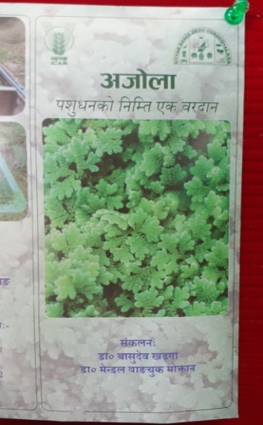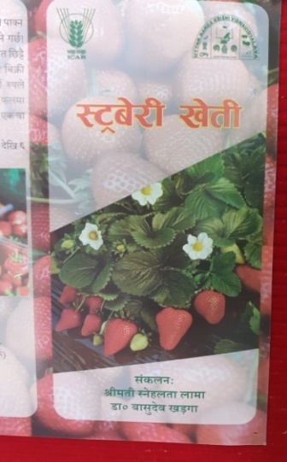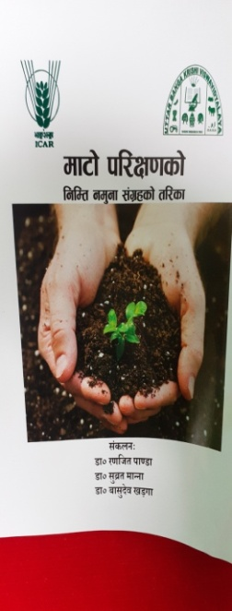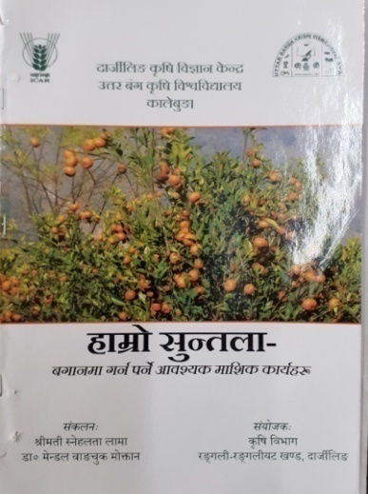

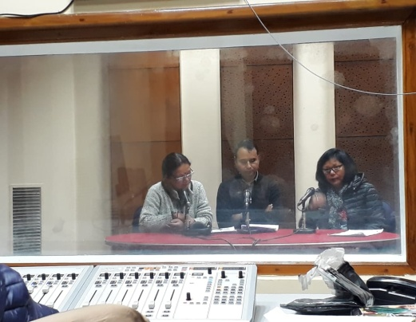

**3.5 a. Production and supply of Technological products**

***Village seed***

|  |  |  |  |  |  |  |  |  |
| --- | --- | --- | --- | --- | --- | --- | --- | --- |
| Crop | Variety | Quantity of seed  (q) | Value  (Rs) | No. of farmers involved in village seed production | Number of farmers  to whom seed provided | | | |
|  |  |  |  |  | SC | ST | Other | Total |
|  |  |  |  |  |  |  |  |  |
|  |  |  |  |  |  |  |  |  |
|  |  |  |  |  |  |  |  |  |
| Total |  |  |  |  |  |  |  |  |

# *KVK farm*

|  |  |  |  |  |  |  |  |
| --- | --- | --- | --- | --- | --- | --- | --- |
| Crop | Variety | Quantity of seed  (q) | Value  (Rs) | Number of farmers  to whom seed provided | | | |
|  |  |  |  | SC | ST | Other | Total |
| Maize | Kaveri | 120 kg. | 1440/- | 3 | 5 | 4 | 12 |
| Turmeric | Paheli local | 90 kg. | 4500/- | 3 | 3 | 3 | 9 |
| Ginger | Gorubathaney | 75 kg. | 3750/- | 4 | 4 | 4 | 12 |
| Potato | Kanchan & Jalandhar | 900 kg. | 22500/- | 8 | 9 | 6 | 25 |
| Grand Total |  |  |  | 18 | 21 | 17 | 58 |

# Production of planting materials by the KVKs

|  |  |  |  |  |  |  |  |
| --- | --- | --- | --- | --- | --- | --- | --- |
| Crop | Variety | No. of planting materials | Value  (Rs) | Number of farmers  to whom planting material provided | | | |
|  |  |  |  | SC | ST | Other | Total |
| **Vegetable seedlings** |  |  |  |  |  |  |  |
| Cauliflower | White Flash | 3200 | 3000 | 7 | 6 | 4 | 17 |
| Cabbage |  |  |  |  |  |  |  |
| Tomato | Jessica | 3200 | 3200 | 6 | 9 | 7 | 22 |
| Brinjal |  |  |  |  |  |  |  |
| Chilli |  |  |  |  |  |  |  |
| Onion |  |  |  |  |  |  |  |
| Others |  |  |  |  |  |  |  |
| **Fruits** |  |  |  |  |  |  |  |
| Mango |  |  |  |  |  |  |  |
| Guava |  |  |  |  |  |  |  |
| Lime |  |  |  |  |  |  |  |
| Papaya |  |  |  |  |  |  |  |
| Banana |  |  |  |  |  |  |  |
| Others (Strawberry) | Festival | 2200 | 4400 | 10 | 9 | 6 | 25 |
| Ornamental plants |  |  |  |  |  |  |  |
| Medicinal and Aromatic |  |  |  |  |  |  |  |
| Plantation |  |  |  |  |  |  |  |
| Spices |  |  |  |  |  |  |  |
| Turmeric |  |  |  |  |  |  |  |
| Tuber |  |  |  |  |  |  |  |
| Elephant yams |  |  |  |  |  |  |  |
| Fodder crop saplings |  |  |  |  |  |  |  |
| Forest Species |  |  |  |  |  |  |  |
| Others, pl.specify (Broom Stick) | Local | 4000 | 12000 | 15 | 12 | 8 | 35 |
| **Total** |  |  |  | **38** | **36** | **25** | **99** |

**Production of Bio- product by KVKs**

| **Bio -product** | **Name of the Bio -product** | **Quantity (no.)** | | **Quantity (Kg.)** | | **Value (Rs.)** | **Number of farmers** | **Quantity (no.)** | **Quantity (Kg.)** | **Value (Rs.)** | **Number of farmers** | **Quantity (no.)** | **Quantity (Kg.)** | **Value (Rs.)** | **Number of farmers** | **Quantity (no.)** | **Quantity (Kg.)** | **Value (Rs.)** | **Number of farmers** |
| --- | --- | --- | --- | --- | --- | --- | --- | --- | --- | --- | --- | --- | --- | --- | --- | --- | --- | --- | --- |
| **Bio- fertilisers** |  | **A&N Islands** | | | | | | **Odisha** | | | | **West bengal** | | | | **Total** | | | |
| Non Symbiotic Azotobacter |  |  |  | |  | |  |  |  |  |  |  |  |  |  |  |  |  |  |
| Vermi compost |  |  |  | |  | |  |  |  |  |  | 2 | Started |  |  |  |  |  |  |
| Azolla |  |  |  | |  | |  |  |  |  |  | 1 | Started |  |  |  |  |  |  |
| Earth worms |  |  |  | |  | |  |  |  |  |  |  |  |  |  |  |  |  |  |
| Compost |  |  |  | |  | |  |  |  |  |  |  |  |  |  |  |  |  |  |
| Worms |  |  |  | |  | |  |  |  |  |  |  |  |  |  |  |  |  |  |
| Blue green algae |  |  |  | |  | |  |  |  |  |  |  |  |  |  |  |  |  |  |
| NADEP |  |  |  | |  | |  |  |  |  |  |  |  |  |  |  |  |  |  |
| Azatobactor |  |  |  | |  | |  |  |  |  |  |  |  |  |  |  |  |  |  |
| Azospirillum |  |  |  | |  | |  |  |  |  |  |  |  |  |  |  |  |  |  |
| PSB |  |  |  | |  | |  |  |  |  |  |  |  |  |  |  |  |  |  |
| Rhizobium |  |  |  | |  | |  |  |  |  |  |  |  |  |  |  |  |  |  |
| Azolla culture |  |  |  | |  | |  |  |  |  |  |  |  |  |  |  |  |  |  |
| **Total** |  |  |  | |  | |  |  |  |  |  |  |  |  |  |  |  |  |  |
| **Bio- pestisides** |  |  |  | |  | |  |  |  |  |  |  |  |  |  |  |  |  |  |
| Neem extract |  |  |  | |  | |  |  |  |  |  |  |  |  |  |  |  |  |  |
| Tobacco extract |  |  |  | |  | |  |  |  |  |  |  |  |  |  |  |  |  |  |
| Trichoder- maviride |  |  |  | |  | |  |  |  |  |  |  |  |  |  |  |  |  |  |
| Panchagavya |  |  |  | |  | |  |  |  |  |  |  |  |  |  |  |  |  |  |
| Trichoderma |  |  |  | |  | |  |  |  |  |  |  |  |  |  |  |  |  |  |
| **Total** |  |  |  | |  | |  |  |  |  |  |  |  |  |  |  |  |  |  |
| **Worms** |  |  |  | |  | |  |  |  |  |  |  |  |  |  |  |  |  |  |
| Eudriluseuniae |  |  |  | |  | |  |  |  |  |  |  |  |  |  |  |  |  |  |
| **Total** |  |  |  | |  | |  |  |  |  |  |  |  |  |  |  |  |  |  |
| **Earth worm** |  |  |  | |  | |  |  |  |  |  |  |  |  |  |  |  |  |  |
| Eiseniafoetida |  |  |  | |  | |  |  |  |  |  |  |  |  |  |  |  |  |  |
| Earth worm |  |  |  | |  | |  |  |  |  |  |  |  |  |  |  |  |  |  |
| **Total** |  |  |  | |  | |  |  |  |  |  |  |  |  |  |  |  |  |  |
| **Bio- fungicides** |  |  |  | |  | |  |  |  |  |  |  |  |  |  |  |  |  |  |
| Trichoder maviridae |  |  |  | |  | |  |  |  |  |  |  |  |  |  |  |  |  |  |
| **Total** |  |  |  | |  | |  |  |  |  |  |  |  |  |  |  |  |  |  |
| **others** |  |  |  | |  | |  |  |  |  |  |  |  |  |  |  |  |  |  |
| Vermiculture |  |  |  | |  | |  |  |  |  |  |  |  |  |  |  |  |  |  |
| Mushroom-spawn |  |  |  | |  | |  |  |  |  |  |  |  |  |  |  |  |  |  |
| Cuelure |  |  |  | |  | |  |  |  |  |  |  |  |  |  |  |  |  |  |
| Mineral mixture |  |  |  | |  | |  |  |  |  |  |  |  |  |  |  |  |  |  |
| Cow dung(dry) |  |  |  | |  | |  |  |  |  |  |  |  |  |  |  |  |  |  |
| Cow dung(wet) |  |  |  | |  | |  |  |  |  |  |  |  |  |  |  |  |  |  |
| **Total** |  |  |  | |  | |  |  |  |  |  |  |  |  |  |  |  |  |  |
| **Grand Total** |  |  |  | |  | |  |  |  |  |  |  |  |  |  |  |  |  |  |
|  |  |  |  | |  | |  |  |  |  |  |  |  |  |  |  |  |  |  |
|  |  |  |  | |  | |  |  |  |  |  |  |  |  |  |  |  |  |  |

# Production of livestock materials

|  |  |  |  |  |  |  |  |
| --- | --- | --- | --- | --- | --- | --- | --- |
| Particulars of Live stock | Name of the breed | Number | Value (Rs.) | No. of Farmers benefitted | | | |
| SC | ST | Other | Total |
| Dairy animals |  |  |  |  | | | |
| Cows |  |  |  |  | | | |
| Buffaloes |  |  |  |  | | | |
| Calves |  |  |  |  | | | |
| Others (Pl. specify) |  |  |  |  | | | |
| Small ruminants |  |  |  |  | | | |
| Sheep |  |  |  |  | | | |
| Goat |  |  |  |  | | | |
| Other, please specify |  |  |  |  | | | |
| Poultry |  |  |  |  | | | |
| Broilers |  |  |  |  | | | |
| Layers |  |  |  |  | | | |
| Duals (broiler and layer) |  |  |  |  | | | |
| Japanese Quail |  |  |  |  | | | |
| Turkey |  |  |  |  | | | |
| Emu |  |  |  |  | | | |
| Ducks |  |  |  |  | | | |
| Others (Pl. specify) |  |  |  |  | | | |
| Piggery |  |  |  |  | | | |
| Piglet |  |  |  |  | | | |
| Hog |  |  |  |  | | | |
| Others (Pl. specify) |  |  |  |  | | | |
| Fisheries |  |  |  |  | | | |
| Indian carp |  |  |  |  | | | |
| Exotic carp |  |  |  |  | | | |
| Mixed carp |  |  |  |  | | | |
| Fish fingerlings |  |  |  |  | | | |
| Spawn |  |  |  |  | | | |
| Others (Pl. specify) |  |  |  |  | | | |
| Grand Total |  |  |  |  | | | |

**3.5. b. Seed Hub Programme - *“Creation of Seed Hubs for Increasing Indigenous Production of Pulses in India”***

i) Name of Seed Hub Centre:

|  |  |
| --- | --- |
| Name of Nodal Officer : |  |
| Address : |  |
| e-mail : |  |
| Phone No. :  Mobile : |  |

ii) Details of Quality Seed Production

|  |  |  |  |  |  |  |
| --- | --- | --- | --- | --- | --- | --- |
| Season | Crop | Variety | Production (q) | | | |
| Target | Area sown (ha) | Production | Category of Seed  (F/S, C/S) |
| Kharif 2020 |  |  |  |  |  |  |
|  |  |  |  |  |  |  |
| Rabi 2020-21 |  |  |  |  |  |  |
|  |  |  |  |  |  |  |
| Summer/Spring 2021 |  |  |  |  |  |  |

iii) Financial Progress

|  |  |  |  |  |
| --- | --- | --- | --- | --- |
| Fund received  (2016-17, 2017-18 2018-19 and2019-20) | Expenditure (Rs. in lakhs) | | Unspent balance  (Rs. in lakhs) | Remarks |
|  | Infrastructure | Revolving fund |
| 2016-17 |  |  |  |  |
| 2017-18 |  |  |  |  |
| 2018-19 |  |  |  |  |
| 2019-20 |  |  |  |  |

iv) Infrastructure Development

|  |  |
| --- | --- |
| Item | Progress |
| Seed processing unit |  |
| Seed storage structure |

3.6. (A) Literature Developed/ Published (with full title, author & reference)

|  |  |  |  |  |
| --- | --- | --- | --- | --- |
| Item | Title | Author’s name | Number | Circulation |
| Research paper |  |  |  |  |
| Seminar/conference/ symposia papers | Webinar |  | 16 |  |
| Books |  |  |  |  |
| Bulletins |  |  |  |  |
| News letter | KVK Newsletter |  | 4 |  |
| Popular Articles |  |  |  |  |
| Book Chapter |  |  |  |  |
| Extension Pamphlets/ literature | Smart Irrigation System  Smart Poultry Unit |  | 2 | 200 |
| Technical reports | Monthly report, Newsletter, Annual Report etc |  | 15 |  |
| Electronic Publication (CD/DVD etc) |  |  |  |  |
| TOTAL |  |  |  |  |

N.B.: Please enclose a copy of each. In case of literature prepared in local language please indicate the title in English

(B) Details of HRD programmes undergone by KVK personnel:

|  |  |  |  |  |  |
| --- | --- | --- | --- | --- | --- |
| Sl. No. | Name of programme | Name of course | Name of KVK personnel and designation | Date and Duration | Organized by |
|  |  |  |  |  |  |

3.7. Success stories/Case studies, if any (two or three pages write-up on 1-2 best case(s) with suitable action photographs)

|  |  |
| --- | --- |
| Name of farmer |  |
| Address |  |
| Contact details (Phone, mobile, email Id) |  |
| Landholding (in ha.) |  |
| Name and description of the farm/ enterprise |  |
| Economic impact |  |
| Social impact |  |
| Environmental impact |  |
| Horizontal/ Vertical spread |  |

3.8. Give details of innovative methodology or innovative technology of Transfer of Technology developed and used during the year

|  |  |  |  |
| --- | --- | --- | --- |
| Sl. No. | Name/ Title of the technology | Name/ Details of the Innovator(s) | Brief details of the Innovative Technology |
|  |  |  |  |
|  |  |  |  |
|  |  |  |  |

3.9. a. Give details of indigenous technology practiced by the farmers in the KVK operational area which can be considered for technology development (in detail with suitable photographs)

|  |  |  |  |
| --- | --- | --- | --- |
| Sl. No. | Crop / Enterprise | ITK Practiced | Purpose of ITK |
|  |  |  |  |
|  |  |  |  |
|  |  |  |  |

b. Give details of organic farming practiced by the farmer

|  |  |  |  |  |  |
| --- | --- | --- | --- | --- | --- |
| Sl. No. | Crop / Enterprise | Area (ha)/ No. covered | Production | No. of farmers involved | Market available (Y/N) |
|  |  |  |  |  |  |

3.10. Indicate the specific training need analysis tools/methodology followed by KVKs

|  |  |  |
| --- | --- | --- |
| Sl. No. | Brief details of the tool/ methodology followed | Purpose for which the tool was followed |
|  |  |  |
|  |  |  |
|  |  |  |

3.11. a. Details of equipment available in Soil and Water Testing Laboratory

|  |  |  |
| --- | --- | --- |
| Sl. No | Name of the Equipment | Qty. |
| 1. | Spectrophotometer | 1 |
| 2. | Flame Photometer | 1 |
| 3. | PH Meter | 1 |
| 4. | Conductivity bridge | 1 |
| 5. | Physical balance | 1 |
| 6. | Chemical balance | 1 |
| 7. | Digestion unit | 1 |
| 8. | Kjeldhal Distillation set | 2 |
| 9. | Mechanical shaker | 1 |
| 10. | Refrigerator | 1 |
| 11. | Hot air oven | 1 |
| 12. | Hot plate | 1 |
| 13. | Grinder | 1 |
| 14. | Water distillation unit (double) | 1 |
| 15. | Chemical and Glass wares | 50 |
| 16. | Soxlet Apparatus (Big &Small) | 2 |
| 17. | Laboratory set up | 1 |
| 18. | Soil and plant sample processing and storage facility | 2 |
| Total | | 17 |

3.11.b. Details of samples analyzed so far :

|  |  |  |  |  |  |
| --- | --- | --- | --- | --- | --- |
| Number of soil samples analyzed | | | No. of Farmers | No. of Villages | Amount realized  (in Rs.) |
| Through mini soil testing kit/labs | Through soil testing laboratory | Total |
| 48 | 0 | 48 | 48 | 4 | 2880 |
|  |  |  |  |  |  |
|  |  |  |  |  |  |

3.11.c. Details on World Soil Day

|  |  |  |  |  |  |  |
| --- | --- | --- | --- | --- | --- | --- |
| Sl. No. | Activity | No. of Participants | No. of VIPs | Name (s) of VIP(s) | Number of Soil Health Cards distributed | No. of farmers benefitted |
| 01 | World Soil Day | 25 | -- | -- | 25 | 25 |

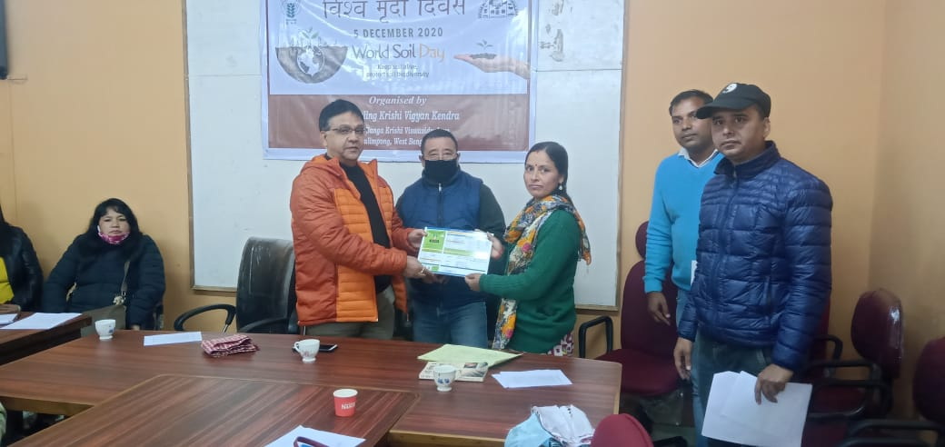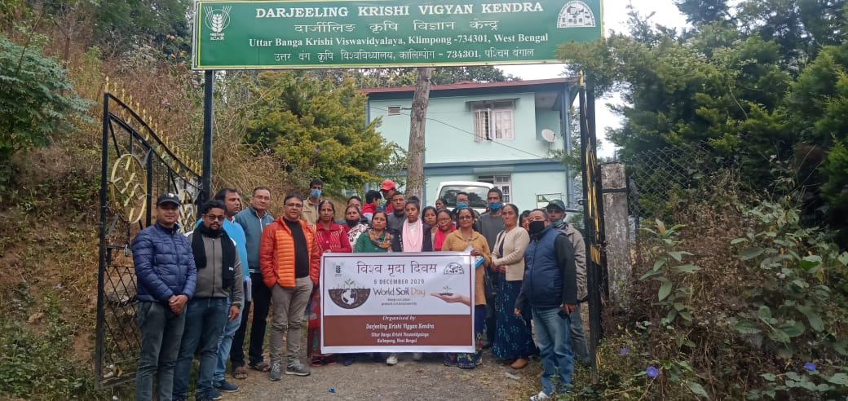

3.12. Activities of rain water harvesting structure and micro irrigation system

|  |  |  |  |  |
| --- | --- | --- | --- | --- |
| No of training programme | No of demonstrations | No of plant material produced | Visit by the farmers | Visit by the officials |
| -- | -- | -- | -- | -- |
|  |  |  |  |  |
|  |  |  |  |  |

3.13. Technology week celebration

|  |  |  |  |
| --- | --- | --- | --- |
| Type of activities | No. of activities | Number of participants | Related crop/livestock technology |
| -- | -- | -- | -- |
|  |  |  |  |

3.14. RAWE/ FET programme - is KVK involved? (Y/N)

|  |  |
| --- | --- |
| No of student trained | No of days stayed |
|  |  |

|  |  |
| --- | --- |
| ARS trainees trained | No of days stayed |
|  |  |

3.15. List of VIP visitors (Minister/ MP/MLA/DM/VC/Zila Sabhadipati/Other Head of Organization/Foreigners)

|  |  |  |
| --- | --- | --- |
| Date | Name of the person | Purpose of visit |
|  |  |  |
|  |  |  |

1. IMPACT
   1. Impact of KVK activities (Not to be restricted for reporting period).

|  |  |  |  |  |
| --- | --- | --- | --- | --- |
| Name of specific technology/skill transferred | No. of participants | % of adoption | Change in income (Rs.) | |
|  |  |  | Before (Rs./Unit) | After (Rs./Unit) |
|  |  |  |  |  |
|  |  |  |  |  |

NB: Should be based on actual study, questionnaire/group discussion etc. with ex-participants

4.2. Cases of large scale adoption

(Please furnish detailed information for each case)

|  |  |
| --- | --- |
| Horizontal spread of technologies | |
| Technology | Horizontal spread |
|  |  |
|  |  |

Give information in the same format as in case studies

4.3. Details of impact analysis of KVK activities carried out during the reporting period

|  |  |  |  |
| --- | --- | --- | --- |
| Sl. No. | Brief details of technology | Impact of the technology in subjective terms | Impact of the technology in objective terms |
|  |  |  |  |
|  |  |  |  |
|  |  |  |  |

4.4. Details of innovations recorded by the KVK

|  |  |
| --- | --- |
| Thematic area |  |
| Name of the Innovation |  |
| Details of Innovator |  |
| Back ground of innovation |  |
| Technology details |  |
| Practical utility of innovation |  |

4.5. Details of entrepreneurship development

|  |  |
| --- | --- |
| Entrepreneurship development | |
| Name of the enterprise | Himalay Atma Nirbhar Udyog, Kalimpong |
| Name & complete address of the entrepreneur | Mrs. Asha Thapa, (Devi Dhara SHG)  Ramitay, Lower Dungra Busty,  Below Livestock Farm,  BPO Rousay, Kalimpong |
| Role of KVK with quantitative data support: | Training and packaging and processing materials (100 no.s) .  Assessment of product for quality checking |
| Timeline of the entrepreneurship development | 6 Months |
| Technical Components of the Enterprise | Food preservation and value addition |
| Status of entrepreneur before and after the enterprise | It was started with Rs. 2000/- per month turnover. Presently its monthly turnover has reached in Rs. 10,000/- per month |
| Present working condition of enterprise in terms of raw materials availability, labour availability, consumer preference, marketing the product etc. ( Economic viability of the enterprise): | Since the raw materials are seasonal, activity is in moderate working condition. |
| Horizontal spread of enterprise | 4 female worker |

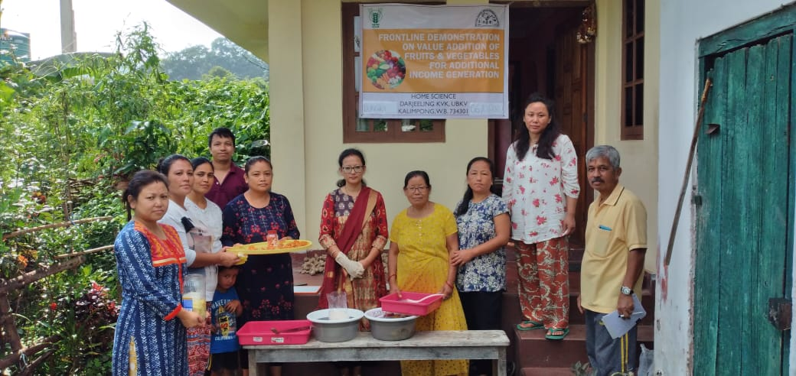 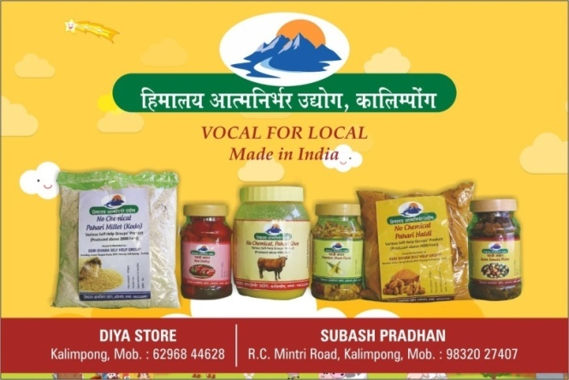

4.6. Any other initiative taken by the KVK

5. LINKAGES

5.1. Functional linkage with different organizations

|  |  |
| --- | --- |
| **Name of organization** | **Nature of linkage** |
| State Agriculture Dept., Govt. of West Bengal | Training |
| Regional Research Station (Hill Zone), Uttar Banga Krishi Viswavidyalaya, Kalimpong |
| Dept. of Animal Recourses Development, Govt. of West Bengal |
| Sasastra Seema Bal (SSB), Siliguri Frontier |
| Regional Station, Indian Agricultural Research Institute, Kalimpong |
| Regional Research Station (Hill Zone), Uttar Banga Krishi Viswavidyalaya, Kalimpong | Demonstration |
| State Agriculture Dept., Govt. of West Bengal |
| Regional Research Station (Hill Zone), Uttar Banga Krishi Viswavidyalaya, Kalimpong | Joint Survey |
| State Agriculture Dept., Govt. of West Bengal |
| State Agriculture Dept., Govt. of West Bengal | Technical Support |
| Regional Research Station (Hill Zone), Uttar Banga Krishi Viswavidyalaya, Kalimpong |
| Dept. of Animal Recourses Development, Govt. of West Bengal |
| Spices Board, Kalimpong, Govt. of India |
| Regional Station, Indian Agricultural Research Institute, Kalimpong |

5.2. List of special programmes undertaken during 2020-21 by the KVK, which have been financed by ATMA/ Central Govt/ State Govt./NABARD/NHM/NFDB/Other Agencies **(information of previous years should not be provided)**

a) Programmes for infrastructure development : NIL

|  |  |  |  |  |
| --- | --- | --- | --- | --- |
| Name of the programme/ scheme | Purpose of programme | Date/ Month of initiation | Funding agency | Amount (Rs.) |
|  |  |  |  |  |
|  |  |  |  |  |
|  |  |  |  |  |

(b) Programme for other activities (training, FLD,OFT, Mela, Exhibition etc.)

|  |  |  |  |  |
| --- | --- | --- | --- | --- |
| Name of the programme/ scheme | Purpose of programme | Date/ Month of initiation | Funding agency | Amount (Rs.) |
| Mulberry based sericulture programme | Research based | 2020-21 | ATMA | 1.5 |
| Varietal assessment Dragon Fruit | Research based | 2020-21 | ATMA | 2.0 |
| Varietal assessment of apple | Research based | 2020-21 | ATMA | 1.5 |
| Smart Poultry Unit | Research & Demonstration | 2020-21 | NABARD | 3.5 |
| Smart Irrigation System | Research & Demonstration | 2020-21 | NABARD | 3.0 |
| DAESI | Diploma Course | 2020-21 | MANAGE | 4.0 |

1. PERFORMANCE OF INFRASTRUCTURE IN KVK

6.1. Performance of demonstration units (other than instructional farm)

|  |  |  |  |  |  |  |  |  |  |
| --- | --- | --- | --- | --- | --- | --- | --- | --- | --- |
| Sl. No. | Name of demo Unit | Year of estt. | Area(Sq.mt) | Details of production | | | Amount (Rs.) | | Remarks |
| Variety/breed | Produce | Qty. | Cost of inputs | Gross income |  |
| 1 | Mushroom Unit | 2020-21 | 20 | Oyster | Fruit | 40 Kg | 1200 | 4000 |  |
| 2 | Azolla Unit | 2020-21 | 2 | Azolla | Fodder | 200 Kg | 1250 | 2000 |  |
| 3 | Bee Keeping | 2020-21 | 5 No.s | Indian bee | Honey | -- |  |  |  |
| 4 | Poultry | 2020-21 | 4 | Kadaknath | Meat | -- |  |  |  |
| Total |  |  |  |  |  |  |  |  |  |

6.2. Performance of Instructional Farm (Crops)

|  |  |  |  |  |  |  |  |  |  |
| --- | --- | --- | --- | --- | --- | --- | --- | --- | --- |
| Name  Of the crop | Date of sowing | Date of harvest | Area (ha) | Details of production | | | Amount (Rs.) | | Remarks |
| Variety | Type of Produce | Qty.(q) | Cost of inputs | Gross income |
| **Seeds** |  |  |  |  |  |  |  |  |  |
| Maize | May 2020 | Aug-Sep 2020 | 900 sq m | Kaveri | Seed | 120 kg. | 1050 | 1440/- |  |
| Turmeric | Mar-Apr 2020 | Jan-Feb 21 | Paheli local | Seed | 90 kg. | 3600 | 4500/- |  |
| Ginger | Mar-Apr 2020 | Jan-Feb 21 | Gorubathaney | Seed | 75 kg. | 2200 | 3750/- |  |
| Potato | Oct-Nov 2020 | Mar-Apr 21 | Kanchan & Jalandhar | Seed | 900 kg. | 16000 | 22500/- |  |
| **Seedlings** |  |  |  |  |  |  |  |  |  |
| Tomato | Jan-Feb 2020 |  | 900 sq ft | Jessica | Seedling | 3200 | 2050 | 3200 |  |
| Cauliflower | Sept –Oct 2020 |  | White Flash | Seedling | 3000 | 1900 | 3000 |  |
| Strawberry |  | June-Jul 20 | Festival | Seedling | 2200 | 3150 | 4400 |  |
| Broomstick |  | June-Jul 20 | Local | Seedling | 4000 | 9300 | 12000 |  |

**Seeds Poduction : Maize (Kaveri) Seedling Production : Tomato (Jessica)**

**Turmeric (Paheli) Cauliflower (white flash)  
  
  
  
  
  
  
 Potato (Kanchan & Jalandhar) Strawberry (Festival)**

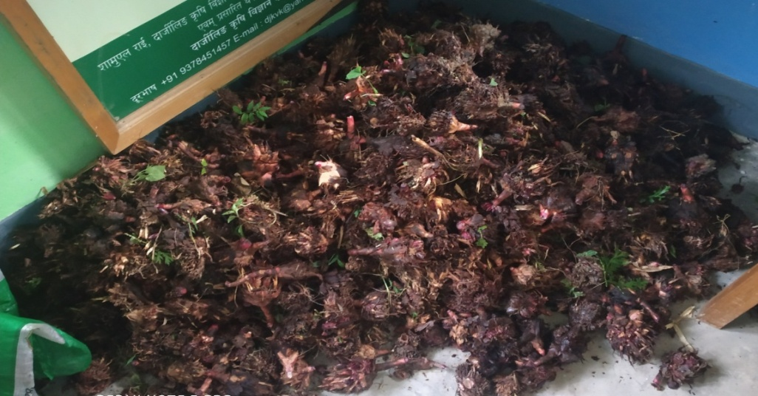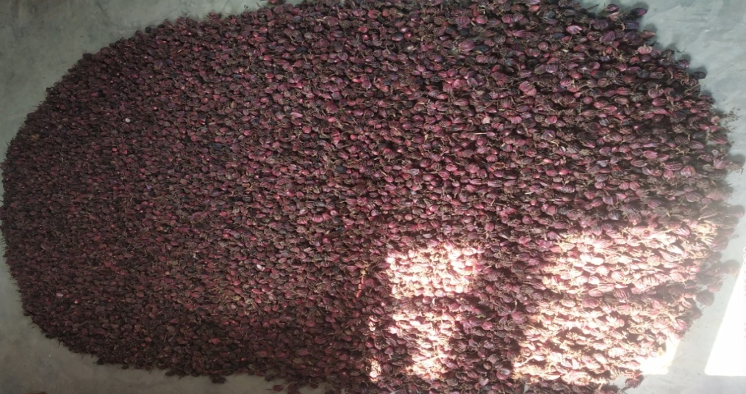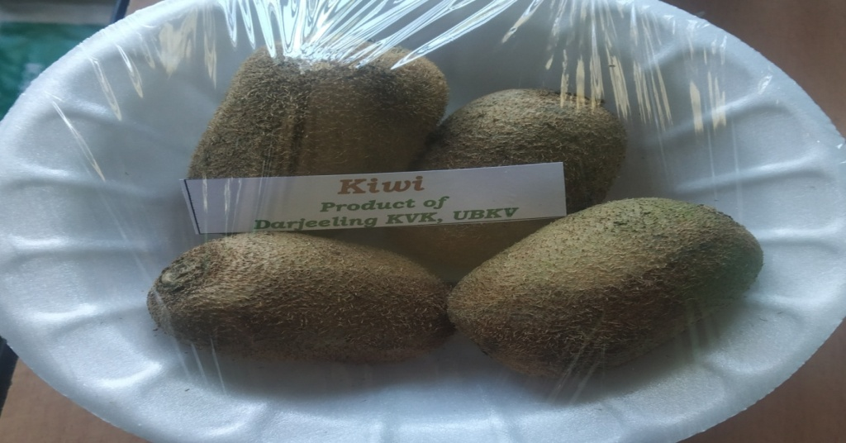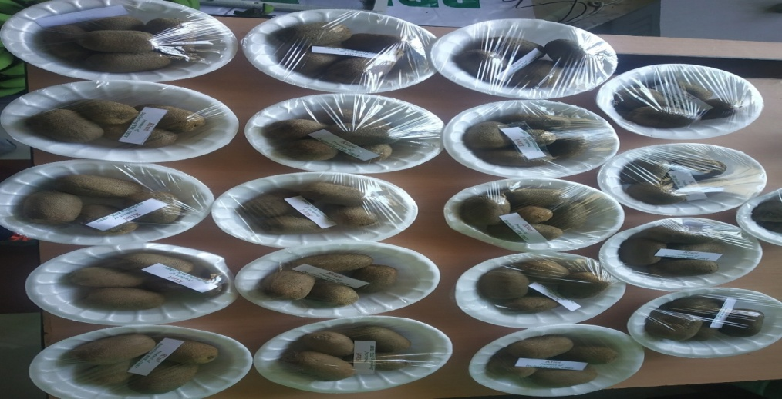

6.3 Performance of Production Units (bio-agents / bio pesticides/ bio fertilizers etc.,)

|  |  |  |  |  |  |
| --- | --- | --- | --- | --- | --- |
| Sl. No. | Name of the Product | Qty. (Kg) | Amount (Rs.) | | Remarks |
| Cost of inputs | Gross income |
| 1. | Mushroom | 37.5 Kg | 1125 | 3750 |  |
| 2 | Vermi-compost | 150 Kg | 300 | 1500 |  |
| 3 | Azolla | 200 Kg | 1250 | 2000 |  |

* 1. Performance of instructional farm (livestock and fisheries production)

|  |  |  |  |  |  |  |  |
| --- | --- | --- | --- | --- | --- | --- | --- |
| Sl.  No | Name  of the animal / bird / aquatics | Details of production | | | Amount (Rs.) | | Remarks |
| Breed | Type of Produce | Qty. | Cost of inputs | Gross income |
| 1. |  |  |  |  |  |  |  |
| 2. |  |  |  |  |  |  |  |
| 3. |  |  |  |  |  |  |  |

6.5 Utilization of hostel facilities

Accommodation available (No. of beds)

|  |  |  |  |
| --- | --- | --- | --- |
| Months | No. of trainees stayed | Trainee days  (days stayed) | Reason for short fall (if any) |
|  |  |  |  |
|  |  |  |  |
|  |  |  |  |
| Total : |  |  |  |

(For whole of the year)

* 1. Utilization of staff quarters

Whether staff quarters has been completed:

No. of staff quarters: 6

Date of completion: 2008

Occupancy details: 2 vacant

|  |  |  |  |  |  |  |
| --- | --- | --- | --- | --- | --- | --- |
| Months | Q I | QII | Q III | QIV | Q V | QVI |
|  |  | | | | | |
|  |  | | | | | |
|  |
|  |

1. FINANCIAL PERFORMANCE

7.1. Details of KVK Bank accounts

|  |  |  |  |
| --- | --- | --- | --- |
| Bank account | Name of the bank | Location | Account Number |
| Darjeeling KVK | SBI | Kalimpong | 11283931150 |
| Darjeeling KVK | Bank of India | Kalimpong | 429310110000033 |

* 1. Utilization of funds under CFLD on Oilseed *(Rs. In Lakhs)*

|  |  |  |  |  |  |
| --- | --- | --- | --- | --- | --- |
| Item | Released by ICAR | | Expenditure | | Unspent balance as on - |
| Kharif | Rabi | Kharif | Rabi |
| -- | -- | --- | -- | -- | -- |
|  |  |  |  |  |  |
|  |  |  |  |  |  |
|  |  |  |  |  |  |

7.3. Utilization of funds under CFLD on Pulses *(Rs. In Lakhs)*

|  |  |  |  |  |  |
| --- | --- | --- | --- | --- | --- |
| Item | Released by ICAR | | Expenditure | | Unspent balance as on 1st January 2021 |
| Kharif | Rabi | Kharif | Rabi |
| Field Pea |  | 90,000/- |  | 89,678/- | 322/- |
|  |  |  |  |  |  |
|  |  |  |  |  |  |
|  |  |  |  |  |  |

* 1. Utilization of KVK funds during the year 2020-21 (Not audited)

| Sl. No. | Particulars | | Sanctioned | Released | Expenditure |
| --- | --- | --- | --- | --- | --- |
| A. Recurring Contingencies | | | | | |
| 1 | Pay & Allowances | | 1,23,00,000 | 1,23,00,000 | 1,22,90,836 |
| 2 | Traveling allowances | | 1,30,000 | 1,30,000 | 1,29,323 |
| 3 | Contingencies | | | | |
| *A* | Stationary, telephone, postage and other expenditure on office running, publication of newsletter | | 1,40,000 | 1,40,000 | 1,39,452 |
| *B* | Training of farmer | 1,05,000 | | 1,05,000 | 1,04,574 |
| *C* | SCSP | | 12,00,000 | 12,00,000 | 5,97,452 |
| *D* | Front line demonstration | 53,000 | | 53,000 | 51,336 |
| *E* | On farm testing (On need based, location specific and newly generated information in the major production system of the area) | | 52,000 | 52,000 | 51,885 |
| *F* | HRD | | 30,000 | 30,000 | 29,966 |
| *G* | Swachhta Expenditure | |  |  |  |
| *H* |  | |  |  |  |
| *I* |  | |  |  |  |
| *J* |  | |  |  |  |
| TOTAL (A) | | | 1,40,10,000 | 1,40,10,000 | 1,33,94,824 |
| B. Non-Recurring Contingencies | | | | | |
| 1 | Library | | 10,000 | 10,000 | -- |
| 2 |  | |  |  |  |
| 3 |  | |  |  |  |
| 4 |  | |  |  |  |
| TOTAL (B) | | | 10,000 | 10,000 | -- |
| C. REVOLVING FUND | | | -- | -- | -- |
| GRAND TOTAL (A+B+C) | | | 1,40,20,000 | 1,40,20,000 | 1,33,94,824 |

7.5. Status of revolving fund (Rs. in lakh) for last three years

|  |  |  |  |  |
| --- | --- | --- | --- | --- |
| Year | Opening balance as on 1st April | Income during the year | Expenditure during the year | Net balance in hand as on 1st April of each year (Kind + cash) |
| 2015-16 | 4,16,841 | 17,24,056 | 16,37,151 | 5,03,745 |
| 2016-17 | 5,03,745 | 2,11,967 | 2,78,520 | 4,37,192 |
| 2017-18 | 4,37,192 | 11,96,326 | 10,65,400 | 5,68,118 |
| 2018-19 | 5,68,118 | 19,53,452 | 19,44,552 | 5,77,018 |
| 2019-20 | 5,77,018 | 2,21,440/- | 6,21,788 | 1,76,670 |

* 1. (i) Number of SHGs formed by KVKs : NIL

(ii) Association of KVKs with SHGs formed by other organizations indicating the area of SHG activities : NIL

(iii) Details of marketing channels created for the SHGs : NIL

* 1. Joint activity carried out with line departments and ATMA : NIL

|  |  |  |  |  |  |
| --- | --- | --- | --- | --- | --- |
| Name of activity | Number of activity | Season | With line department | With ATMA | With both |
|  |  |  |  |  |  |
|  |  |  |  |  |  |
|  |  |  |  |  |  |

8. Other information

8.1. Prevalent diseases in Crops : NIL

|  |  |  |  |  |  |
| --- | --- | --- | --- | --- | --- |
| Name of the disease | Crop | Date of outbreak | Area affected (in ha) | % Commodity loss | Preventive measures taken for area (in ha) |
|  |  |  |  |  |  |

8.2. Prevalent diseases in Livestock/Fishery : NIL

|  |  |  |  |  |  |
| --- | --- | --- | --- | --- | --- |
| Name of the disease | Species affected | Date of outbreak | Number of death/ Morbidity rate (%) | Number of animals vaccinated | Preventive measures taken in pond (in ha) |
|  |  |  |  |  |  |

9.1. Nehru Yuva Kendra (NYK) Training : NIL

|  |  |  |  |  |  |
| --- | --- | --- | --- | --- | --- |
| Title of the training programme | Period | | No. of the participant | | Amount of Fund Received (Rs) |
| From | To | M | F |
|  |  |  |  |  |  |

9.2. *mKisan* Portal (National Farmers’ Portal/ SMS Portal) : NIL

|  |  |  |
| --- | --- | --- |
| Type of message | No. of messages | No. of farmers covered |
| Crop |  |  |
| Livestock |  |  |
| Fishery |  |  |
| Weather |  |  |
| Marketing |  |  |
| Awareness |  |  |
| Training information |  |  |
| Other |  |  |
| **Total** |  |  |

9.3. *KVK* Portal and Mobile App

|  |  |  |
| --- | --- | --- |
| Sl. No. | Particulars | Description |
| 1. | No. of visitors visited the portal | *--* |
| 2. | No. of farmers registered in the portal | *406* |
| 3. | Mobile Apps developed by KVK | *1* |
| 4. | Name of the App | *KVK online Agrimart* |
| 5. | Language of the App |  |
| 6. | Meant for crop/ livestock/ fishery/ others | crop/ livestock |
| 7. | No. of times downloaded | *--* |

9.4. a. Observation of Swachh Bharat Programme

|  |  |
| --- | --- |
| Date/ Duration of Observation | Activities undertaken |
|  |  |

b. Details of Swachhta activities with expenditure

|  |  |  |
| --- | --- | --- |
| **Activities** | **Number** | **Expenditure (in Rs.)** |
| 1. Digitization of office records/ e-office |  |  |
| 1. Basic maintenance |  |  |
| 1. Sanitation and SBM |  |  |
| 1. Cleaning and beautification of surrounding areas |  |  |
| 1. Vermicomposting/   Composting of biodegradable waste management & other activities on generate of wealth for waste |  |  |
| 1. Used water for agriculture/ horticulture application |  |  |
| 1. Swachhta Awareness at local level |  |  |
| 1. Swachhta Workshops |  |  |
| 1. Swachhta Pledge |  |  |
| 1. Display and Banner |  |  |
| 1. Foster healthy competition |  |  |
| 1. Involvement of print and electronic media |  |  |
| 1. Involving the farmers, farm women and village youth in the adopted villages (no of adopted village) |  |  |
| 1. No of Staff members involved in the activities |  |  |
| 1. No of VIP/VVIPs involved in the activities |  |  |
| 16. Any other specific activity (in details) |  |  |
| **Total** |  |  |

9.5. Observation of National Science day

|  |  |
| --- | --- |
| Date of Observation | Activities undertaken |
|
|  |  |

9.6. Programme with Seema Suraksha Bal/ BSF

|  |  |  |
| --- | --- | --- |
| Title of Programme | Date | No. of participants |
|  |  |  |

9.7. Agriculture Knowledge in rural school

|  |  |  |  |
| --- | --- | --- | --- |
| Name and address of school | Date of visit to school | Areas covered | Teaching aids used |
|  |  |  |  |

Give good quality 1-2 photograph(s)

9.8. Details of ‘*Pre-Rabi Campaign’* Programme

|  |  |  |  |  |  |  |  |  |  |  |  |  |
| --- | --- | --- | --- | --- | --- | --- | --- | --- | --- | --- | --- | --- |
| Date of programme | No. of Union Ministers attended the programme | No. of  Hon’ble MPs (Loksabha/ Rajyasabha) participated | No. of State Govt. Ministers | Participants (No.) | | | | | | | Coverage by Door Darshan (Yes/No) | Coverage by other channels (Number) |
| MLAs Attended the programme | Chairman ZilaPanchayat | Distt. Collector/ DM | Bank Officials | Farmers | Govt. Officials, PRI members etc. | Total |
|  |  |  |  |  |  |  |  |  |  |  |  |  |

9.9. Details of Swachhta Hi Sewa programme organized

|  |  |  |  |  |  |
| --- | --- | --- | --- | --- | --- |
| Sl.  No. | Activity | No. of villages Involved | No. of Participants | No. of VIPs | Name (s) of VIP(s) |
|  |  |  |  |  |  |

9.10. Details of Mahila Kisan Divas programme organized

|  |  |  |  |  |  |
| --- | --- | --- | --- | --- | --- |
| Sl.  No. | Activity | No. of villages Involved | No. of Participants | No. of VIPs | Name (s) of VIP(s) |
|  |  |  |  |  |  |

9.11. No. of Progressive/ Innovative/ Lead farmer identified (category wise)

|  |  |  |  |
| --- | --- | --- | --- |
| Sl.  No. | Name of Farmer | Address of the farmer with contact no. | Innovation/ Leading in enterprise |
|  |  |  |  |

9.12. Revenue generation

| Sl.No. | Name of Head | Income(Rs.) | Sponsoring agency |
| --- | --- | --- | --- |
| 1. |  |  |  |

9.13. Resource Generation:

|  |  |  |  |  |  |
| --- | --- | --- | --- | --- | --- |
| Sl. No. | Name of the programme | Purpose of the programme | Sources of fund | Amount  (Rs. lakhs) | Infrastructure created |
|  |  |  |  |  |  |

9.14. Performance of Automatic Weather Station in KVK

|  |  |  |
| --- | --- | --- |
| Date of establishment | Source of funding i.e. IMD/ICAR/Others (pl. specify) | Present status of functioning |
|  |  |  |

9.15. Contingent crop planning

|  |  |  |  |  |  |
| --- | --- | --- | --- | --- | --- |
| Name of the state | Name of district/KVK | Thematic area | Number of programmes organized | Number of Farmers contacted | A brief about contingent plan executed by the KVK |
|  |  |  |  |  |  |

10. Report on Cereal Systems Initiative for South Asia (CSISA)

1. Year:
2. Introduction / General Information:

|  |  |  |  |  |  |  |
| --- | --- | --- | --- | --- | --- | --- |
|  | Title | Objective | Treatment details | Date of sowing | Replication | Result with photographs |
| Experiment 1 |  |  |  |  |  |  |
| Experiment 2 |  |  |  |  |  |  |
| Experiment 3 |  |  |  |  |  |  |
| Others (If any) |  |  |  |  |  |  |

11. Details of TSP

1. Achievements of physical output under TSP during 2017-18

|  |  |
| --- | --- |
| **Programmes** | **Physical achievements** |
| Asset creation (Number; Sprayer, ridge maker, pump set, weeder etc.) |  |
| On-farm trials (Number) |  |
| Frontline demonstrations (Number) |  |
| Farmers training (in lakh) |  |
| Extension personnel training (in lakh) |  |
| Participants in extension activities (in lakh) |  |
| Seed production (in tonnes) |  |
| Planting material production (in lakh) |  |
| Livestock strains and fingerlings production (in lakh) |  |
| Soil, water, plant, manures samples testing (in lakh) |  |
| Provision of mobile agro – advisory to farmers (in lakh) |  |
| No. of other programmes (Swachha Bharat Abhiyaan, Agriculture knowledge in rural school, Planting material distribution, Vaccination camp etc.) |  |

1. Fund received under TSP in 2020-21 (Rs. In lakh):
2. (i) Achievements of physical outcome under TSP during 2020-21

|  |  |  |  |
| --- | --- | --- | --- |
| Sl. No. | Description | Unit | Achievements |
|
| 1 | Change in family income | % |  |
| 2 | Change in family consumption level | % |  |
| 3 | Change in availability of agricultural implements/ tools etc. | No. per household |  |

(ii) Table:

| ***Sl.***  ***No.*** | ***Description*** | ***Unit*** | ***Achievements*** |
| --- | --- | --- | --- |
| 1 | Number of Technologies Identified after Assessment | Number |  |
| 2 | Upgraded Skills and Knowledge of farmers | Number |  |
| 3 | Oriented extension personnel in frontier areas of agricultural technology | Number |  |
| 4 | Increased availability of quality seed | Quintal |  |
| 5 | Increased availability of quality Planting material | Number |  |
| 6 | Increased availability of live-stock strains and fingerlings | Number |  |
| 7 | Testing of Soil & water samples for balance fertilizer use | Number |  |

|  |  |  |  |  |  |  |  |
| --- | --- | --- | --- | --- | --- | --- | --- |
| **2020-21** | | | | | | | |
| Name of KVK | Year since ARYA is initiated in the KVK (specify year) | No. of Training programs | No. of rural youth trained | | No. of youth established units | | No. of entrepreneurial units established |
|  |  |  | **M** | **F** | **M** | **F** |  |
|  |  |  |  |  |  |  |  |
|  |  |  |  |  |  |  |  |

1. Location and Beneficiary Details during 2020-21

|  |  |  |  |  |  |  |
| --- | --- | --- | --- | --- | --- | --- |
| ***District*** | ***Sub-district*** | ***No. of Village covered*** | ***Name of village(s)***  ***covered*** | ***ST population benefitted***  ***(No.)*** | | |
|  |  |  |  | M | F | T |
|  |  |  |  |  |  |  |
|  |  |  |  |  |  |  |
|  |  |  |  |  |  |  |

**12.** Schedule caste Output & Outcome achievements

|  |  |  |  |
| --- | --- | --- | --- |
| Sl.  No. | Indicator/Activities | Unit of Indicator | Achievements |
| 1 | Farmers, farm women trained by KVKs | Number |  |
| 2 | Extension personnel trained by KVKs | Number |  |
| 3 | On-farm trials conducted by KVKs | Number |  |
| 4 | Frontline demonstrations conducted by KVKs | Number |  |
| 5 | Quantity of seeds produced | Quintal |  |
| 6 | Planting materials Produced | Number |  |
| 7 | Livestock strains and fingerlings produced | Number |  |
| 8 | Soil & water samples tested | Number |  |

13**.** Information pertaining to ARYA Project

14. Progress report of NICRA KVK (Technology Demonstration component) during the period

(Applicable for KVKs identified under NICRA)

Natural Resource Management

|  |  |  |  |  |  |  |  |  |  |  |  |  |  |  |
| --- | --- | --- | --- | --- | --- | --- | --- | --- | --- | --- | --- | --- | --- | --- |
| Name of intervention undertaken | Numbers under taken | No of units | Area (ha) | No of farmers covered / benefitted | | | | | | | | | | Remarks |
| SC | | ST | | | Other | | Total | | |
|  |  |  |  | M | F | | M | F | M | F | M | F | T |  |
|  |  |  |  |  |  | |  |  |  |  |  |  |  |  |
|  |  |  |  |  |  | |  |  |  |  |  |  |  |  |

Crop Management

|  |  |  |  |  |  |  |  |  |  |  |  |  |
| --- | --- | --- | --- | --- | --- | --- | --- | --- | --- | --- | --- | --- |
| Name of intervention undertaken | Area (ha) | No of farmers covered / benefitted | | | | | | | | | | Remarks |
| SC | | ST | | | Other | | Total | | |
|  |  | M | F | | M | F | M | F | M | F | T |  |
|  |  |  |  | |  |  |  |  |  |  |  |  |
|  |  |  |  | |  |  |  |  |  |  |  |  |

Livestock and fisheries

|  |  |  |  |  |  |  |  |  |  |  |  |  |  |  |
| --- | --- | --- | --- | --- | --- | --- | --- | --- | --- | --- | --- | --- | --- | --- |
| Name of intervention undertaken | Number of animals covered | No of units | Area (ha) | No of farmers covered / benefitted | | | | | | | | | | Remarks |
|  |  |  |  | SC | | ST | | | Other | | Total | | |  |
|  |  |  |  | M | F | | M | F | M | F | M | F | T |  |
|  |  |  |  |  |  | |  |  |  |  |  |  |  |  |

Institutional interventions

|  |  |  |  |  |  |  |  |  |  |  |  |  |  |
| --- | --- | --- | --- | --- | --- | --- | --- | --- | --- | --- | --- | --- | --- |
| Name of intervention undertaken | No of units | Area (ha) | No of farmers covered / benefitted | | | | | | | | | | Remarks |
|  |  |  | SC | | ST | | | Other | | Total | | |  |
|  |  |  | M | F | | M | F | M | F | M | F | T |  |
|  |  |  |  |  | |  |  |  |  |  |  |  |  |

Capacity building

|  |  |  |  |  |  |  |  |  |  |  |
| --- | --- | --- | --- | --- | --- | --- | --- | --- | --- | --- |
| Thematic area | No of Courses | No of beneficiaries | | | | | | | | |
|  |  | SC | ST | | Other | | | Total | | |
|  |  | M | F | M | F | M | F | M | F | T |
|  |  |  |  |  |  |  |  |  |  |  |

Extension activities

|  |  |  |  |  |  |  |  |  |  |  |
| --- | --- | --- | --- | --- | --- | --- | --- | --- | --- | --- |
| Thematic area | No of activities | No of beneficiaries | | | | | | | | |
|  |  | SC | ST | | Other | | | Total | | |
|  |  | M | F | M | F | M | F | M | F | T |
|  |  |  |  |  |  |  |  |  |  |  |

Detailed report should be provided in the circulated Performa

15. Awards/Recognition received by the KVK

|  |  |  |  |  |  |
| --- | --- | --- | --- | --- | --- |
| Sl. No. | Name of the Award | Year | Conferring Authority | Amount | Purpose |
|  |  |  |  |  |  |
|  |  |  |  |  |  |
|  |  |  |  |  |  |

Award received by Farmers from the KVK district

|  |  |  |  |  |  |  |
| --- | --- | --- | --- | --- | --- | --- |
| Sl. No. | Name of the Award | Name of the Farmer | Year | Conferring Authority | Amount | Purpose |
|  |  |  |  |  |  |  |
|  |  |  |  |  |  |  |
|  |  |  |  |  |  |  |

16. Any significant achievement of the KVK with facts and figures as well as quality photograph

17. Number of commodity based organizations/ farmers’ cooperative society/ FPO formed/ associated with during last one year (Details of the group/society may be indicated)

|  |  |  |  |  |  |  |  |  |
| --- | --- | --- | --- | --- | --- | --- | --- | --- |
| Sl. No. | Name of the organization/ Society | Trust Deed No.& date | Date of Trust Registration  Address | Proposed Activity | Commodity Identified | No. of Members | Financial position  (Rupees in lakh) | Success indicator |
|  |  |  |  |  |  |  |  |  |
|  |  |  |  |  |  |  |  |  |
|  |  |  |  |  |  |  |  |  |

1. Integrated Farming System (IFS)

Details of KVK Demo. Unit

|  |  |  |  |  |  |  |  |
| --- | --- | --- | --- | --- | --- | --- | --- |
| Sl.  No. | Module details (Component-wise) | Area under IFS (ha) | Production (Commodity-wise) | Cost of production in Rs. (Component-wise) | Value realized in Rs. (Commodity-wise) | No. of farmer adopted practicing IFS | % Change in adoption during the year |
|  |  |  |  |  |  |  |  |
|  |  |  |  |  |  |  |  |

19.Technologies for Doubling Farmers' Income

|  |  |  |  |  |  |
| --- | --- | --- | --- | --- | --- |
| Sl. No. | Name of the Technology | Brief Details of Technology (3- 5 bullet points) | Net Return to the farmer (Rs.) per ha per year due to adoption of the technology | No. of farmers adopted the technology in the district | One high resolution ‘Photo’ in ‘jpg’ format for each technology |
| 1 |  |  |  |  |  |
| 2 |  |  |  |  |  |

20.Report on Digital Farming Initiatives in Agriculture/ Digital Ag. Extension Service

|  |  |  |  |  |  |
| --- | --- | --- | --- | --- | --- |
|  | Database prepared/ covered for | | KVK level Committee | | Various activity conducted for farmers |
| Phase | Total no. of villages | Total no. of farmers | Date of formation | Name of members |  |
| I (up-to 15.03.2018) |  |  |  |  |  |
| II (up-to 24.04.218) |  |  |  |  |  |
| Total |  |  |  |  |  |

21.Information on Visit of VIPs to KVKs, if any : NIL

| Date of Visit | Name of Hon’ble Minister | Name of Ministry | Salient points in his/ her observation  (2-3 bulleted points) |
| --- | --- | --- | --- |
|  |  |  |  |

22.a) Information on **ASCI** Skill Development Training Programme, if undertaken during 2019-20 and 2020-21

|  |  |  |  |  |  |  |  |
| --- | --- | --- | --- | --- | --- | --- | --- |
| Year | Name of the Job role | Name of the certified Trainer of KVK for the Job role | Date of start of training | Date of completion of training | No. of participants | Whether uploaded to SDMS Portal (Y/N) | Fund utilized for the training (Rs.) |
| 2016-17 |  |  |  |  |  |  |  |
|  |  |  |  |  |  |  |  |
| 2017-18 |  |  |  |  |  |  |  |
|  |  |  |  |  |  |  |  |
| 2018-19 |  |  |  |  |  |  |  |
|  |  |  |  |  |  |  |  |
| 2019-20 |  |  |  |  |  |  |  |

b) Information on Skill Development Training Programme (**Other than ASCI or less than 200 hrs**., if any) if undertaken during 2020-21

|  |  |  |  |  |  |  |  |  |  |  |  |  |
| --- | --- | --- | --- | --- | --- | --- | --- | --- | --- | --- | --- | --- |
| Thematic area of training | Title of the training | Duration (in hrs.) | No. of participants | | | | | | | | | Fund utilized for the training (Rs.) |
|  |  |  | SC | | ST | | Other | | Total | | |  |
|  |  |  | M | F | M | F | M | F | M | F | T |  |
|  |  |  |  |  |  |  |  |  |  |  |  |  |

1. Information on NARI Project (if applicable)

|  |  |  |  |  |  |  |
| --- | --- | --- | --- | --- | --- | --- |
| **Name of Nodal Officer** | **No. of OFT on specified aspects** | **Title(s) of OFT** | **No. of FLD on specified aspects** | **No. of capacity development programme on specified aspects** | **Total no. of farm women/ girls involved in the project** | **Details of Issues related to gender mainstreaming addressed through the project** |
|  |  |  |  |  |  |  |
|  |  |  |  |  |  |  |
|  |  |  |  |  |  |  |

1. Information on Krishi Kalyan Abhiyan Phase- I/ Phase-II/ Phase-III, if applicable

***Krishi Kalyan Abhiyan- I and II***

1. **Training**

|  |  |  |  |  |  |  |  |  |  |  |  |
| --- | --- | --- | --- | --- | --- | --- | --- | --- | --- | --- | --- |
| ***Name of programme*** | ***No. of programmes*** | ***No. of farmers benefitted*** | | | | | | | | | ***No. of officials attended the programme*** |
| **SC** | | **ST** | | **Others** | | **Total** | | |
|  |  | **M** | **F** | **M** | **F** | **M** | **F** | **M** | **F** | **T** |  |
|  |  |  |  |  |  |  |  |  |  |  |  |
| **KKA-I** |  |  |  |  |  |  |  |  |  |  |  |
| **KKA-II** |  |  |  |  |  |  |  |  |  |  |  |

1. **Distribution of seed/ planting materials/ input/ others**

| ***Name of programme*** | ***No. of Programme*** | ***Total quantity distributed*** | | | | ***No. of farmers benefited*** | | | | | | | | | | ***No. of other officials (except KVK)***  ***attended the programme*** |
| --- | --- | --- | --- | --- | --- | --- | --- | --- | --- | --- | --- | --- | --- | --- | --- | --- |
| ***Seed (q)*** | ***Planting material (lakh)*** | ***Input (kg)*** | ***Other (kg/ No.)*** | ***SC*** | | ***ST*** | | ***Others*** | | ***Total*** | | |  | |
| ***M*** | ***F*** | ***M*** | ***F*** | ***M*** | ***F*** | ***M*** | ***F*** | ***T*** |
| **KKA-I** |  |  |  |  |  |  |  |  |  |  |  |  |  |  |  | |
| **KKA-II** |  |  |  |  |  |  |  |  |  |  |  |  |  |  |  | |

1. **Livestock and Fishery related activities**

| ***Name of programme*** | ***No. of Programme*** | ***Activities performed*** | | | | ***No. of farmers benefited*** | | | | | | | | | ***No. of other officials (except KVK)***  ***attended the programme*** |
| --- | --- | --- | --- | --- | --- | --- | --- | --- | --- | --- | --- | --- | --- | --- | --- |
| ***No. of animals vaccinated*** | ***No. of animals dewormed*** | ***Feed/ nutrient supplements provided (kg)*** | ***Any other (Distribution of animals/ birds/ fingerlings)***  ***[No.]*** | ***SC*** | | ***ST*** | | ***Others*** | | ***Total*** | | |
| ***M*** | ***F*** | ***M*** | ***F*** | ***M*** | ***F*** | ***M*** | ***F*** | ***T*** |
| **KKA-I** |  |  |  |  |  |  |  |  |  |  |  |  |  |  |  |
| **KKA-II** |  |  |  |  |  |  |  |  |  |  |  |  |  |  |  |

1. **Other activities**

| ***Name of programme*** | ***Activities*** | ***No. of farmers benefited*** | | | | | | | | | ***No. of other officials (except KVK)***  ***attended the programme*** |
| --- | --- | --- | --- | --- | --- | --- | --- | --- | --- | --- | --- |
| ***SC*** | | ***ST*** | | ***Others*** | | ***Total*** | | |
| ***M*** | ***F*** | ***M*** | ***F*** | ***M*** | ***F*** | ***M*** | ***F*** | T |
| KKA-I | Soil Health Card Distributed |  |  |  |  |  |  |  |  |  |  |
| NADEP  Pit established |  |  |  |  |  |  |  |  |  |  |
| Farm implements distributed |  |  |  |  |  |  |  |  |  |  |
| Others, if any |  |  |  |  |  |  |  |  |  |  |
| KKA-II | Soil Health Card Distributed |  |  |  |  |  |  |  |  |  |  |
| NADEP  Pit established |  |  |  |  |  |  |  |  |  |  |
| Farm implements distributed |  |  |  |  |  |  |  |  |  |  |
| Others, if any |  |  |  |  |  |  |  |  |  |  |

***Krishi Kalyan Abhiyan- III***

|  |  |  |  |  |  |  |  |  |  |  |  |
| --- | --- | --- | --- | --- | --- | --- | --- | --- | --- | --- | --- |
| ***No. of villages covered*** | ***No. of animal inseminated*** | ***No. of farmers benefitted*** | | | | | | | | | ***Any other, if any***  ***(pl. specify)*** |
| ***SC*** | | ***ST*** | | ***Others*** | | ***Total*** | | |
| ***M*** | ***F*** | ***M*** | ***F*** | ***M*** | ***F*** | ***M*** | ***F*** | T |  |
|  |  |  |  |  |  |  |  |  |  |  |  |

25. Nutri-garden

|  |  |  |  |  |
| --- | --- | --- | --- | --- |
| **Sl.no.** | **Name of KVK** | **Established in KVK Campus** | **No. of nutria-garden established in the village** | **Major vegetables production** |
|  |  |  |  |  |
|  |  |  |  |  |
|  |  |  |  |  |

Please provide one or two good quality photographs

26. Any other programme organized by KVK, not covered above

|  |  |  |  |  |  |
| --- | --- | --- | --- | --- | --- |
| **Sl. No.** | **Name of the programme** | **Date of the programme** | **Venue** | **Purpose** | **No. of participants** |
|  |  |  |  |  |  |
|  |  |  |  |  |  |
|  |  |  |  |  |  |

27.Good quality action photographs of overall achievements of KVK during the year (best 10)

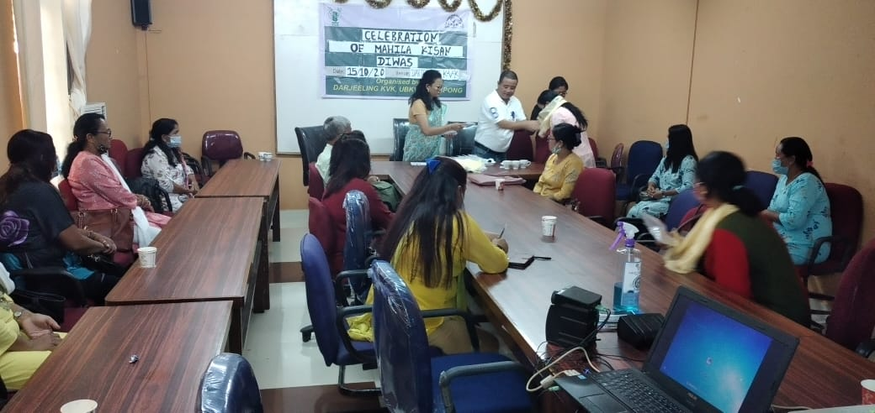

Celebration of Mahila Kisan Diwas 2021

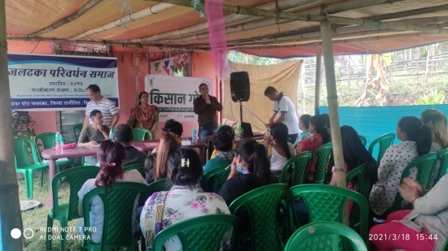

Kishan Gosthi Formation

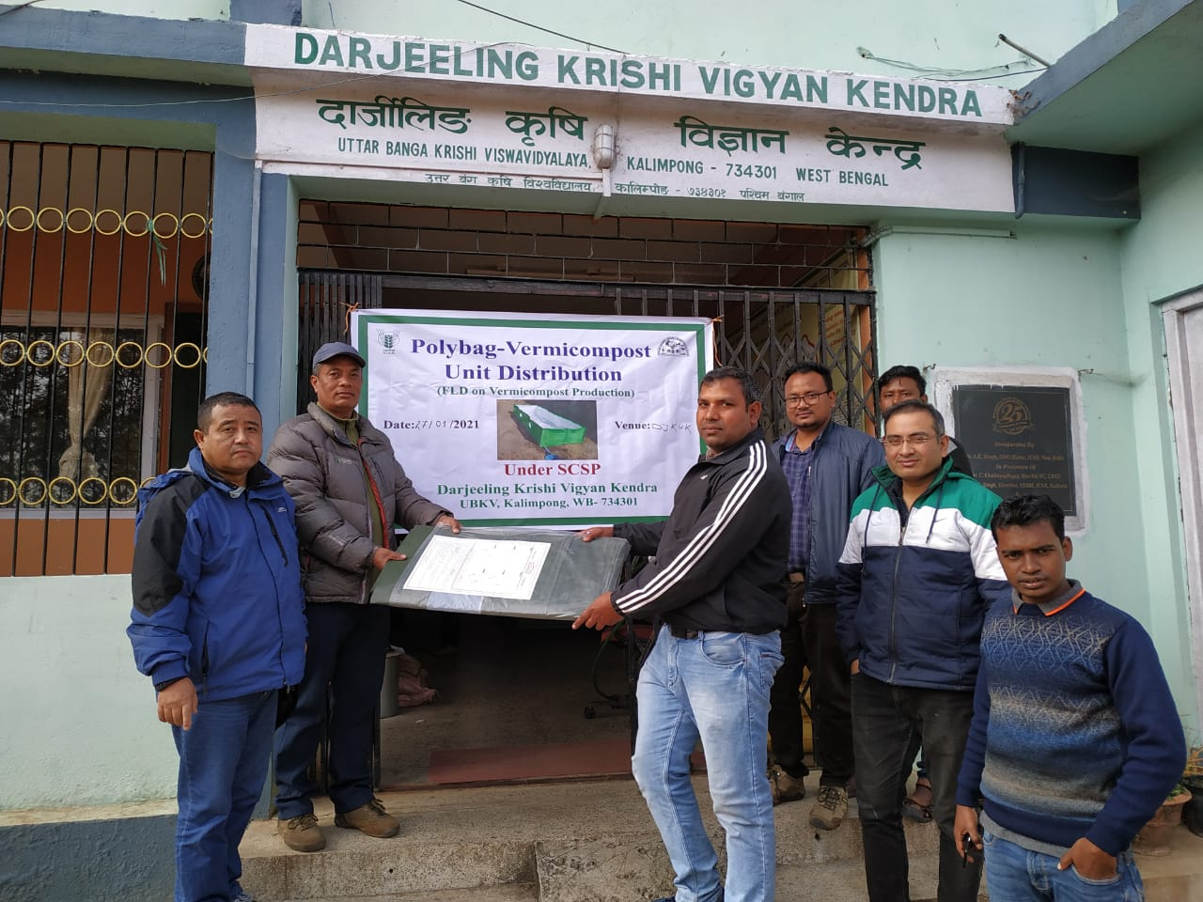

Distribution of Vermi Compost - Polybag

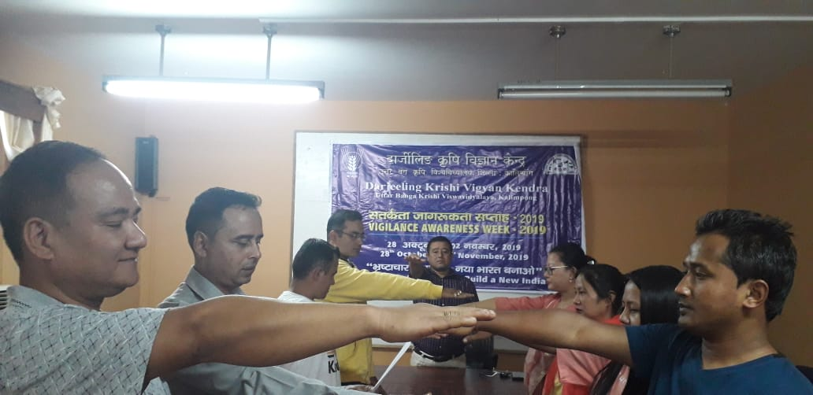

Constitution Day Celebration

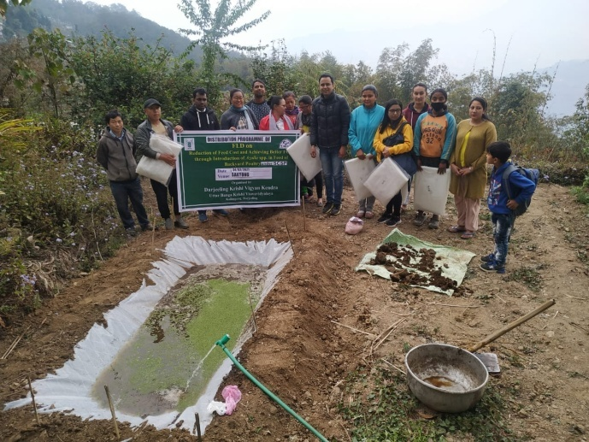

Establishment of Azolla Unit

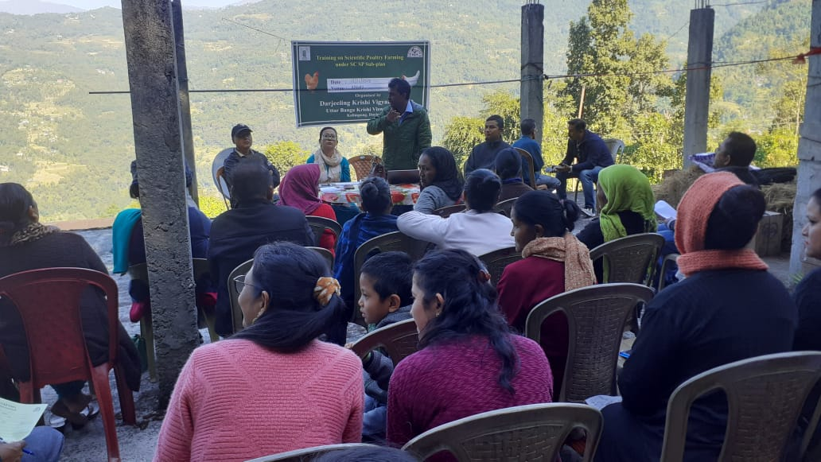

Off-campus Training Programme

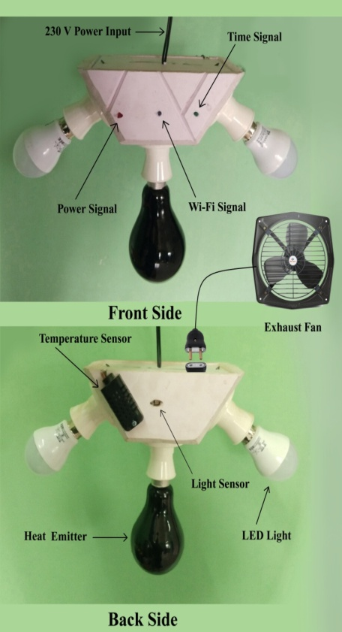

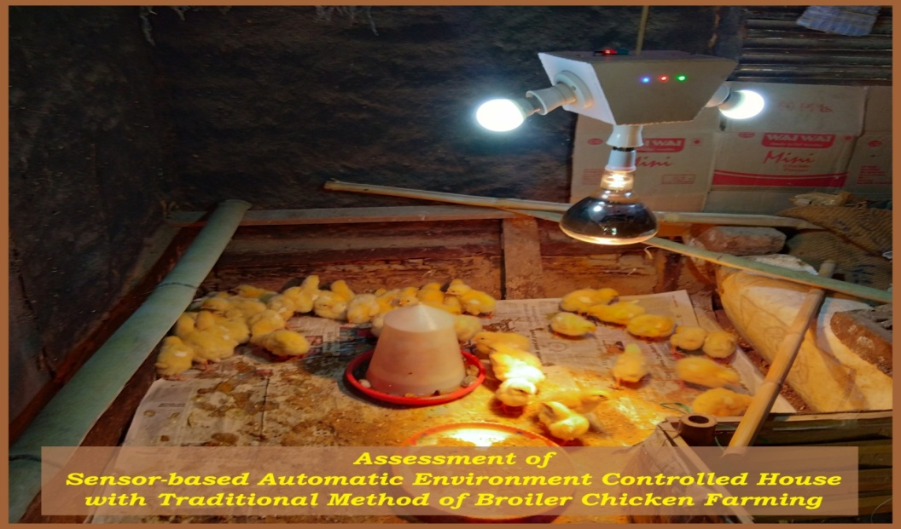

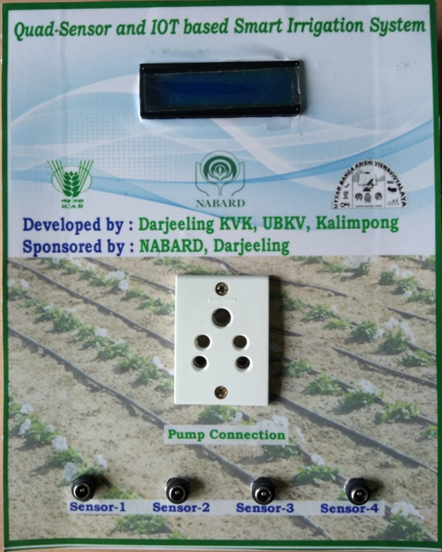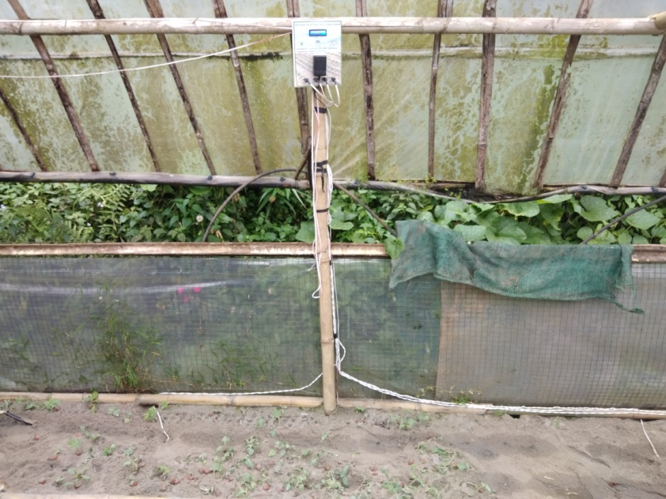

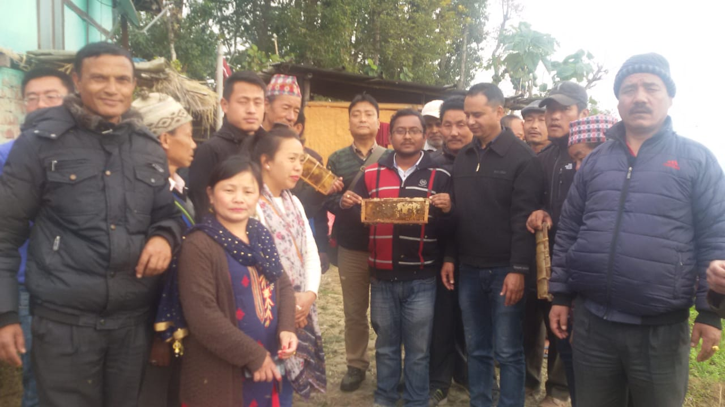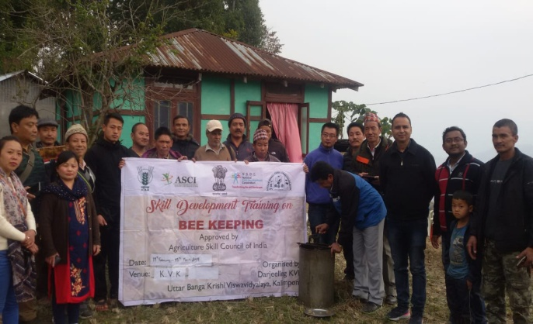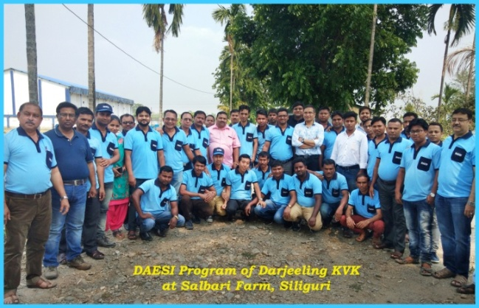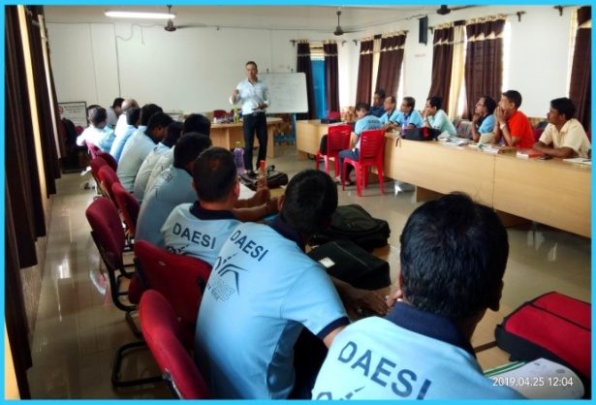

28. SC SP quarter-wise

**Table-I: Schedule Caste Output & Outcome Achievement/Indicators for 2020-21 (QUARTER-WISE)**

**Physical Output 2020-2021**

| **Sl. No.** | **Indicator/Activities** | **Unit of Indicator** | **Quarterly Breakup (Target)** | **Targets Achieved** | **No. of Beneficiaries** | **Outcome** |
| --- | --- | --- | --- | --- | --- | --- |
| 1 | **Farmers, farm women trained by KVKs** | **Number** | Q-1  Q-2  Q-3  Q-4 :15 | Q-1  Q-2  Q-3  Q-4 : 16 | Q-1  Q-2  Q-3  Q-4 :459 |  |
| 2 | **Extension personnel trained by KVKs** | **Number** | Q-1  Q-2  Q-3  Q-4 : 6 | Q-1  Q-2  Q-3  Q-4 : 4 | Q-1  Q-2  Q-3  Q-4 : 139 |  |
| 3 | **On-farm trials conducted by KVKs** | **Number** | Q-1 :2  Q-2 :4  Q-3 :2  Q-4 :2 | Q-1 : 1  Q-2 : 1  Q-3 : 1  Q-4 : 2 | Q-1 3  Q-2 4  Q-3 : 3  Q-4: 8 |  |
| 4 | **Frontline demonstrations conducted by KVKs** | **Number** | Q-1 :2  Q-2 :3  Q-3 :4  Q-4 :3 | Q-1 : 1  Q-2 : 1  Q-3 :2  Q-4 : 3 | Q-1 : 12  Q-2 : 28  Q-3 : 32  Q-4 : 60 |  |
| 5 | **Quantity of seeds produced** | **Quintal** | Q-1  Q-2  Q-3  Q-4 | Q-1  Q-2  Q-3  Q-4 | Q-1  Q-2  Q-3  Q-4 |  |
| 6 | **Planting materials Produced** | **Number** | Q-1  Q-2  Q-3  Q-4 | Q-1  Q-2  Q-3  Q-4 | Q-1  Q-2  Q-3  Q-4 |  |
| 7 | **Livestock strains and fingerlings produced** | **Number** | Q-1  Q-2  Q-3  Q-4 | Q-1  Q-2  Q-3  Q-4 | Q-1  Q-2  Q-3  Q-4 |  |
| 8 | **Soil & water samples tested** | **Number** | Q-1  Q-2  Q-3  Q-4 | Q-1  Q-2  Q-3  Q-4 | Q-1  Q-2  Q-3  Q-4 |  |